Gait Analysis Activity Tutorial
Below is one example of a method used by students to analyze the GSM data:
Students started with this spreadsheet:
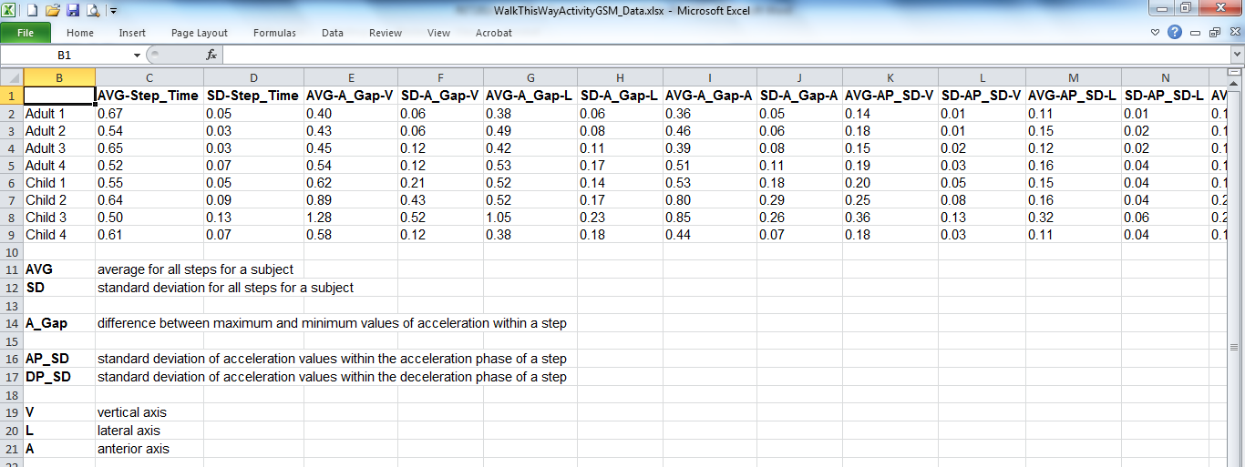

They then color-coded the data (that is, adults in red, children in blue):
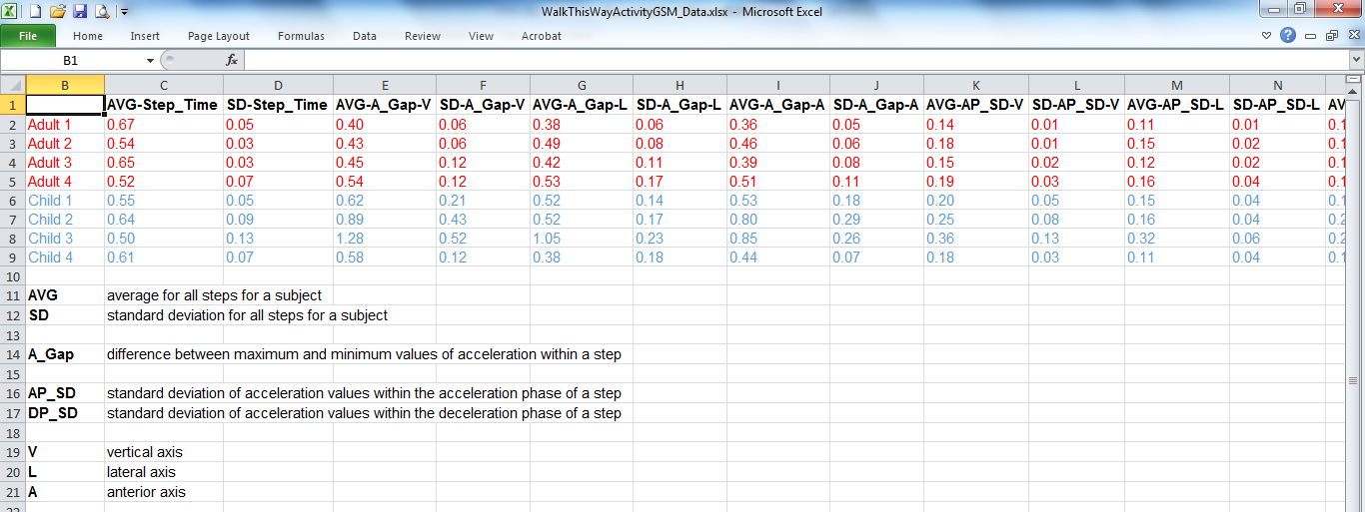

Then each column was sorted numerically from smallest value to largest:
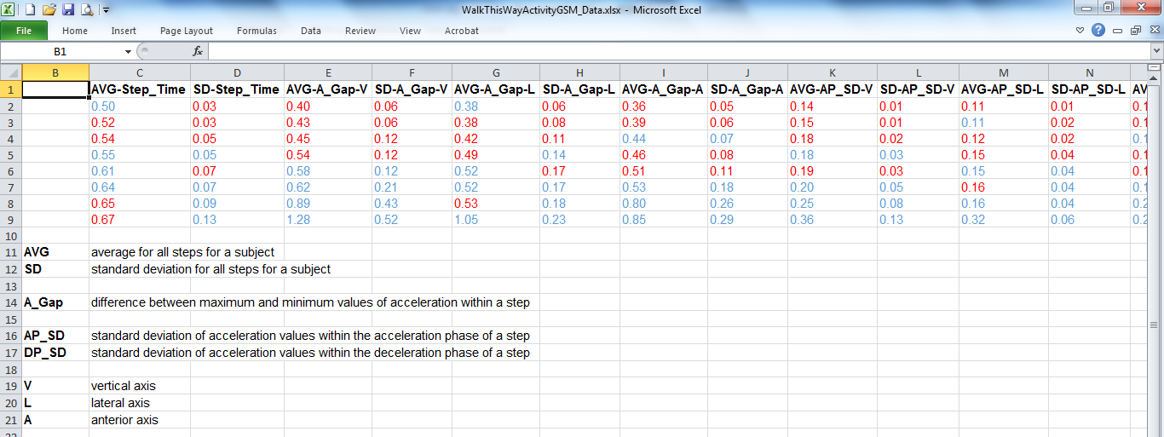

Then students looked for columns where the metric showed differences between adults and children. For example, in column E, AVG-A_Gap-V values for all adults are less than the values for all children. Students chose several columns to use in developing a model to predict whether a subject is an adult or a child based on their GSM metrics. Below is one group’s model:
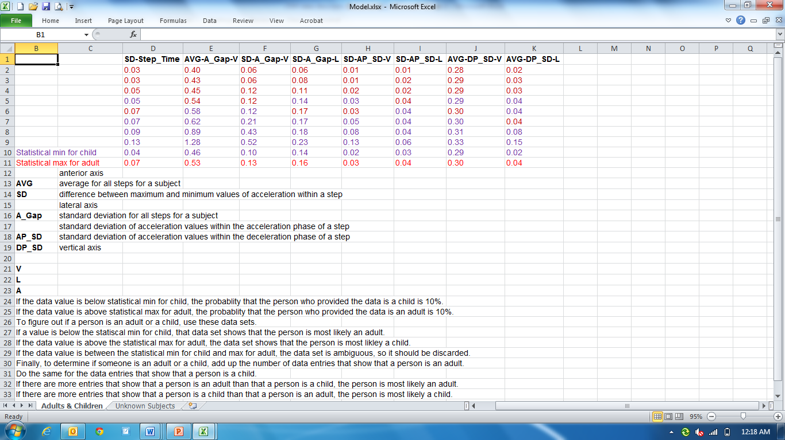

Then students applied their model to three unknown subjects to predict whether each was an adult or a child:

Unknown 1 and Unknown 3 were children. Unknown 2 was an adult.

