Storing Android Accelerometer Data: App Design Assessment

Answer Key

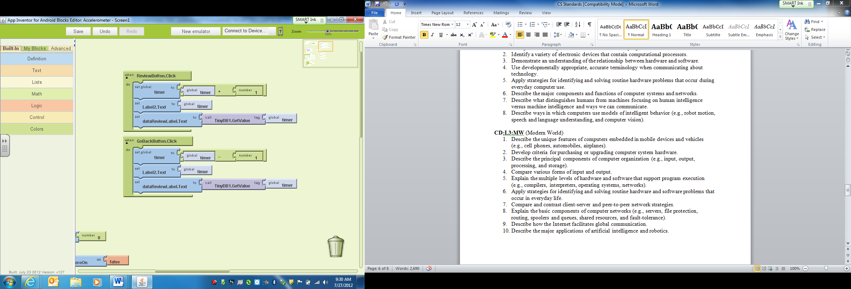Below is a screen shot of a sample of App Inventor code. The code shows the control of two buttons. Explain what happens when each button is clicked and how the code works.

**Solutions:**

**Review Button:**

When the review button is clicked, the value of timer will be incremented by 1, the display on Label2 will be changed to the new value of timer, and the display of the dataReviewLabel will be changed to the value of TinyDB1 stored at the index value of timer. In other words, dataReviewLabel will display the value recorded at the new value of timer.

**GoBackButton:**

When the GoBackButton is clicked, the value of timer will be decremented by one. The display of Label 2 will be changed to the new value of timer, and the display of the dataReviewLabel will be changed to the value of TinyDB1 stored at the index value of timer. In other words, dataReviewLabel will display the value recorded at the new value of timer.