Explain Some Python Code
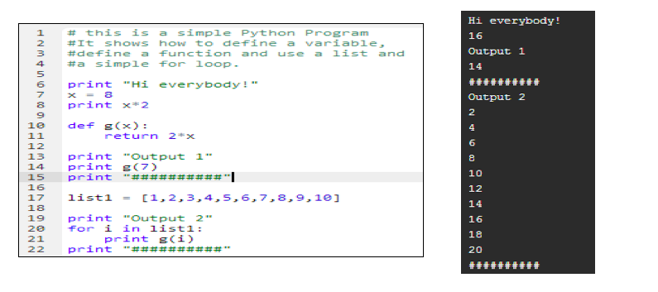

- Retype, compile and execute the code using the Python compiler.
- As part of your analysis, answer the following questions:
- What is the purpose of the quotation marks used in print statements?
- Is x = 8 the same as 8 = x?
- Does the indentation matter?
- How does the ‘for’ loop work?
- Next, make some changes to the code based on your analysis, then recompile and execute the code again. For example try 8 = x instead of x = 8 or change the x = 8 to x = 3, etc.
Did your changes to the code work the way you expected they would, based on your prior analysis and experience? Explain.

