Explain Some Python Code
Answer Key
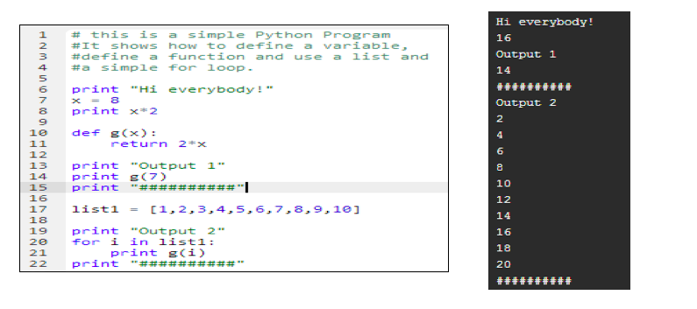

- Retype, compile and execute the code using the Python compiler.
- As part of your analysis, answer the following questions:
- What is the purpose of the quotation marks used in print statements? They tell the computer to print exactly what is inside the quotation marks.
- Is x = 8 the same as 8 = x? No, the order matters in variable declaration. The value on the right will be stored in the variable on the left.
- Does the indentation matter? In the Python language, yes. Indented lines belong to the first non-indented line above.
- How does the ‘for’ loop work? The for loop takes every element of list1, calls it ‘i’ for temporary computation, and performs an operation. In this case, every element is put into the function g(x).
- Next, make some changes to the code based on your analysis, then recompile and execute the code again. For example try 8 = x instead of x = 8 or change the x = 8 to x = 3, etc.
Did your changes to the code work the way you expected they would, based on your prior analysis and experience? Explain.
Answers will vary.

