**Features of the acceleration vs. time graph correspond to step characteristics.**

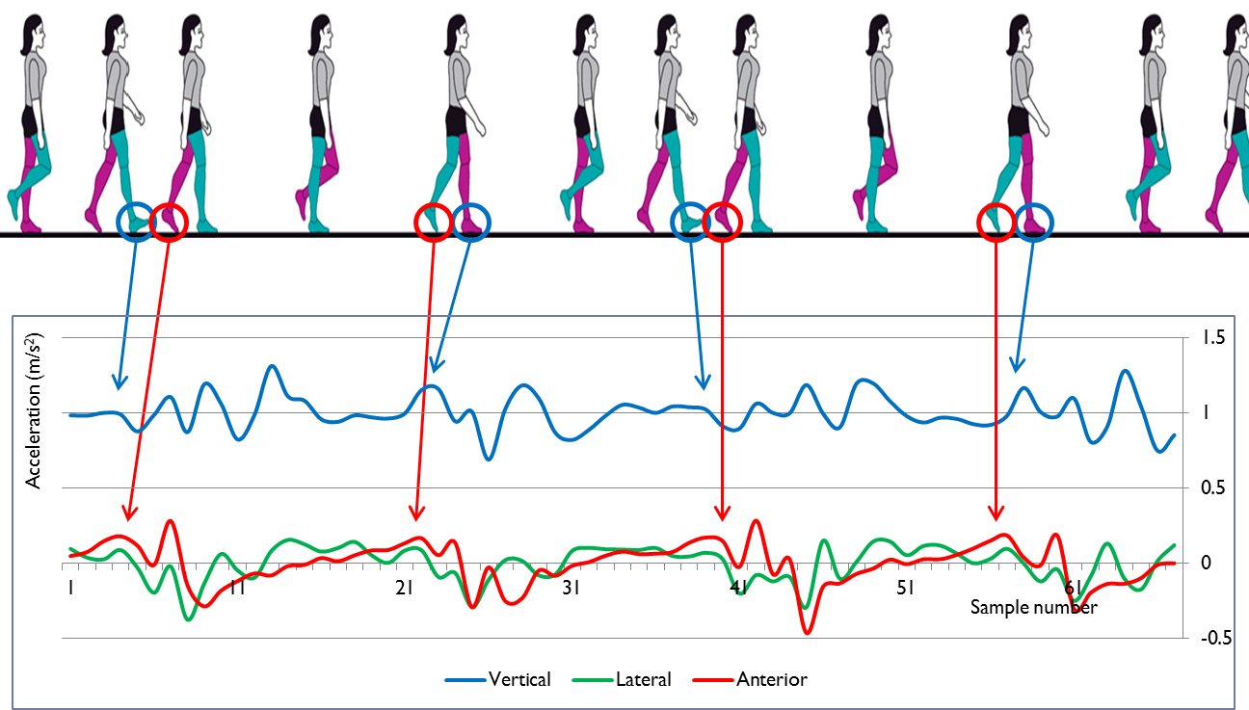

*Graphic source*: I.-K. Youn, S. Choi, J. Youn, K. Bastola, H. Ali, “Human Feature Tracking by Gait Signature Metrics,” *Microsoft PowerPoint* file, University of Nebraska Omaha, 2013.