Engineering Design Process Quiz
- What is the engineering design process?
____________________________________________________________________________________
____________________________________________________________________________________
____________________________________________________________________________________
- In the diagram below, fill in the steps of engineering design process.
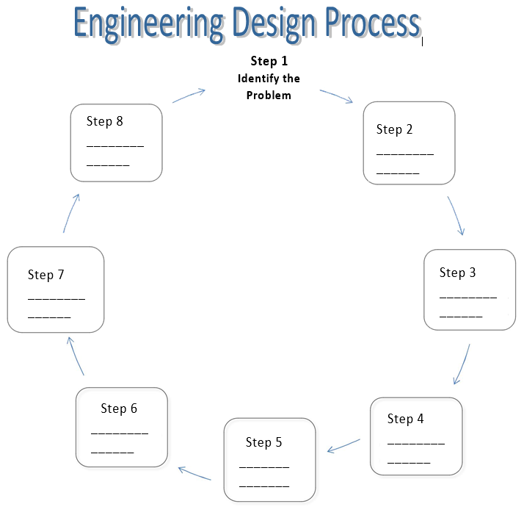

Communicate the solution

