Project Packet

Introduction

Engineering Design Challenge: The U.S. Postal Service reports that many cell phones are damaged in the shipping process. Your engineering challenge is to design new packaging to better protect cell phones during transport. You will conduct trials of different materials to determine the safest height from which to drop the phone while trying to make it weigh as little as possible.

For the trials testing, your group will create three prototypes. Then, you will create a fourth prototype for the final testing day. Your team may choose provided materials: cardboard, plastic, rubber bands, paper and fabric. Each prototype must be made of the same materials and have the same general design; the only thing that may differ is how much material is used so that the weight varies to meet the requirements.

If, when tested, no damage happens to the “cell phone”—such as breaks, chips, cracks and scratches—you will have achieved a safe drop. To test your prototypes, instead of using real cell phones, we will use pieces of glass that the shape and size of cell phones.

By the end of the design process, your team will be able to compare and contrast across teams, and determine the most reliable design of composite materials, taking into considering cost effectiveness and durability. You will do this by creating a budget for your prototype costs and comparing that to other groups. This project requires you to use the math and science concepts of graphing data, linear regression, velocity, acceleration, and force. Let’s get started to protect that cell phone!

Objectives
- Follow the steps of the engineering design process to find a solution, likely using a composite process, for creating the most cost-effective and durable cell phone shipping packaging.
- Describe the positive and negative attributes of using different materials to design protective structures and apply their understanding of the different materials to make choices concerning structure and design.
Final Product Expectations (Engineering Project Constraints)
- Create a new packaging design that uses the following materials: cardboard, plastic, rubber bands, paper, fabric, glue, and/or tape.
- For the trials testing, create three prototypes. Then, create a fourth prototype for the final testing day.
- You may use just one material or make a composite of multiple materials—but only use the listed materials, no others. For each prototype, you must use the same general design and materials. The only thing that may change is the prototype mass, and therefore, the amount of each material you use.
- Prototype requirements:

The size must be larger than 13 x 7 x 0.5 cm, but smaller than 20 x 10 x 5 cm.

The devices must be able to open up and close in order to hold the “cell phone.”

The prototypes weights MUST fall in these ranges: The first prototype protective package must weigh 12-14 grams (mass without the “cell phone”). The second package must weigh 16-18 grams. The third must weigh 20-22 grams. The final testing day prototype must follow all of the same expectations, but be the lightest weight—8-10 grams.
- After collecting data from testing the first three prototypes, make a linear regression graph. From this graph, make a prediction of the maximum height the package can drop without breaking. When you predict the height, be careful not to undershoot or overshoot the height.

If the package is damaged when dropped from your predicted height, you miss 15% of the points on your final project grade.

If the package is not damaged, you continue to drop it from higher heights until it is.

If the package breaks from a height 10 cm above what you predicted, you lose the same amount of points as if it had broken the first time you dropped it (from your predicted height).

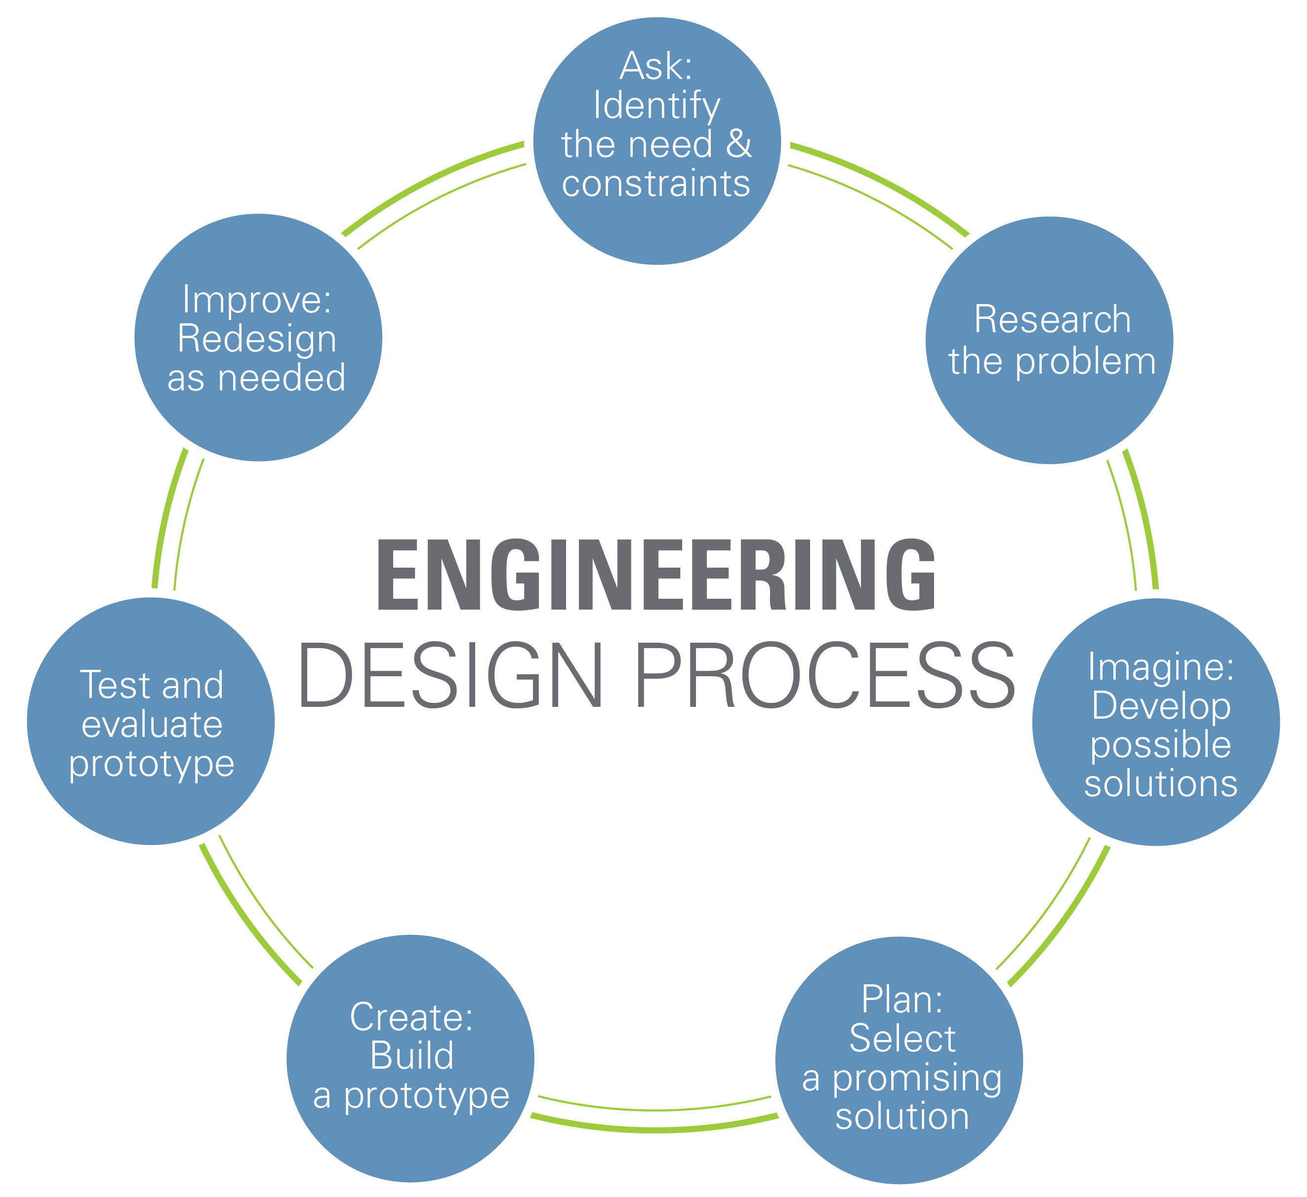
Engineering Design Process

Instructions: From this point on, fill in each part of this packet as the project is completed.
Tip: Write the due date next to each section.
Part 1: Ask: Identify the needs & constraints Due date _________ Grade ____
What is the problem you are trying to solve? (Answer in 1 or 2 complete sentences.) ____________________________________________________________________________________________________________________________________________________________________________________________________________________________________________________________________________________________________________________________________________________
____________________________________________________________________________________________________________________________________________________________________________________________________________________________________________________________________________________________________________________________________________________
Part 1 Rubric | 0 pts | 1 pt
Problem attempt | Did not attempt to answer the question. | Attempted to answer the question.
Complete sentence | Question was not answered in a complete sentence. | Question was answered in a complete sentence.
Correct answer | The answer was not correct. | The answer was correct.

Part 2: Imagine: Develop possible solutions Due date _________ Grade ____
On your own, brainstorm ideas for the new packing device. Before you are put into teams, you must have a drawing of your idea. Your drawing does not need to be perfect, but make it legible and label the materials you imagine using for each aspect or part of the design.

Part 2 Rubric | 0 pts | 1 pt | 2 pts
Student drawing | Did not attempt to draw a design. | Attempted to draw a design. | Made a comprehensive drawing.
Drawing is legible | The general prototype design was not clear from the drawing. | The general prototype design was somewhat clear from the drawing. | The general prototype design was very clear from the drawing.
Materials are labeled | None of the materials were labeled or identified. | Some materials are labeled or identified. | All of materials are labeled or identified.

Part 3: Research the Problem Due date _________ Grade ____
Instructions: Answer the questions in complete sentences and write down the reliable website where you obtained the information. Do not use Wikipedia. Website suggestions:
- http://www.nbcnews.com/id/18538484/ns/nbc_nightly_news_with_brian_williams/t/paper-or-plastic-whats-greener-choice/#.V4URCylTX8E
- http://www.explainthatstuff.com/composites.html
- http://articles.latimes.com/1991-11-30/news/mn-238_1_recycling-centers
- Of the provided/permitted materials, which are the most expensive?

Source citation: __________________________________________________________

- Of the provided/permitted materials, which are the cheapest?

Source citation: __________________________________________________________

- What is a composite material?

Source citation: __________________________________________________________

- Of the provided/permitted materials, which is the most harmful to the environment?
What sorts of problems does it pose?

Source citation: __________________________________________________________

- Of the provided/permitted materials, which is the heaviest? Which material is the lightest?

Source citation: __________________________________________________________

Part 3 Rubric | 0 pts | 1 pt | 2 pts | 3 pts
Complete sentences | No questions are answered in complete sentences. | Some questions are answered in complete sentences. | Most questions are answered in complete sentences. | All questions are answered in complete sentences.
Citations | No citations are given or all citations are unreliable sources. | Citations are given for each question but most are unreliable sources. | Citations are given for each question but some are unreliable sources. | Citations are given for each question and all are reliable sources.

Part 4: Plan: Select a promising solution Due date _________ Grade ____
Instructions: As a team, decide on the final prototype. Make your decision based on your research. For example, consider material durability, weight, cost, etc. Draw a neat and legible final prototype below. Label the drawing to identify the materials used, packing device parts, and estimated dimensions.

Part 4 Rubric | 0 pts | 1 pt | 2 pts
Drawing is neat and legible | It appears that little to no time went into making a neat and clear prototype drawing; the general prototype design is not understandable at all. | It appears that some time was spent making a neat and clear prototype drawing; the general prototype design is somewhat understandable. | It is evident that adequate time was spent making a neat and clear prototype drawing; the prototype design is very understandable.
Materials are labeled | No materials are labeled. | Some materials are labeled. | All materials are labeled.
Packing device parts identified | No packing device parts are labeled. | Some packing device parts are labeled. | All packing device parts are labeled.
Estimated dimensions | No dimensions are listed. | The estimated dimensions do not fall into the required dimensions. | The estimated dimensions are listed and fall into the required dimensions.

Part 5: Create, build, test and evaluate prototype(s); and Improve: Redesign as needed
Due date _________ Grade ____
Step 1: Build a prototype of your team’s final solution. Refer to the Final Product Expectations on page 1.
Step 2: As you are building it, test and evaluate the prototype. Drop it from different heights.
Step 3: Improve the prototype to make it the best design possible.
Step 4: Once you know what you want your final design to be, make the final three prototypes to be used on trial day. Again, be sure to meet the requirements of the Final Product Expectations on page 1.
Step 5: Keep track of the material costs (refer to the teacher’s budget sheet), how much of each material your group used, and how much in total your group has spent on its prototypes.
Notes from the design/build/test/improve process:

Part 5 Rubric | 0 pts | 1.5 pts | 3 pts
Prototype requirements | The three prototypes are built, but do not meet all of the requirements. | The three prototypes are built, but only meet some of the requirements. | The three prototypes are build and meet all of the requirements.
Three prototypes compared to each other | The three prototypes do not use the same materials and do not follow the same general design. | All three prototypes use the same materials OR they all follow the same general design. | All three prototypes use the same materials and follow the same general design.
Testing and evaluating the prototype | The group was never seen testing its prototype and cannot explain any of the tests or evaluations they made while building the prototypes. | The group was seen testing its prototype a few times and can explain some of the tests/evaluations they made while building the prototypes. | The group was seen a testing its prototype several times and can explain many of the tests/evaluations they made while building the prototypes.
Improving the prototype | Student cannot explain any improvements made during the iterative process. | Student can explain few improvements made during the iterative process. | Student can explain several improvements made during the iterative process.
Budget | The price of each material, how much of that material was used, and the total cost is not reported. | The price of some of the materials used and how much of that material was used is reported. | The price of each material used, how much of that material was used, and the total cost is reported.

Part 6: Trials Day Date _________ Grade ____
Step 1: Into your package prototype that weighs 10-12 g, carefully place a glass piece, which represents a cell phone.
Step 2: Drop the package from a height determined by your teacher; a suggested starting height is 48 inches. Keep track of the drop heights and results.
Step 3: Get ready to time how long it takes to drop, from release to hitting the ground. Assign one team member to be the timer. Even though the only time needed is for the drop when the package prototype is damaged, you need to time each trial in case that’s the drop when it is damaged.
Step 4: Go ahead and drop the package. Make sure that you drop it exactly how the teacher modeled it be done at the beginning of class.
Step 5: If the package is damaged*, stop and record all of the information about that drop. If not, continue to drop the package in 10-cm increments until the package is damaged.
*A package is considered damaged if any deformation occurs to the package or the device inside: cracked, chipped, scratched, dented, etc.
Step 6: Repeat this process for the other two other replicas (16-18 g and 20-22 g prototypes). Get from your teacher the pre-determined heights at which to drop the prototypes.
Step 7: Record your measurements in the data table below.
Instructions: Fill in the table to get the information for your linear regression graphs and your final lab report.
Package Weight | Package Weight  + “Cell Phone” | Height at Which Package  Was Damaged | Time It Takes  to Hit the Ground

Part 6 Rubric | 0 pts | 1 pt | 2 pts | 3 pts
Data table | Data table not filled in. | Data table mostly filled in but missing units. | Data table is completely filled in but is missing units OR is mostly filled in and includes units. | Data table is completely filled in and includes units.

Part 7: Linear Regression Graph Due date ________ Grade ____
Step 1: Create a scatter plot of your data on a Google sheets page. Only use the weight and height data. Put weight on the x-axis and height on the y-axis.
Step 2: Draw a line of best fit.
Step 3: Choose two most appropriate coordinates that the line of best fit goes through, and use those two points to write the equation for the line (use the y=mx+b form).
Equation for line of best fit: ____________________________

Part 7 Rubric | Points awarded | Max points
Weight and height are on the correct axes |  | 1
Scatter plot has a title |  | 1
X- and Y-axes are labeled |  | 2
Points are plotted accurately |  | 1
Line of best fit is drawn correctly |  | 1
Correct equation is written for line |  | 1
TOTAL |  | 7

Part 8: Make Your Prediction Due date _________ Grade ____
For your final test drop, use your 8 to 10-gram prototype package (mass without “cell phone”). Based on your linear regression graph, make a prediction of the maximum height a package can drop without breaking. When you are predicting the height, try not to undershoot or overshoot the height. If the package is damaged when dropped from the height you predict, you lose 15% of the points on your final project grade. If the box is not damaged, continue to drop it until it is. If the package breaks from a height that is 10 cm above your predicted height, you lose the same amount of points as if it had broken the first time you dropped it (from your predicted height).
Write a complete sentence that follows this prompt:
If the total package weighs _______ grams, then it will be able to drop from a height of ______ meters because…
_______________________________________________________________________________________________________________________________________________________________________________________________________________________________________________________________
Part 8 Rubric | 0 pts | 1 pt | 2 pts | 3 pts
Prediction | No prediction is written. | Written prediction is not in a complete sentence. | The written prediction is a complete sentence but is missing the “because” portion of the statement. | The written prediction is a complete sentence and includes the “because” portion of the statement.

Part 9: Final Testing Day Date _________ Grade ____
Step 1: Take your final prototype. This should be the one that weighs between 8-10 grams.
Step 2: Take your package and carefully place the sheet of glass (which represents a cell phone) into your design.
Step 3: The package will be dropped from the height you predicted that the box should be able to fall from without breaking. One student should measure the height.
Step 4: The time it takes from being released to hitting the ground needs to be timed.
Step 5: Go ahead and drop your box. Make sure that you are dropping it the way that was modeled for you by the teacher at the beginning of class. This should be done with the bottom of the box facing the ground and dropping it horizontally.
Step 6: Check to see if your box was damaged*. It was damaged, you will lose points and you are finished. If it wasn’t damaged, the box will continue to be dropped in increments of 5 centimeters. If it takes more than 10 centimeters before there is deformation, you will lose points just as many points as if the package broke on the first try.
*A package is considered damaged if any deformation occurs to the package or the device inside: cracked, chipped, scratched, dented, etc.
Step 7: Record all of your findings in this data table.
Weight of Package + “Cell Phone” | Predicted Height that Package Will Be Damaged | Actual Height at Which Package WAS Damaged | Time It Takes to Hit the Ground

Part 9 Rubric | 0 pts | 1 pt | 2 pts
Prototype requirement | The prototype is built but does not meet any of the requirements. | The prototype is built, but only meet some of the requirements. | The prototype is built and meets all of the requirements.
Data table | Data table is not filled in. | Data table is filled in but missing units. | Data table is completely filled in and includes units.
Predicted height was accurate: ______/15
Part 10: Analysis Questions Due date _________ Grade ____
Instructions: Answer the following analysis questions in complete sentences. Some questions have multiple parts; be sure to answer each part. For those that involve calculations, show your work.
- What was the velocity that the prototype package fell for each trial and on the final testing day? What was the acceleration of the package for each trial and on the final testing day? Does a trend exist for velocity and acceleration impacting the amount of damage on the package? Explain.

- Using the mass and velocity, with how much momentum did the box hit the ground for each trial? How did the amount of momentum affect damages? What would have happened if the momentum was higher or lower?

- What elements of your prototype package were successful and what elements of your package were unsuccessful, and why?

- How would a higher weight on your prototype package impact the height at which the package could be dropped without being damaged?

- Why is the engineering design process important when making new products? Explain.

Part 10 Rubric | 0 pts | 1 pt | 2 pts
Completion | No questions are answered. | Some questions are answered. | All questions are answered.
Work is shown | When solving math-based problems, no work is shown. | When solving math-based problems, some work is shown. | When solving math-based problems, all work is shown

Part 11: Writing the Lab Report Due date _________ Grade ____
Instructions: Write a summary report to describe what you did in the project, results, and findings. Include the following sections. Write in third person. Refer to the Lab Report Rubric for grading details.
- Abstract: What was tested in the lab research, how was it tested, what were the results?
- Purpose: Explain the purpose of the lab research in one complete sentence. Also briefly recap the engineering design challenge—what was the problem to solve?
- Procedure: IN YOUR OWN WORDS, write the steps that were taken in order to complete the research and testing. Write in past tense and in third person. Include materials information.
- Data tables: Include labeled data tables.
- Graphs: Include a weight vs. height graph with a line of best fit AND a distance vs. time graph, both from Trials Day data. Make the graphs in Google sheets and copy/paste them into the report.
- Error analysis: Describe two types of systemic errors that may have taken place during the project and may have affected your results.
- Analysis questions: Write answers to the analysis questions (Part 10) in complete sentences and in paragraph form.
- Calculations: Include the calculations you made to solve the analysis questions.
- Budget: Create a labeled budget table that lists each material used, the material cost for 1 quantity of that item, how many quantities you used, the total cost your team used for that material, and then the total cost of all the materials tallied up.
- Conclusion: Summarize the results of the lab in 4-5 sentences. Reflect upon the engineering design challenge: Explain why or why not your design worked, and how you would improve it next time.

