Engineering Design Process Handout

This representation of the engineering process is a guide of what actually happens in an engineering task. The actual process is much less linear, often going from later steps in the cycle back to earlier steps as the engineer gathers more data about their project.

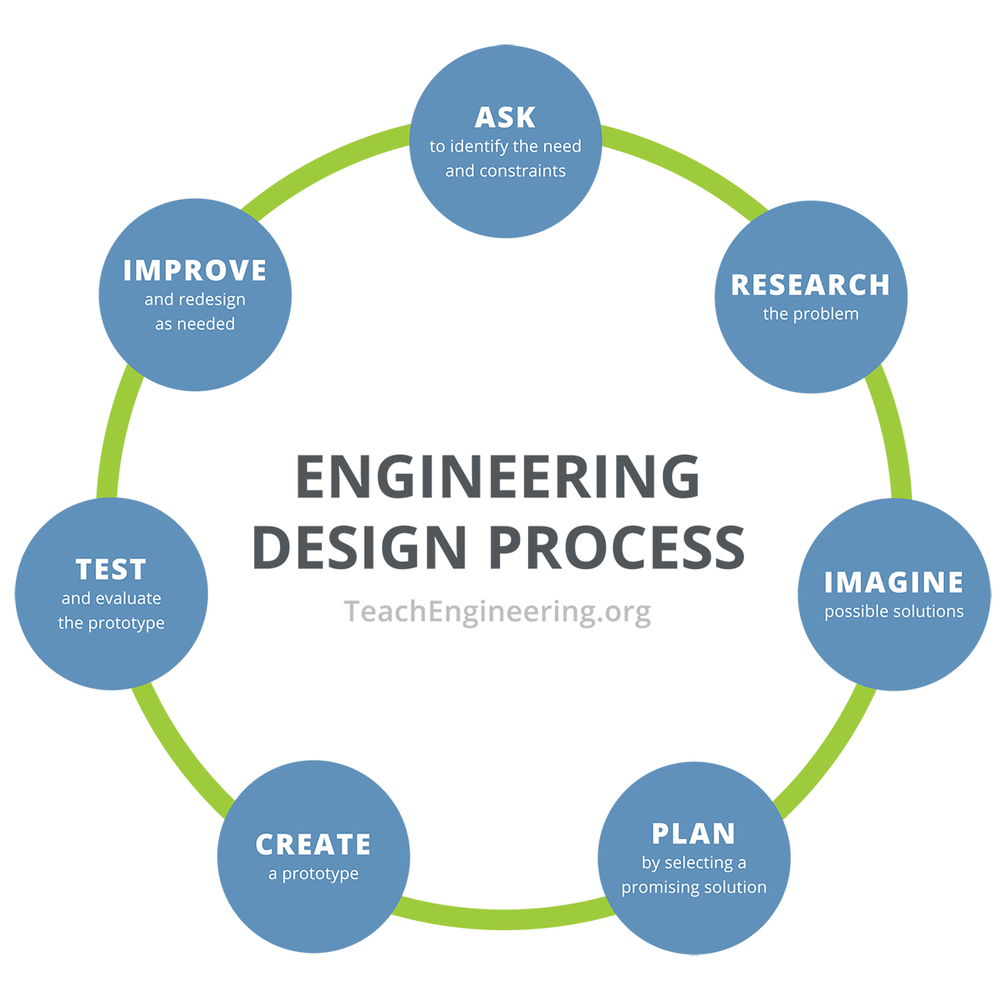

- Ask to identify the need or problem
- Specify and prioritize requirements and constraints to better define the need or problem

- Research the need or problem
- Examine current state of the issue and current solutions
- Explore other options via the internet, library, interviews, etc.

- Imagine possible solution(s)
- Brainstorm possible solutions
- Draw on mathematics and science
- Articulate the possible solutions in two and three dimensions
- Refine the possible solutions

- Plan by selecting the best possible solution(s)
- Determine, using simple analysis, which solution(s) best meet(s) the original requirements

- Create a prototype
- Model the selected solution(s) in two and three dimensions

- Test and evaluate the solution(s)
- Does it work?
- Does it meet the original design constraints?

- Improve and re-design as needed
- Overhaul the solution(s) based on information gathered during the tests and presentation

