Forces, Scatter Plots, and Polygons Worksheet Answer Key

Normal Forces
- A normal force exists between two solid objects when their surfaces are pressed together due to other forces acting on one or both objects. (For example, a box sitting on a table)
- If an object is sitting on a table (or level surface), then the normal force is opposite and equal of the weight of the object.

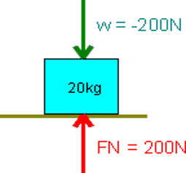

Tension Forces
- A tension force occurs when a rope, wire, cord or similar device without slack pulls on another object.
- The tension force always points in the direction of the pull.
- F = mg where m= mass (kg) and g= gravity constant (9.8 m/s²)

The image below is an elevator with mass 300 kg hanging from a single cable

Scatterplots
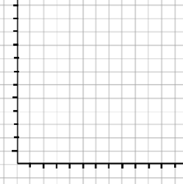

x | y
1 | 2
2 | 4
3 | 6
4 | 8

x | y
1 | 0
2 | 1
3 | 2
4 | 3

Draw each shape. What makes this shape different than the others? Which would hold the most weight?
The number of sides and how the shapes interlock make them different from each other. Shapes that can tightly interlock and cover the most area can hold the most weight. Drawing a repeating pattern of the shape is a good method to visually see how much area a shape can cover and how well the shape interlocks with itself.

- Triangle
- Square
- Hexagon holds the most weight; covers more area
- Trapezoid
- Circle

