Forces, Scatter Plots, and Polygons Worksheet

Normal Forces
- A normal force exists between two solid objects when their surfaces are pressed together due to other forces acting on one or both objects. (For example, a box sitting on a table.)
- If an object is sitting on a table (or level surface), then the normal force is opposite and equal of the weight of the object.

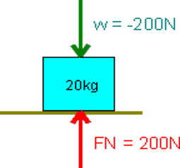

Tension Forces
- A tension force occurs when a rope, wire, cord or similar device without slack pulls on another object.
- The tension force always points in the direction of the pull.
- F = mg where m= mass (kg) and g= gravity constant (9.8 m/s²)

The image below is an elevator with mass 300 kg hanging from a single cable

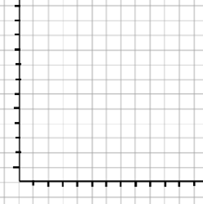
Scatterplots

x | y
1 | 2
2 | 4
3 | 6
4 | 8

x | y
1 | 0
2 | 1
3 | 2
4 | 3

Draw each shape. What makes this shape different than the others? Which would hold the most weight?

- Triangle
- Square
- Hexagon
- Trapezoid
- Circle

