Day 2 Exit Slip

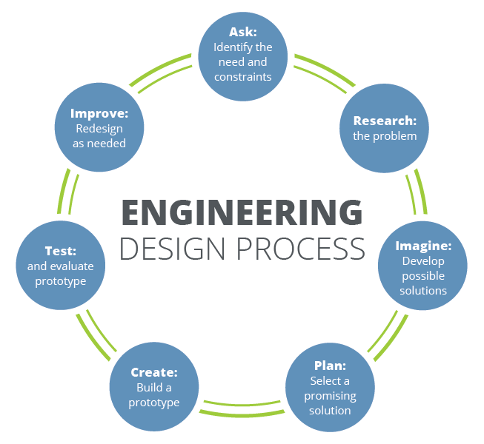

- Looking at the above Engineering Design Process (EDP) graphic and thinking about the past two days of class, explain where your group is in the EDP.

- What step(s) of the EDP will you be in tomorrow and explain your future actions.

