Engineering Journal

Complete as instructed.

Questions to keep in mind throughout this process.

- What is clean cooking? Is clean cooking important? Why/Why not?

- What does the family structure look like in the US?

- What does cooking at home look like in the US?

- What does the family structure look like in Kenya?

- What does cooking at home look like in Kenya?

- Is knowledge of culture important to scientific innovation? If so, how? Provide an example.
- What are engineers doing at Burn Design Lab in Vashon, Washington?

- What United Nations Sustainable Development Goals are met by you and the Burn Design Lab working on the clean cookstoves? How do they make the world a better place?

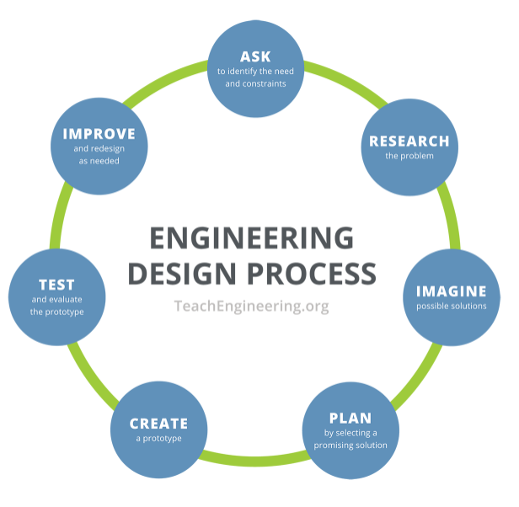
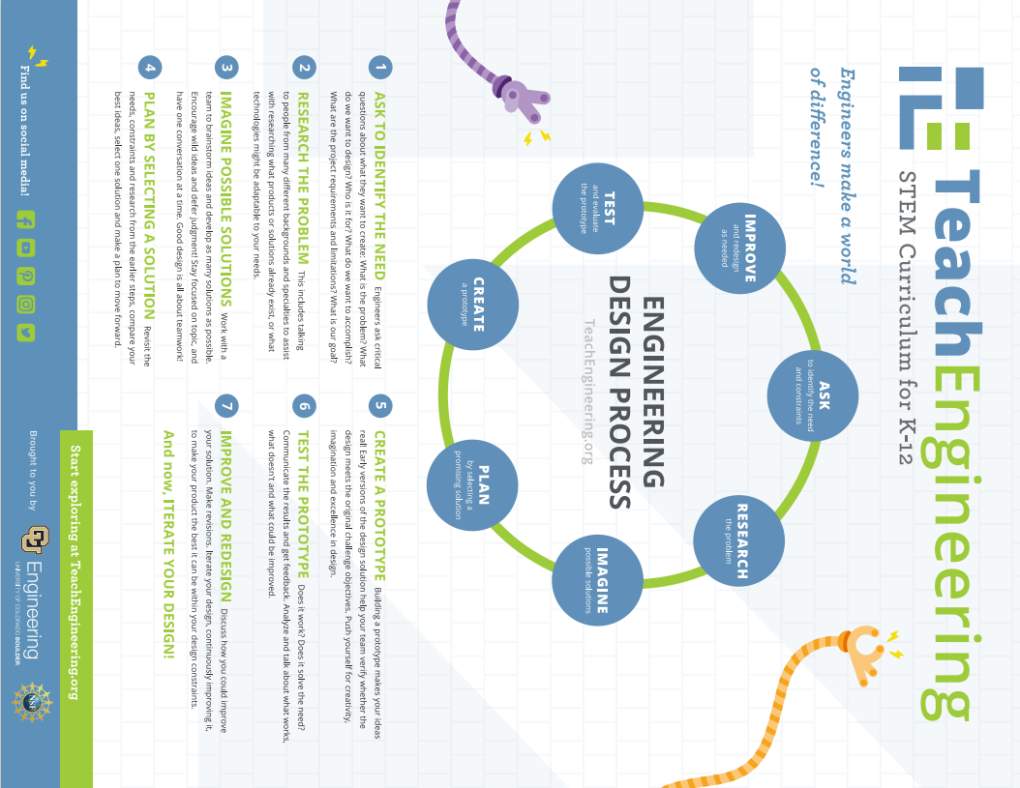

Ask - Complete the T-Chart and Identify the constraints.
What do you know about clean cooking? | What do you need to know about clean cooking in order to build a cookstove?

Constraints: Watch
- Cookstove Design #1: https://www.youtube.com/watch?v=uKpar5nvCns
- Cookstove Design #2 :https://www.youtube.com/watch?v=o_JLfPrLqOo
- Cookstove Design #3: http://www.youtube.com/watch?v=rvddmcl6iDo
- Cookstove Design #4: https://www.youtube.com/watch?v=deCzUOZyII8

As a class, decide on what cookstove can constraints your class must follow. Some options include: only one can per cookstove, two cans of the same size, two cans of different sizes, etc. Note: In order to get usable scientific data, every group must use the same number of and same sized cans.

Reminder,

Research - Read the articles and answer
Part A. Burn Design Lab
Go to www.burndesignlab.org/about
  - What do they design?

  - Scroll down to “A Local Solution for a Global Problem.” According to the World Health Organization (WHO), how many people use open fires to heat their homes and cook?

  - What is one of the BDL aims?

  - Scroll down to “How We Work.” What are the 5 parts of the (Engineering Design) cycle that BDL engages in?

  - Click “Mission” (at the top). Watch the video? BDL works witch partners in other countries. What knowledge do the people in these countries bring?

  - What is one country BDL partners with?

  - What university in Ghana partners with BDL?

Go to https://www.burndesignlab.org/blogs/success-stories-aller-stove. Read the blog.
- Paraphrase what Juana Pedro, President of the Women’s Committee at Buena Vista, said?

- Paraphrase what Juan Juan De Francisco said?

- Paraphrase what Teresa Francisco said about the cookstove with relationship to her eyes?

- Paraphrase what she said about the cookstove with relationship to her children?

Part B. Cookstoves
Watch
- Nigeria's Okey Esse Creates Clean Cooking Power Stove | Tech Trends - YouTube:https://www.youtube.com/watch?v=sgAunt6omjs

Watch 3 of the 4 videos listed below
- How Clean Cookstoves Improve Lives - YouTube: https://www.youtube.com/watch?v=Yu5SdH2_0JU&t=9s
- Clean Cookstoves: “Black Inside, Three Women’s Voices”:https://www.youtube.com/watch?v=qm9ODkF4VRo
- Clean Cookstove Project in Kenya: https://www.youtube.com/watch?v=L65htWQ4EmE&t=72s

Designing cleaner stoves for the developing world: https://www.youtube.com/watch?v=Z0XrARfLfuk

- What is clean cooking?

- What are the benefits of clean cooking versus using an open fire to cook?

- What 3 United Nations Sustainable Development Goals are being met by this work?

- Is clean cooking important? Why/Why not?

Part C. The United Nations Sustainable Development Goals
- Go to https://www.un.org/sustainabledevelopment/student-resources/
- Scroll down to “Frieda.”
- Read the digital book and note the colorful boxes in the illustrations.
- What is Goal #3?

- What is Goal #5?

- What is Goal #7?

- What is Goal #10?

- What is Goal #11?

- What is Goal #17?

Part D. Culture and Innovation
Watch: https://www.youtube.com/watch?v=J3Zsj4Lfs_o
- Half of the two million people who die are children under the age of ________. This is the equivalent of these children smoking 2 ______________ ________ ______________________ per day.
- What were two problems with the stove made by the large British oil company?

- Technology + _______________________
- So many attempts to improve the lives of people in poverty fail because they do not take a ____________ centered approach and they fail to take into account how real people live (their real behaviors) and ______________________ preferences.
- A design consideration that needed to be made was that people in different regions cook different ____________.
- In Guatemala, people make tortillas, so they need a ___________ cooking surface.
- In Ghana, they stir large ___________ of stew so they need a __________ stove that won’t topple.
- What are two reasons why we shouldn’t just give these stoves away?

- In order to market the stoves effectively, what is one thing the company has to do?

- Is knowledge of culture important to scientific innovation (design)? If so, why? Provide an example.

Part E. Life in Kenya.
Watch and answer.
https://www.youtube.com/watch?v=NhkqcflxtiI&t=5s
- Describe the family and home in this video.

- Describe the food in this video.

- The person who did the cooking was of which gender?

- Where was the cooking done? What was used to cook the food?

An Indigenous Community in Kenya: the Luhya people: https://www.youtube.com/watch?v=kQVUYmiEREA
African Village Life/Cooking The Most Appetizing Kenyan village Food: https://www.youtube.com/watch?v=8v7qZv-D2JE
- Tell two things that surprised you about what you saw.

- Describe the foods and things used or cooking. Is the food mostly processed food or natural plants, crops, meat, etc.?

Another Indigenous Kenyan People Group:
https://www.youtube.com/watch?v=ThcppnztYpw
https://www.youtube.com/watch?v=NorrsBsOnZ0
- Describe the values these men and their community operate with.

- What can you say about (Masai) Kenyan families based on these videos?

Life in Nairobi, Kenya
https://www.youtube.com/watch?v=dI0WovGPD6c
https://www.youtube.com/watch?v=pLYXOMCkFHQ
https://www.youtube.com/watch?v=Q32aZTNP1JE
- Tell two things that surprised you about life in Nairobi, the capital city of Kenya.

- Describe what you see in the backgrounds of these videos.

- Describe the foods you saw in these videos?

https://www.youtube.com/watch?v=ChyPpnQaBs0
- Tell 4 things you think of when you hear the term Africa.

- Based on all the videos you’ve seen, what can you ascertain (guess/say/assume) about Kenyan families?

Imagine (Individual Brainstorm) - Draw a detailed sketch of your design. Be sure to include the number size, and shapes of any holes or openings. If you are working with a digital Engineering Journal, you may sketch on paper and then upload a picture of your sketch or sketch in program, app, etc. Share/Show your file with(to) your teacher. Have your teacher initial your packet/file and record your points in the gradebook.
Teacher Initials: _______

Plan (Group Decision) - Sketch your team's final design. Include a statement detailing why you picked this design. If you are working with a digital Engineering Journal, you may sketch on paper and then upload a picture of your sketch or sketch in program, app, etc. Take your packet/computer to your teacher. Have your teacher initial when you finish and record your points in the gradebook.
Teacher Initials: _______

Build Prototype - Build your prototype. Paste/Upload two pictures (or provide two sketches) from different angles of your prototype below.

Test Prototype - Upload a picture or provide a sketch of your team testing your prototype while you do Cookstove Lab I:Testing the Cookstove.

Evaluation of Data: Class Discussion - Record the trends observed in the class data that were discussed by your class and your thoughts on your redesign. Take your packet/computer to your teacher. Have your teacher initial when you finish and record your points in the gradebook.
Trends:

____________________________________________________________________________________________
Redesign Thoughts/Ideas and Why:

Teacher Initials:_______

Redesign Plan - Describe the changes decided upon and sketch your team’s new cookstove. Upload a picture if working with a digital journal. Have your teacher initial your packet.
Teacher Initials:_______

Redesign Build - Upload a picture or provide a detailed sketch of your team’s redesigned cookstove. Take your packet/computer to your teacher. Have your teacher initial when you finish and record your points in the gradebook.
Teacher Initials:_______

Testing the Redesign - Upload a picture or provide a sketch of your team doing Cookstove Lab II:Testing the Redesign.

Reflection - Copy your answers from Lab II: Testing the Redesign below. Take your packet/computer to your teacher. Have your teacher initial when you finish and record your points in the gradebook.
- Did your redesign have a longer or shorter boil time?

- What are your thoughts as to why?

- If you could redesign it again, what would you do?

Teacher Initials:_____

Extra Credit
Go to Student Resources - United Nations Sustainable Development (https://www.un.org/sustainabledevelopment/student-resources/ ). Scroll down to 170 Actions to Transform Our World. Read the digital book. Choose 4 Goals. Choose one action you, your friends, our class, etc could do for each goal.

Goal Number | Goal | Action

