Cookstove Lab I: Testing the Cookstove

Instructions. You will do a Boiling Test to test the effectiveness of your stove. To do this, you will measure the time it takes the stove to boil a “pot” 100 mL water. Your “pot” is a small aluminum loaf pan or steel mug. Though we will not do it here, further testing that is normally done on stoves includes a Thermal Efficiency Test.
- Paste two pictures (or detailed sketches) from different angles of your stove below. Also, record the number of small, medium and large holes in your cookstove.
Picture 1 | Picture 2 | Holes
Small: ______

Medium: ____

Large: ______

Total: _______

- Record the mass of the cook stove. Always remember units! ________________
- Fill the cook stove ⅔ full with charcoal. Record the mass of the stove and the fuel. Always remember units! ____________________
- Subtract to find the mass of the fuel used. Record that here. Always remember units! ______________
- Add/remove charcoal so that it matches the mass the class decided upon. Record the new mass of the can and the charcoal. Always remember units! _______________
- Ask your instructor where the room temperature water is. Use a graduated cylinder to measure exactly 100 mL of room temperature water.
- Pour the water into your “pot.” (Reminder: This is a small aluminum loaf pan or steel mug.)
- When instructed, go to the hood (or outside). Set up apparatus as shown in Figures 1 and 2 below using a ring stand, ring clamp, and wire mesh.

- Your teacher will help you light your fuel. (Paper or twigs may be needed to help light it.) When the fire has burned out and the coals are glowing or have “ashed” over, the cook stove is ready for testing.
- Start a timer.
- When the water begins to boil, stop the timer. Record the time it took to boil water. Always remember units! ________________
- Use tongs, hot hands, etc., to pour your remaining water down the drain or in the grass, and pour your remaining coals in the Dutch oven. Cover the Dutch oven to fully extinguish the fuel. Clean up your work area.
- Upload your two pictures of your cookstove, the number of holes, and the time it took to boil 100 mL water on the Cookstove Class Data Sheet.

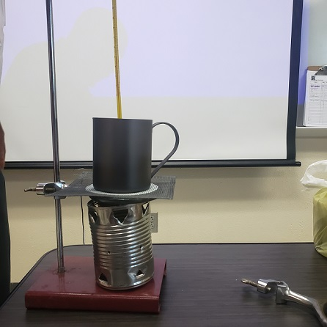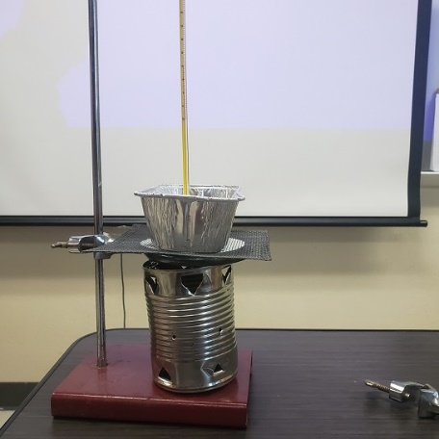
Figure 1. Figure 2.
Questions. Answer using the Cookstove Class Data Sheet.
- Find the 5 shortest boil times. List them from longest to shortest. Below each one, list the total number of holes.

- Looking for trends. Is there a correlation between boil time and the total number of holes? If so, explain. (For example, cookstoves that have shorter boil times have more (total) holes. Or, the cookstoves that have shorter boil times have fewer holes. Or, there is no relationship between the total number of holes and the boil time.)

- Find the 5 shortest boil times. List them from longest to shortest. Below each one, list the number of small holes.

- Looking for trends. Is there a correlation between boil time and the number of small holes? If so, explain. (For example, cookstoves that have shorter boil times have a higher number of small holes. Or, cookstoves that have shorter boil times have a lower number of small holes. Or, there is no relationship between the boil time and the number of small holes.)

- Find the 5 shortest boil times. List them from longest to shortest. Below each one, list the number of medium holes.

- Looking for trends. Is there a correlation between boil time and the number of medium holes? If so, explain.

- Find the 5 shortest boil times. List them from longest to shortest. Below each one, list the number of medium holes.

- Looking for trends. Is there a correlation between boil time and the number of large holes? If so, explain.

- Are there any other trends that you notice among the class data?

- Look at the Class Data, what was the shortest boil time? _____________
- Describe/Sketch the design of that cookstove.

- Based on the Class Data, how do you plan to change your cookstove to improve its boil time?

