**MAP OF KROGER STORE, HUBER HEIGHTS, OHIO USA**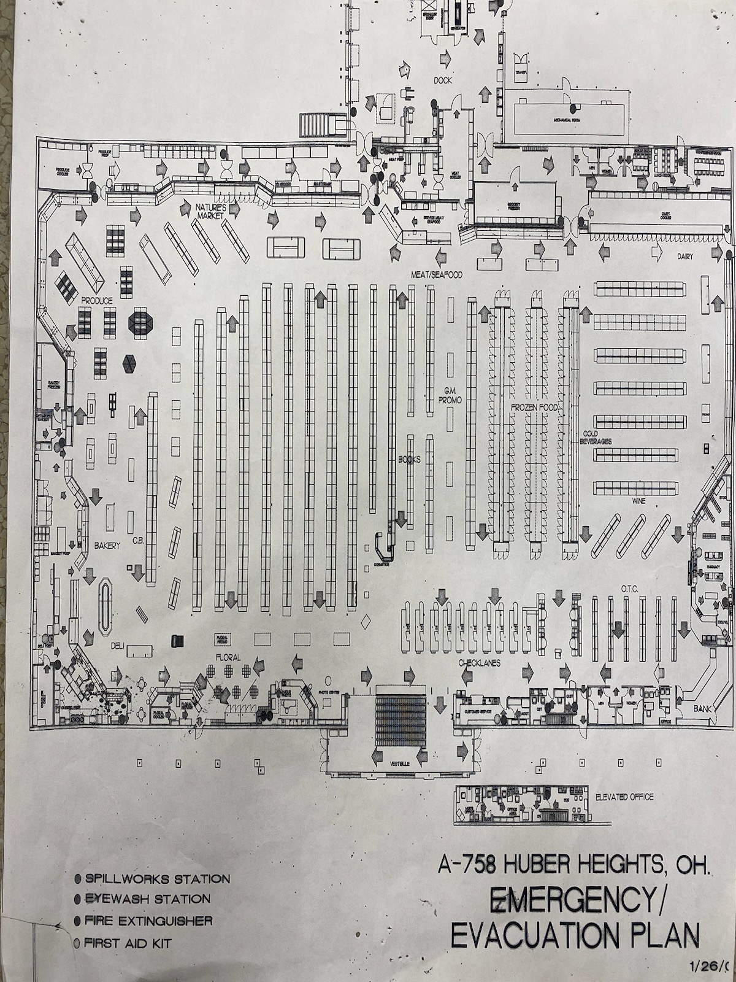

**LOCATE THE FOLLOWING ON THIS MAP:**

**- FLORAL SECTION AS #1 - PRODUCE SECTION AS #2 - BAKERY SECTION AS #3**

**- GRAB-AND-GO ITEMS AS #4 - PHARMACY AS #5 - GENERAL MERCHANDISE AS #6**

**- DAIRY PRODUCTS AND FOOD - IMPULSE SECTION AS #8 - SEASONAL SECTION(S) AS #9**

**STAPLES AS #7**

**- COFFEE SHOP AS #10 - MEAT/FOOD STAPLES AS #11 - SERVICE DESK AS #12**