Engineering Design Challenge Sheet

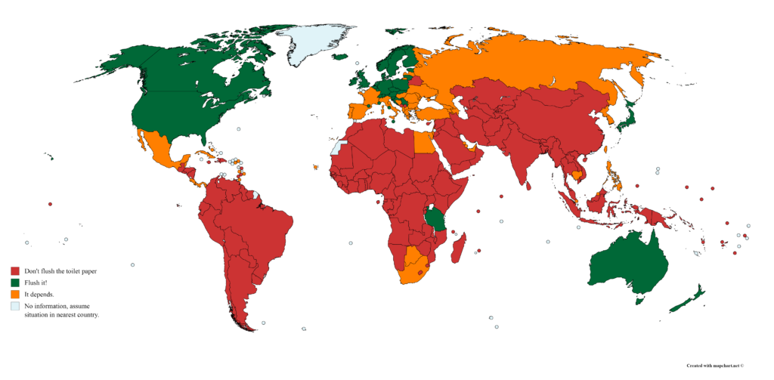
https://brilliantmaps.com/flush-toilet-paper

Most countries in the world dispose of toilet paper completely differently than we do in the United States. In fact, it might be a surprise to learn that in most countries people dispose of their toilet paper in the trashcan, or that there is not any toilet paper in the bathroom at all. So, what happens if you’re traveling and you have a blunder and accidentally toss your toilet paper into the toilet? Will the toilet clog? Will it mess up the entire sewage system? Will you get in trouble? If this unfortunate situation arises, is there something you can do?

Scenario: You are traveling in Ecuador. After a long day, you head to the “baño.” After doing what needed to be done, you have a “brain fart”--pun intended–and you throw the toilet paper in the toilet and flush it. Yikes, the bowl is filling up and it is clogged. What can you do to unclog it?

Your “baño” is in a wooded area with many plants including trees, shrubs, grasses, fruits, and vegetables. You are inspired by the Indigenous Kichwa people of Yambiro, Otavalo, Ecuador, who have used plants for various reasons for thousands of years. You wonder if you could find plants containing chemicals that could dissolve the toilet paper.

After you choose a plant that may contain helpful chemicals, you must decide how to get to the chemicals. Just throwing a whole plant on top of the toilet paper will likely cause a bigger crisis. Processes such as squeezing, crushing, and heating may help you get usable substances to address the problem.

Basic Agenda: You will be given time to research, share out, brainstorm and plan. Then, you will be given samples of toilet paper to test on. Then, your plant (stuff) will be added to a clogged toilet (funnel clogged with toilet paper and 250 mL water). The amount of water in the receiving container will be measured every 3 minutes for 15 minutes. Visual inspection will also be made. You will then be given time to share out, re-evaluate, brainstorm, plan, and test again.

