Gate Handout #1
Label each of the following truth tables as an OR, AND, BUFFER, or NOT gate based on the truth table inputs and outputs by putting your answer in the box in the output column. Defend your answer using 1-4 complete sentences.
Note: All of these tables are set up from the perspective of the green trucks. Hints: Ask yourself, “Is the truck that is going in (the input) green?” “Is the truck coming out (the output) green?” Include the following terms in your explanation: ‘green truck(s)’, ‘truck(s) that is(are) not green’, ‘input’, and ‘output’.
Truth Table #1
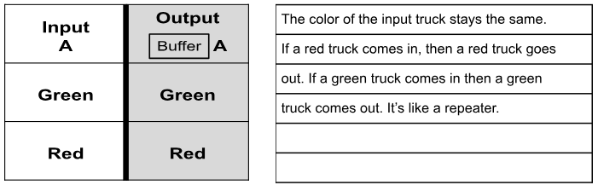

Truth Table #2
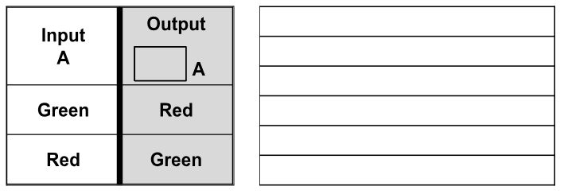

Truth Table #3
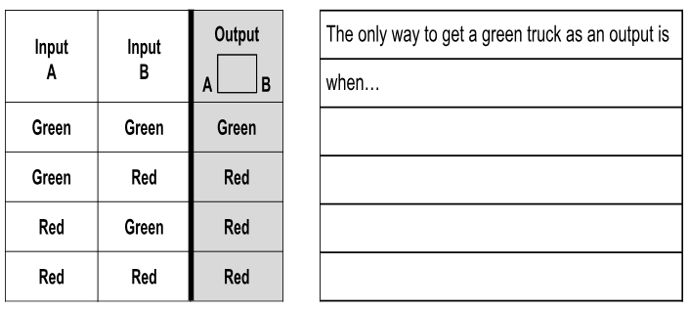

Truth Table #4
