Gate Handout #2 Answer Key
Three new truth tables have been provided for the XOR, NAND, and NOR gates. Use the names and your knowledge of the other gates to determine the correct outputs. Defend your answer using 1-4 complete sentences on the lines provided.
Note: All of these tables are set up from the perspective of the green trucks. Hints: Ask yourself, “Is the truck going in (the input) green?” “Is the truck coming out (the output) green?”

Truth Table #5
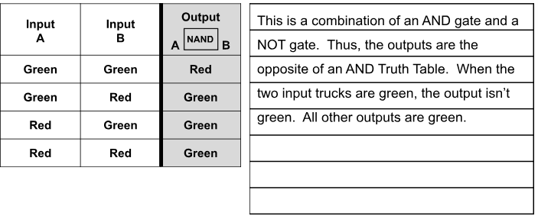

Truth Table #6
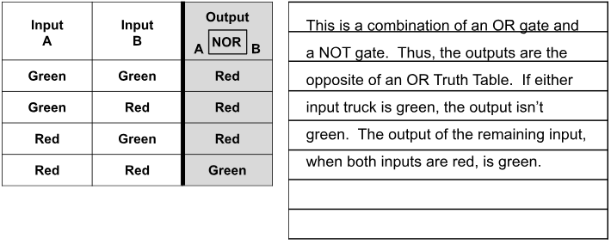

Truth Table #7
