Decibels Pre-Quiz

- What causes a sound to occur?
_________________________________________________________________________________________________________________________________________________________________________________________________________________________________________________________
- What are three materials that absorb sound?
_________________________________________________________________________________________________________________________________________________________________________________________________________________________________________________________
- What are three materials that reflect sound and cause an echo?
_________________________________________________________________________________________________________________________________________________________________________________________________________________________________________________________
- What mediums can sound travel through?
_________________________________________________________________________________________________________________________________________________________________________________________________________________________________________________________
- If you are soundproofing a room, this means you are doing what?
_________________________________________________________________________________________________________________________________________________________________________________________________________________________________________________________
. 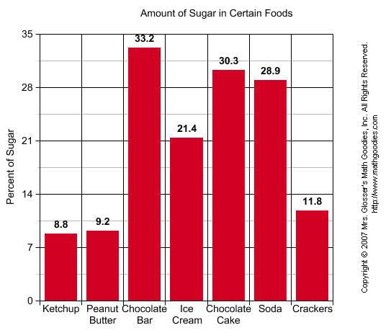
- What is the information that this graph is showing you?

- What is the difference in percentage in sugar between ice cream and crackers?

- What has the highest percentage of sugar?

- What is being measured on the y axis?

- What goes on the x axis?

