# **Cool Puppy! Worksheet**

# **Engineering Design Challenge**

# One day after school, you went for a walk around your neighborhood and found a lost puppy! The puppy had no collar or tag, so you decided to take matters into your own hands. You rescued this lost puppy from the side of the road, but your mom is not willing to have your puppy in the house. The weather prediction is for a record-setting heat wave and you are worried about your puppy being outside in the heat, so you decide to build a doghouse to protect your puppy from the thermal energy of the sun. The Supplies4U Store is full of supplies that you can buy; now you just have to choose what materials you want to use to design and build the coolest doghouse for your puppy! From your saved allowances, you have $12 to spend. Now you must carefully spend your savings to buy materials to build this doghouse!

**Materials & Tools**

* various building supplies
* various adhesives and tools
* light / heat source
* thermometers
* timer

**Constraints**

* All supplies used must be purchased within your **$12 budget**.
* A budget tracking report must be provided prior to testing.
* The doghouse must protect the puppy from the outside heat.
* Your dog must fit completely inside the doghouse;  
    
  Puppy dimensions: ________________________
* The doghouse temperature must stay under 32 ℃ (90 ℉) when out in the “sun” for 30 minutes.
* The dog must be able to exit the doghouse for access to a water dish!
* The doghouse must be a self-supporting structure.

**Notes**

**Design-Plan-Create**

1. Follow the steps of the *engineering design process* to brainstorm and plan your doghouse.

**Engineering Design Process**

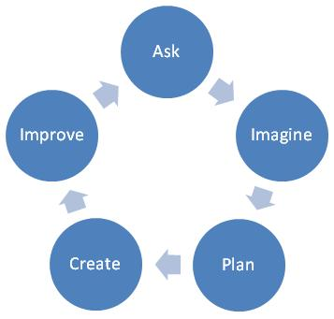

**The Goal**

1. Keep track of your spending by filling in the budget sheet on the next page.
2. Construct your doghouse.

**Test-Analyze-Improve**

1. Place your doghouse in the testing area with one thermometer inside the doghouse and one thermometer outside the doghouse.
2. Record your before-testing observations below:

|  |  |
| --- | --- |
| Temperature inside doghouse before testing | Temperature outside doghouse before testing |
|  |  |

1. Set a timer for 30 minutes; turn on the light and begin the test.
2. After 30 minutes, record your observations below:

|  |  |
| --- | --- |
| Temperature inside doghouse after 30 minutes | Temperature outside doghouse after 30 minutes |
|  |  |

1. How effective was your doghouse in protecting your puppy?

|  |
| --- |
|  |

1. If you could redesign your doghouse, how would you modify your design to make it better?

|  |
| --- |
|  |

**Budget Tracking Report**

|  |  |  |  |  |  |
| --- | --- | --- | --- | --- | --- |
| **Date** | **Material** | **Price** | **Quantity** | **Cost** | **Balance** |
| Budget 🡺 | | | | | **$ 12.00** |
|  |  |  |  |  |  |
|  |  |  |  |  |  |
|  |  |  |  |  |  |
|  |  |  |  |  |  |
|  |  |  |  |  |  |
|  |  |  |  |  |  |
|  |  |  |  |  |  |
|  |  |  |  |  |  |
|  |  |  |  |  |  |
|  |  |  |  |  |  |
|  |  |  |  |  |  |
|  |  |  |  |  |  |