Parts of a Microscope Sheet Answer Key

power switch | focus knob | lamp
objective lens | eyepiece | stage
Label the main parts of the microscope in the diagram below using the helping words given in the box.

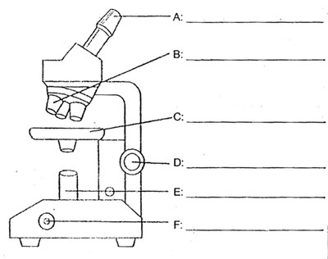

eyepiece
objective lens

stage

focus knob

lamp

power switch

