Bacteria! It’s Everywhere! Rubric
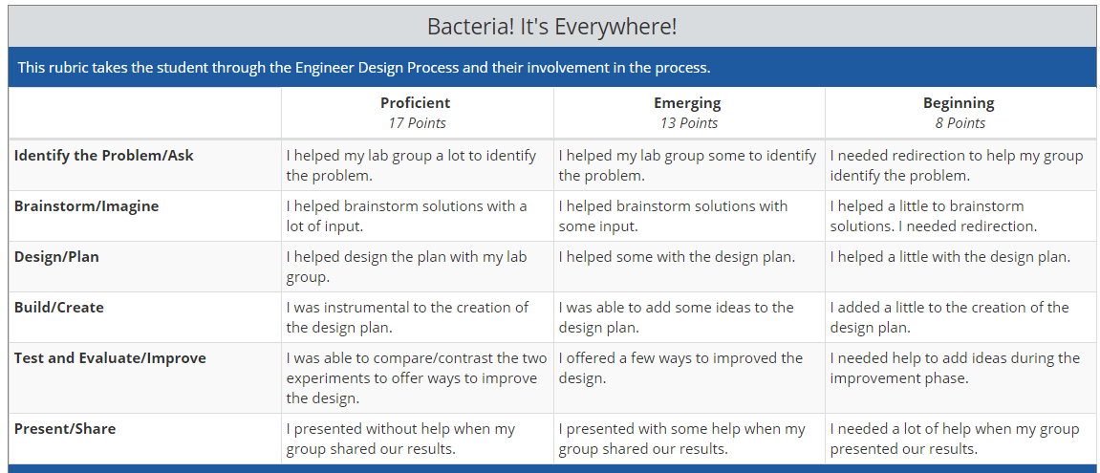
Comments:

