**Recycling Sort Pre-Assessment**

*Trash or Recycle?*

Instructions: Sort by deciding if each picture can be recycled or is waste and goes in the trash.

Trash

Recycle

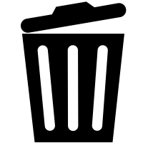

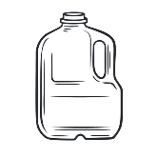

plastic milk jug

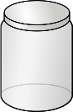

glass jar

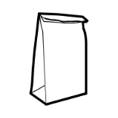

paper bag



wood/stick

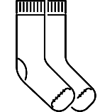

socks/clothing

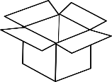

cardboard box

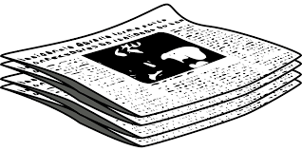

newspaper



frying pan



chips wrapper

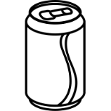

aluminum can

Reduce - Reuse – Recycle

Instructions: Sort the sentences by deciding if it is an example of reducing, reusing, or recycling.

Reuse

Recycle

Reduce

Trading, donating or selling toys instead of throwing them away.

Throwing away paper scraps into the correct bin.

Using less water and electricity.

Composting food scraps to make fertilizer.

Using reusable forks and spoons instead of plastic utensils.

Collecting plastic bottles, glass jars, soda cans, and cardboard.

I can save the Earth by…

