Plan and Design - Worksheet #2
Problem: You and your family recently went to your favorite place on the water to spend the day fishing and swimming but as you neared the water you noticed warning signs saying it was unsafe to enter the water due to the presence of toxic algae.

Instructions: Your goal as an engineer is to plan, design, create and test a prototype that will remove 75% of the harmful algae blooms (HAB) from the water. You will only get class time to do this and you can only use materials provided by the teacher.

Essential questions:
- What materials can best be used to create our prototype?
- Why did we choose these specific materials?
- How will we create a design that explains how our prototype will remove harmful algae from water?

Step 1: Plan your prototype:
      - Plan: As a group, choose a design that you think will best clean the water of algae. (This can be based on what you learned during your research or it could be based off one of your team member’s brainstormed ideas.) Sketch your design below.

      - Plan: Based on the design you choose, now select the materials you want to use for your prototype. List your materials below:

Step 2: Design your prototype:
      - Design: Draw your prototype. You may use Google Drawings or use the Prototype Sketch Worksheet. Be sure to label each different part of your prototype.

      - Design: Answer the following questions in complete sentences explaining your materials. Attach more paper if necessary.

        - What materials are you using to engineer your prototype?

  - Why did you choose each of these materials to engineer your prototype?

5. Turn in your written explanations and blueprint for teacher feedback.

Where are your blueprints located? Circle one. Google Drawings Prototype Sketch Worksheet

Sample Design Drawing:

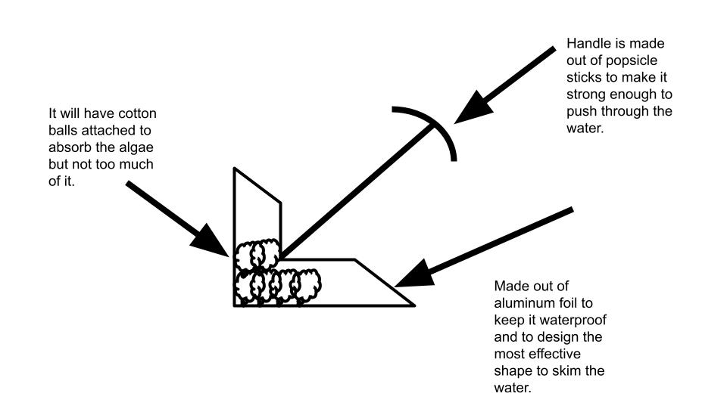

Rubric
Category | 3 | 2 | 1 | 0
Design Drawing | Design drawing is neat  and all parts of the prototype are labeled with materials. | Design drawing is neat but only some of the parts are labeled with materials. | Design drawing is not neat and only some of the parts are labeled with materials. | Did not submit a design drawing .
Explanation of Materials | Both questions are answered in complete sentences and all materials are explained. | Both questions are answered in complete sentences but only some materials are explained. | Only one question is answered with little or no materials explained. | Did not submit an explanation of materials.

Total points earned: ________ / 6 = ________________%

Teacher Feedback:

