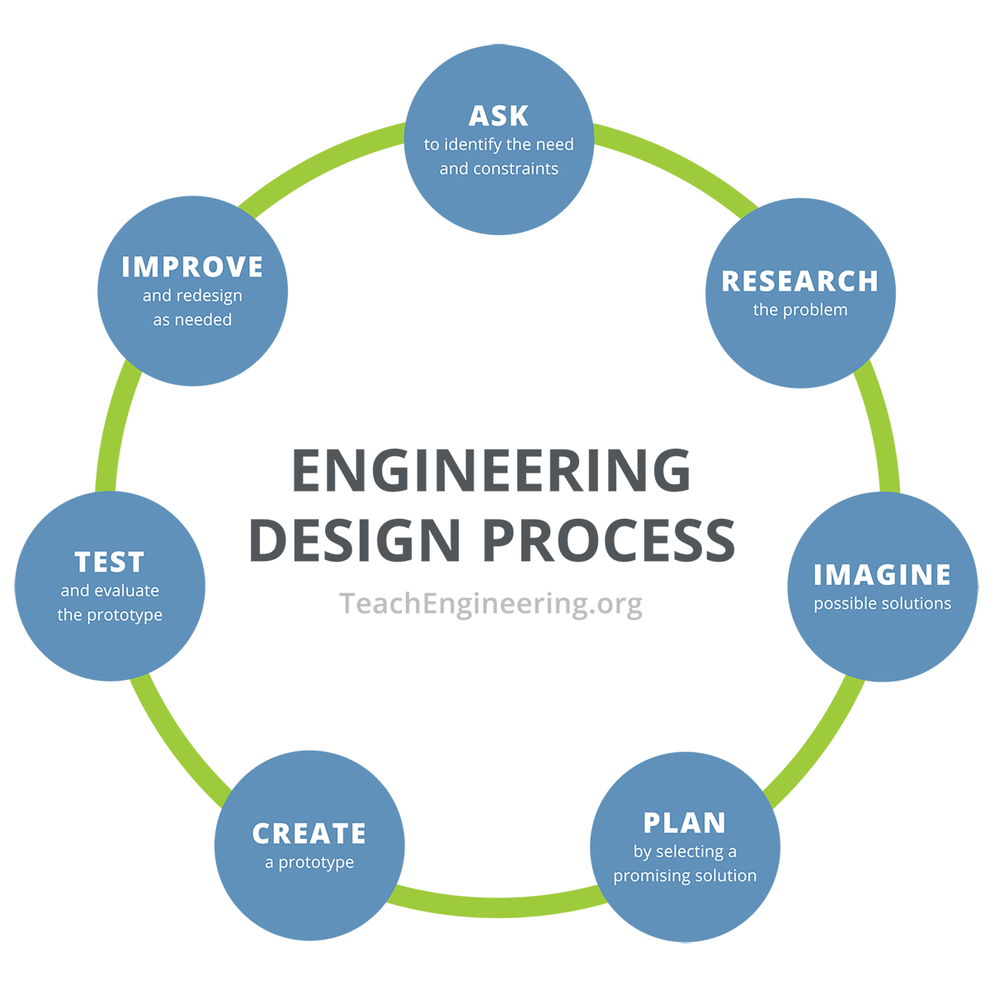
Operation Airdrop - Engineering Design Notebook

- What do we want to design? What are the limitations of the design?

- What materials and tools did engineers use to solve this real-world problem?

- What is your proposed modification? How does the modification improve the design?

- How will you use the materials to build your prototype?

- What is working? What is not working? Are there any design changes that need to be made?

- In comparison to another team’s designs, how do you evaluate your prototype?

- How would you redesign your prototype?

