Optional Assessment

Author: Bridgette Clarkston
From: “Got Algae?” A sorting activity for introducing the weird and wonderful diversity of algae

Note: Time estimate provided for each question.
1) List three of the general characteristics of algae.

2) From the list below, identify a type of algae that is an example of an exception to a general characteristic,
and explain how it is an exception.
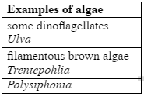

3) List three features of land plants that algae lack, and for each, briefly explain why the feature is
unnecessary in an aquatic environment.

4) Here is a phylogeny of the Eukaryotes similar to the version presented in class, with 12 names
removed (white boxes). Put each of the six algal groups listed below into their correct position in this
phylogeny. Note: You will only fill in six of the 12 available boxes.

