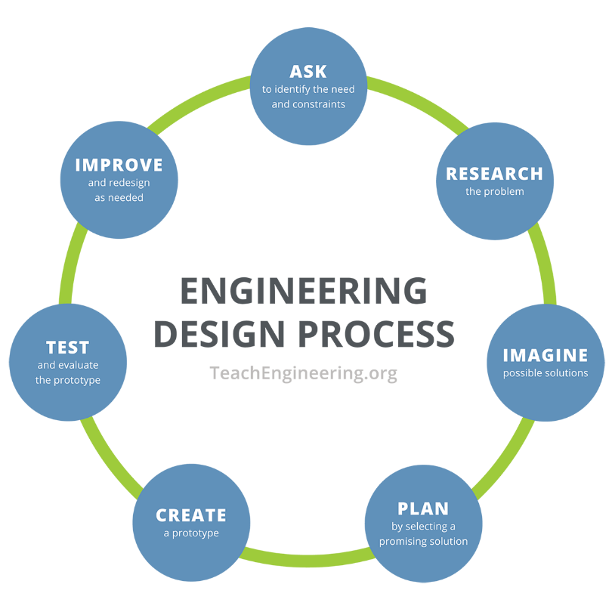**Research Notebook**

**Ask: Identify the need and constraints**

**Instructions:** Answer the following questions.

1. What is the current event/issue/problem? (Example: soil erosion, lack of clean water, cleaning up oil spills)
2. What is the exact question/problem you are trying to solve? Try to narrow down your problem statement by thinking about the following: What is the problem to solve? What do we want to design? Who is it for? What do we want to accomplish? What are the project requirements? What are the limitations? What is the goal?

**Research: Learn about the problem**

**Instructions:** Break up your Essential Question into 6 smaller questions. What do you need to know to solve the problem? Find/research the answers to these questions and then write down your notes or thoughts.

|  |
| --- |
| **Question 1:** |
| **Notes:** |
| **Question 2:** |
| **Notes:** |
| **Question 3:** |
| **Notes:** |
| **Question 4:** |
| **Notes:** |
| **Question 5:** |
| **Notes:** |
| **Question 6:** |
| **Notes:** |

**Research (continued)**

**Vocabulary Instructions:** While you were researching the answers to your questions, you should have found new vocabulary words. Pick 6 new words related to your topic and define those words below.

|  |
| --- |
| **Word 1:** |
| **Definition:** |
| **Word 2:** |
| **Definition:** |
| **Word 3:** |
| **Definition:** |
| **Word 4:** |
| **Definition:** |
| **Word 5:** |
| **Definition:** |
| **Word 6:** |
| **Definition:** |

**Imagine: Brainstorm solutions**

**Instructions:** As an individual, brainstorm and sketch 4-5 ideas below to solve your problem. Label parts and materials you would like to use. Remember, no idea is too crazy in this step! Make sure to think outside the box.

|  |
| --- |
|  |

**Plan: Select a promising solution**

**Instructions:** In a round-robin fashion, have each team member share their brainstormed ideas. After ALL of the ideas have been shared, the group should agree on ONE solution to try. This can be a brainstormed idea from a group member, or a combination of multiple ideas. Sketch that solution below. Label parts and materials you would like to use. Everyone in the group should have essentially the same sketch, since this is your group’s idea.

|  |
| --- |
|  |

**Plan: (continued)**

Instructions: Answer the following questions.

**Decisions:** When sketching your rough draft above, what important decisions did your group make for your design? List those decisions below.

1.

2.

3.

4.

5.

**Measurements:** What measurements are needed to make your design? List those measurements below.

1.

2.

3.

4.

5.

**Constraints/Potential issues:** What constraints does your design have? What potential issues might arise with your design? List those constraints and potential issues below.

1.

2.

3.

4.

5.

**Orthographic views:** Using your decisions and measurements above, create an orthographic projection of your design. Hint: Think of how your design will look as a 3D model and, one side at a time, draw the smaller shapes (like a circle, triangle, or square) that are a part of that side. Make sure to measure those smaller shapes accordingly.

Top View:

Front View:

Back View:

Side View:

Rear View:

**Create: Draw a prototype in CAD**

**CAD:** Draw your design in CAD. (Include pictures of your CAD model of your prototype.)

**Prototype:** (Include pictures of your prototype here.)

**Reflection**

1. Successes: What went well during this activity?
2. Improvements: What would you do differently with your design?
3. Obstacles: During this activity, what obstacles did you and your group deal with?
4. Summary: In 10-15 sentences, summarize the work and your group’s experience during this activity.