**Paper Football Physics – Worksheet**

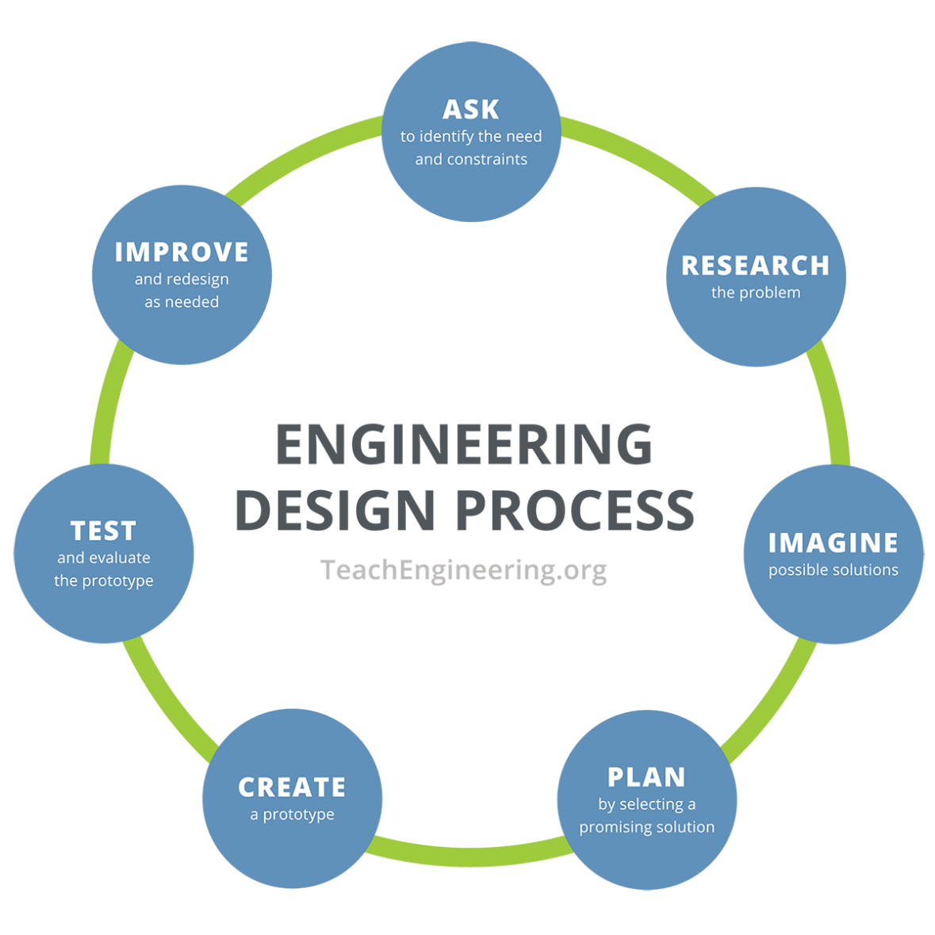**Instructions:** Using the engineering design process, design, create, and test three different paper football shapes to see which one flies the farthest.

1. **Ask** **–** Identify the need and constraints of this problem.

____________________________________________________________________________

____________________________________________________________________________

____________________________________________________________________________

____________________________________________________________________________

____________________________________________________________________________

1. **Research –** Research and learn about concussions and how to reduce them by changing the football.

____________________________________________________________________________

____________________________________________________________________________

____________________________________________________________________________

____________________________________________________________________________  
  
____________________________________________________________________________

____________________________________________________________________________

____________________________________________________________________________

1. **Imagine** – Individually sketch out four possible solutions.

|  |  |
| --- | --- |
| a. | b. |

|  |  |
| --- | --- |
| c. | d. |

1. **Plan** – Have each team member share their sketches. As a team, select THREE different solutions. These can be specific solutions or a mixture of ideas. Draw your team’s solutions in the boxes below. Make sure to identify the dimensions of your solutions. (After everyone in the group has drawn the group’s chosen designs, get the teacher’s approval.)

|  |
| --- |
| **Design #1** |
| **Design #2** |
| **Design #3** |

1. **Create** – Build your prototypes exactly as shown in your group’s drawings.
2. **Test** – Using the testing area, test your designs.

|  |  |  |  |  |
| --- | --- | --- | --- | --- |
| **Design** | **Airtime (s)** | **Distance traveled (cm)** | **Calculated Velocity (cm/s)** | **Observations of Performance** |
| **#1** |  |  |  |  |
| **#2** |  |  |  |  |
| **#3** |  |  |  |  |

**Instructions:** Based on your tests, answer the following questions.

1. What worked in your designs, and why?

__________________________________________________________________________________

__________________________________________________________________________________

__________________________________________________________________________________

__________________________________________________________________________________

__________________________________________________________________________________

1. What did not work in your designs, and why?

__________________________________________________________________________________

__________________________________________________________________________________

__________________________________________________________________________________

__________________________________________________________________________________

__________________________________________________________________________________

1. How would you improve your designs?

__________________________________________________________________________________

__________________________________________________________________________________

__________________________________________________________________________________

__________________________________________________________________________________

__________________________________________________________________________________

__________________________________________________________________________________

__________________________________________________________________________________

1. **Improve** – Make changes and retest your updated prototype.

|  |  |  |  |  |
| --- | --- | --- | --- | --- |
| **Redesign** | **Airtime (s)** | **Distance traveled (cm)** | **Calculated Velocity (m/s)** | **Observations of Performance** |
| **#1** |  |  |  |  |
| **#2** |  |  |  |  |
| **#3** |  |  |  |  |

1. Did your changes improve your prototype? How?

__________________________________________________________________________________

__________________________________________________________________________________

__________________________________________________________________________________

__________________________________________________________________________________

1. What worked in your updated design, and why?

__________________________________________________________________________________

__________________________________________________________________________________

__________________________________________________________________________________

__________________________________________________________________________________

1. What did not work in your updated design, and why?

__________________________________________________________________________________

__________________________________________________________________________________

__________________________________________________________________________________

__________________________________________________________________________________

d. How would you improve your redesign?

__________________________________________________________________________________

__________________________________________________________________________________

__________________________________________________________________________________

__________________________________________________________________________________

__________________________________________________________________________________