There Will Be Drugs Worksheet Answer Key
Example answers
Scenario: You have invented a new miracle drug for the treatment and prevention of a harmful disease. The easiest way for patients to take the drug at home to protect themselves is orally. However, the drug cannot be released immediately because they would die of toxic doses. Your challenge: Design an encapsulation coating that prevents the drug from being released upon immediate placement into an aqueous environment. Before a company will purchase your drug design, you must prove to them that the encapsulation works by demonstrating it with a large-scale model. They want to see you demonstrate control over the drug’s initial release time and duration time.
For the large-scale model, use only simple household materials and ignore biocompatibility at this stage. Use a colorful flavored drink powder to represent the miracle drug that needs to be placed inside the fully built shell before closure. After building your encapsulation prototype, test it by anchoring it underwater and measuring the drug release initial time and duration time. Revise and retest your design as needed.
5
10
Design constraints: Initial drug release at __________ minutes and lasting for __________ minutes.
- Begin by assessing the available materials and supplies. Brainstorm ideas for how to cover the shell and make the materials adhere by making a list of your encapsulation ideas.
Papier-mâché newpapers around the Wiffle ball and put the drink powder inside.
Wrap the ball in shop towels and duct tape the edges; cover that with foam and tape shut.
Duct tape over all of the ball’s holes; poke small holes in duct tape; wrap in shop towels.
Wrap the Wiffle ball in weed barrier fabric; cover with shop towels and duct tape.
- Sketch some of your design ideas on extra paper or on the back of this sheet. Choose one design that your group agrees to construct; draw it below and make a list of all the needed materials and how you will use them. Have the teacher check your design plan before you start to build.
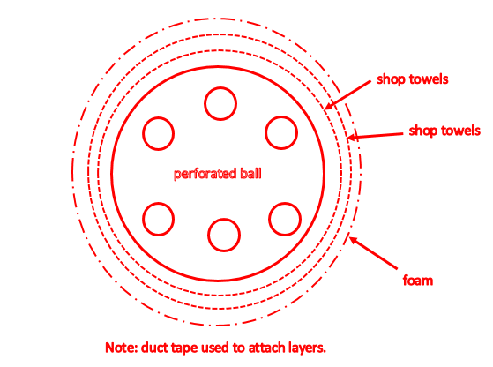

Teacher initials

- Test your design prototype by securing it underwater. Use a timer to measure how long it takes for the drug powder to initially release—or if it even releases at all. You will know it has released when you see colored water. Then keep timing to measure the full length of the release.
Time when Kool-Aid® released: | 1 minute 30 seconds
Time when Kool-Aid® release ended: | 50 minutes
Duration of release: | 48 minutes

- From what you learned during the testing, what are the pros and cons of your design?

The Kool-Aid was slow in initially releasing from the Whiffle ball and then released more quickly than desired. Holes poked in the duct tape would help the initial release occur more quickly.

- Redesign your encapsulation prototype to improve the original design. Draw below your revised design, indicating where and which materials and supplies will be used.
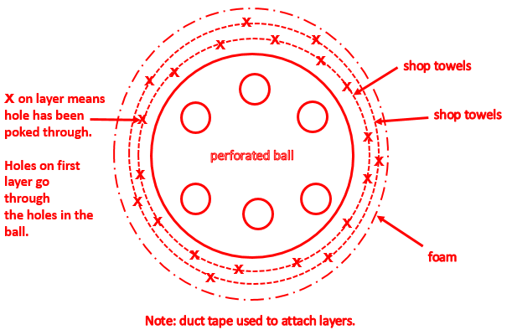

- Fabricate your revised design.

- Test your revised design prototype the same way you tested the first one. Determine whether it works better or worse than your first design.

Time when Kool-Aid® released: | 1 minute
Time when Kool-Aid® release ended: | 25 minutes
Duration of release: | 24 minutes

- What are the pros and cons of your second design?

The drug release had a shorter release time and duration. We could improve this by layering more shop towels, foam and weed-barrier fabric.

- Think of improvements to your previous design by sketching them on extra paper or on the back of this sheet. Draw your revised plan below. Show that you can control the time when the drug (drink powder) is released by demonstrating that you can have a variety of times.
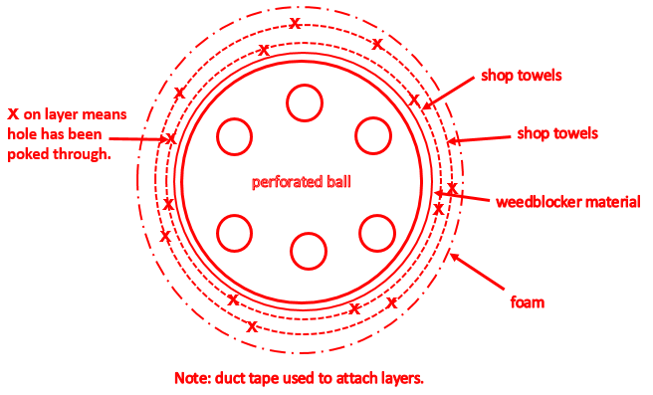

- Fabricate your improved design.

- Test your revised design prototype.
Time when Kool-Aid® released: | 5 minutes
Time when Kool-Aid® release ended: | 50 minutes
Duration of release: | 45 minutes

- What are the pros and cons of this design?

In attempting to improve the initial release time, we inadvertently extended the release duration. We will decrease the duration by adding more holes for the drink powder to diffuse through.

- Try to improve your design one last time by sketching on extra paper or on the back of this sheet your design enhancement ideas. Draw your final revised plan below. Then build and test your new design.
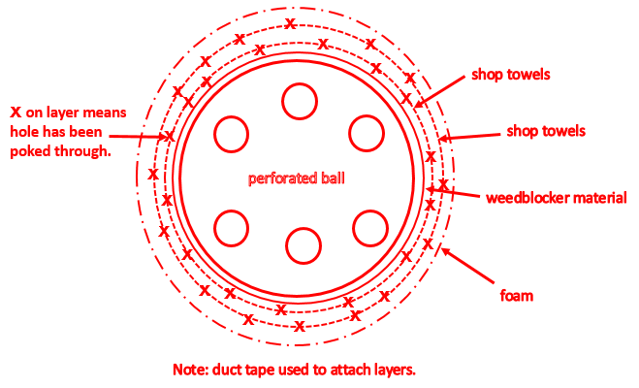

Time when Kool-Aid® released: | 5 minutes
Time when Kool-Aid® release ended: | 30 minutes
Duration of release: | 25 minutes

- Summary Diagram of Design Changes and Improvements: To conclude, make a diagram on paper or using PowerPoint® to show how your designs changed and/or improved by explaining your materials/methods along with the release times for each design.

Answers will vary.

