**Experimental Data Analysis Answer Key**

***Department of Civil and Environmental Engineering, University of Massachusetts, MA, USA***

|  |  |  |  |  |  |  |  |  |  |
| --- | --- | --- | --- | --- | --- | --- | --- | --- | --- |
| **Data Set 1** | | | | | | | | | |
| **Statistics** | | | | **Unpatched Specimens** | | | **Patched  Specimens** |  | **Patching Configuration** |
| Sample mean: | |  | | 173,418.267 | | | 276,733.167 |  |  |
| Sample std dev: | | Sx = | | 31,917.338 | | | 85,681.856 |  |
| C. variation (%): | | Cv = | | 18.405 | | | 30.962 |  |
| Minimum | | Min = | | 114,189 | | | 159,747 |  |
| First quartile: | | Q1 = | | 154,586 | | | 212,374 |  |
| Median: | | Q2 = | | 178,796 | | | 256,072 |  |
| Third quartile: | | Q3 = | | 198,140 | | | 360,752 |  |
| Maximum | | Max = | | 212,164 | | | 457,370 |  |
| 10% trim mean: | |  | | 176,636.535 | | | 270,596.357 |  |
| **Efficiencies:** | **ER =** | | **159.576 %** | | **EM =** | **143.22 %** | |  | unstressed/one-side patches  80 MPa, 15 Hz |

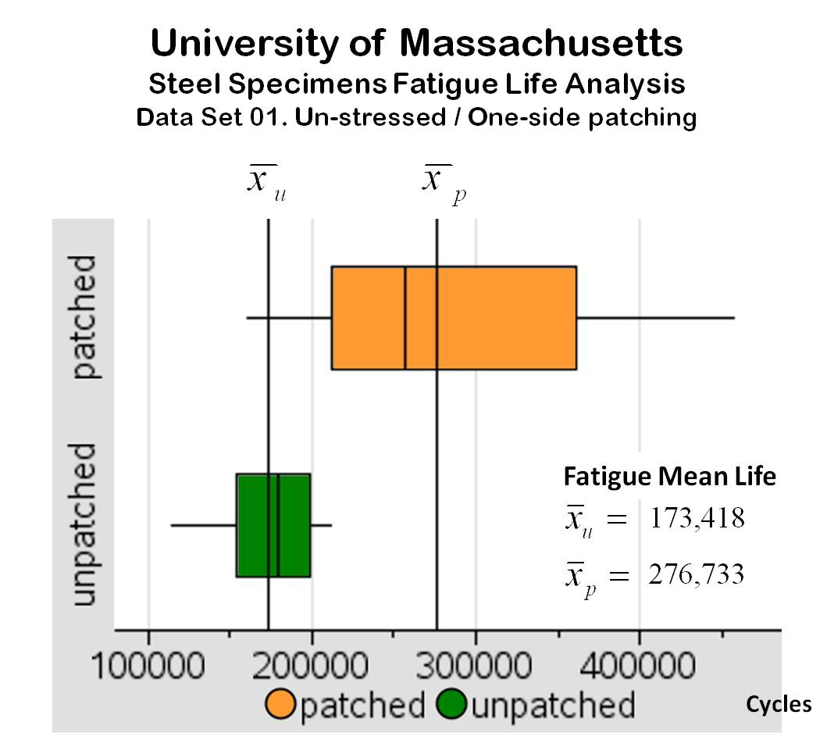

Mean Fatigue Life

**Figure A.** The first repair method proposed by the University of Massachusetts is expected to increase the mean fatigue life of cracked steel specimens about 1.6 times and be effective about 75% of the time.

This box-and-whisker plot compares the fatigue life data of patched and unpatched specimens tested at the University of Massachusetts.

The analysis of Data Set 1 shows that the CFRP patching arrangement used increased the mean fatigue life (MFL) of cracked steel specimens about 1.6 times, but the variability of this extended MFL was about three times greater than the variability of the MFL of the unpatched specimens. In the five-number summary graph for this data set (Figure A), it can be seen that about 75% of the patched specimens performed better than the unpatched specimens; in 25% of the patched specimens the patching was ineffective. Reading the medians of the specimens tested, the *relative* *median efficiency* is about 1.4, similar to the MFL ratio. In summary, this method is expected to extend the MFL of cracked steel about 1.6 times in only 75% of the repairs.

**Figure A.** The first repair method proposed by the University of Massachusetts is expected to increase the mean fatigue life of cracked steel specimens about 1.6 times and be effective about 75% of the time.

This box-and-whisker plot compares the fatigue life data of patched and unpatched specimens tested at the University of Massachusetts.

|  |  |  |  |  |  |  |  |  |  |
| --- | --- | --- | --- | --- | --- | --- | --- | --- | --- |
| **Data Set 2** | | | | | | | | | |
| **Statistics** | | | | **Unpatched Specimens** | | | **Patched  Specimens** |  | **Patching Configuration** |
| Sample mean: | |  | | 346,922.125 | | | 434,118.313 |  |  |
| Sample std dev: | | Sx = | | 33,659.442 | | | 88,707.717 |  |
| C. variation (%): | | Cv = | | 9.702 | | | 20.434 |  |
| Minimum | | Min = | | 283,173 | | | 274,551 |  |
| First quartile: | | Q1 = | | 326,142.5 | | | 377,013.5 |  |
| Median: | | Q2 = | | 347,281 | | | 434,046.5 |  |
| Third quartile: | | Q3 = | | 368,395 | | | 483,028 |  |
| Maximum | | Max = | | 410,671 | | | 617,712 |  |
| 10% trim mean: | |  | | 347,432.75 | | | 431,906 |  |
| **Efficiencies:** | **ER =** | | **125.134 %** | | **EM =** | **124.984 %** | |  | unstressed/one-side patches  80 MPa, 15 Hz |

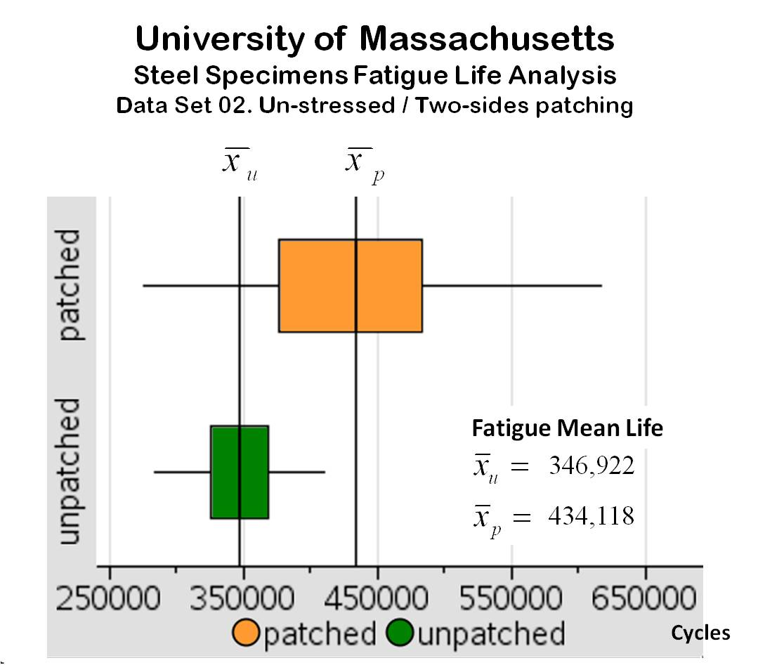

Mean Fatigue Life

**Figure B.** The second repair method proposed by the University of Massachusetts is expected to increase the mean fatigue life of cracked steel specimens about 1.25 times and be effective about 50% of the time.

This box-and-whisker plot compares the fatigue life data of patched and unpatched specimens tested at the University of Massachusetts.

The analysis of Data Set 2 shows that the CFRP patching arrangement used increased the mean fatigue life (MFL) of cracked steel specimens on average by 1.25 times, with a variability for this extended MFL about 2.6 times greater than the variability of the MFL of the unpatched specimens. In the five-number summary graph for this data set (Figure B), it can be seen that about 50% of the patched specimens performed better than the unpatched specimens; in practically half of the patched specimens the patching was ineffective. In both, patched and unpatched specimens, the corresponding means and medians were practically identical, no significant difference was found between *median fatigue life ratio* (*patched to unpatched*) and the MFL ratio. In summary, this method is expected to extend the mean fatigue life of cracked steel about 1.25 times in only 50% of the repairs.

***School of Civil Engineering, Southwest Jiaotong University. China***

***Institute for Rehabilitation of Buildings and Structures, University of Braunschweig, Germany***

|  |  |  |  |  |  |  |  |  |  |
| --- | --- | --- | --- | --- | --- | --- | --- | --- | --- |
| **Data Set 3** | | | | | | | | | |
| **Statistics** | | | | **Unpatched Specimens** | | | **Patched  Specimens** |  | **Patching Configuration** |
| Sample mean: | |  | | 165,333.333 | | | 226,000 |  |  |
| Sample std dev: | | Sx = | | 14,105.662 | | | 16,236.883 |  |
| C. variation (%): | | Cv = | | 8.53 | | | 7.18 |  |
| Minimum | | Min = | | 136,000 | | | 198,000 |  |
| First quartile: | | Q1 = | | 160,000 | | | 216,500 |  |
| Median: | | Q2 = | | 166,500 | | | 223,500 |  |
| Third quartile: | | Q3 = | | 173,000 | | | 239,000 |  |
| Maximum | | Max = | | 189,000 | | | 255,000 |  |
| 10% trim mean: | |  | | 165,900 | | | 225,900 |  |
| **Efficiencies:** | **ER =** | | **136.694 %** | | **EM =** | **134.234 %** | |  | unstressed/one-side patches  117 MPa,25 Hz |

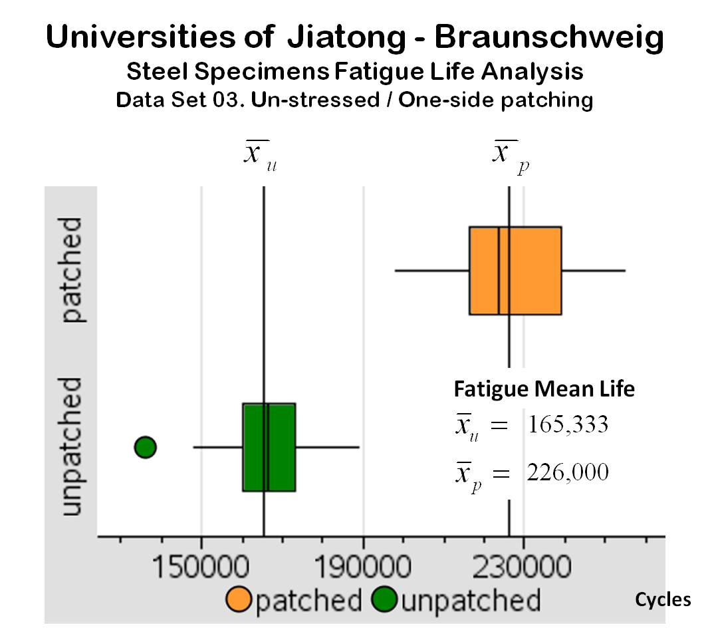

Mean Fatigue Life

**Figure C.** The first repair method proposed by the Universities of Jiatong and Braunschweig is expected to increase the mean fatigue life of cracked steel specimens about 1.4 times and be effective 100% of the time.

This box-and-whisker plot compares the fatigue life data of patched and unpatched specimens tested at the Universities of Jiatong and Braunschweig.

The analysis of Data Set 3 shows that the CFRP patching arrangement used increased the mean fatigue life (MFL) of cracked steel specimens on average by 1.4 times, with a variability practically the same as the variability of the MFL of the unpatched specimens. In the graph of the five-number summary for this data set (Figure C), it can be seen that all the patched specimens (100%) performed better than the unpatched specimens. Reading the medians of the specimens tested, the *relative* *median efficiency* increased about 1.34 times, very close to the MFL ratio. In summary, this method is expected to extend the mean fatigue life of cracked steel about 1.4 times.

|  |  |  |  |  |  |  |  |  |  |
| --- | --- | --- | --- | --- | --- | --- | --- | --- | --- |
| **Data Set 4** | | | | | | | | | |
| **Statistics** | | | | **Unpatched Specimens** | | | **Patched  Specimens** |  | **Patching Configuration** |
| Sample mean: | |  | | 165,333.333 | | | 556, 500 |  |  |
| Sample std dev: | | Sx = | | 14,105.662 | | | 47,038.669 |  |
| C. variation (%): | | Cv = | | 8.53 | | | 8.45 |  |
| Minimum | | Min = | | 136,000 | | | 474,000 |  |
| First quartile: | | Q1 = | | 160,000 | | | 525,000 |  |
| Median: | | Q2 = | | 166,500 | | | 557,500 |  |
| Third quartile: | | Q3 = | | 173,000 | | | 587,500 |  |
| Maximum | | Max = | | 189,000 | | | 639,000 |  |
| 10% Trim mean: | |  | | 165,900 | | | 556,500 |  |
| **Efficiencies:** | **ER =** | | **365.593 %** | | **EM =** | **334.835 %** | |  | stressed patches @ 1200 MPa  117 MPa, 25 Hz |

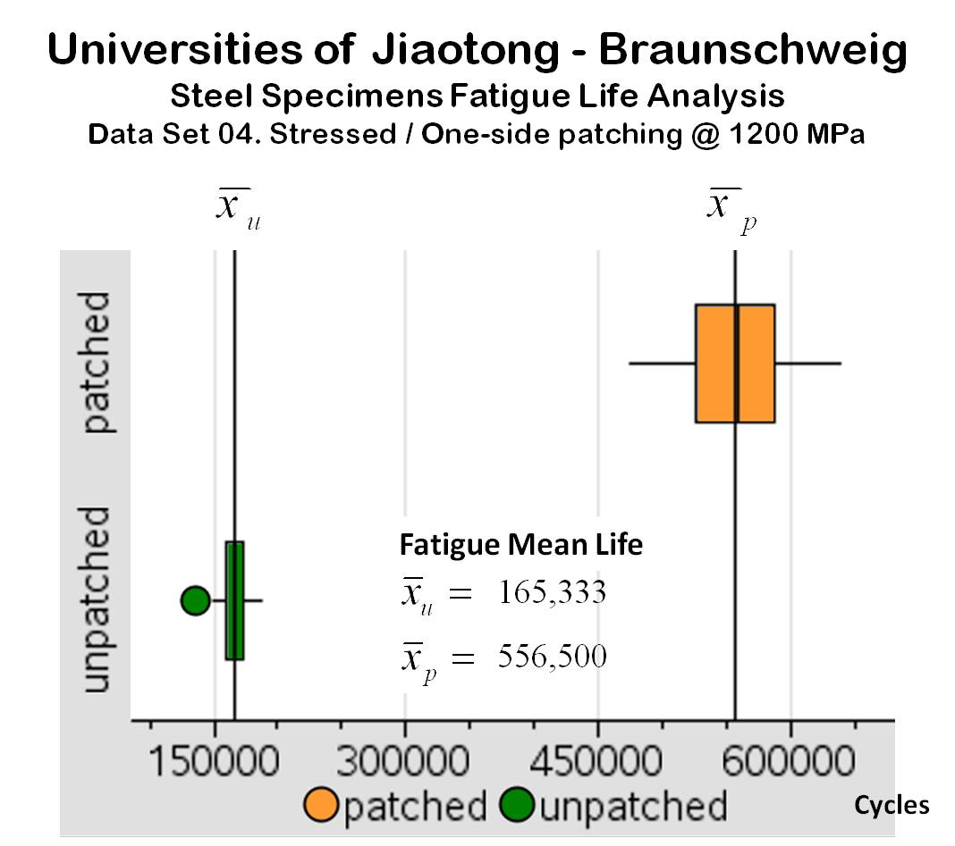

Mean Fatigue Life

**Figure D.** The second repair method proposed by the Universities of Jiatong and Braunschweig is expected to increase the mean fatigue life of cracked steel specimens about 3.4 times and be effective 100% of the time.

This box-and-whisker plot compares the fatigue life data of patched and unpatched specimens, tested at the Universities of Jiatong and Braunschweig.

The analysis of Data Set 4 shows that the CFRP patching arrangement used increased the mean fatigue life (MFL) of cracked steel specimens on average by 3.7 times, with a variability very similar to the variability of the MFL of the unpatched specimens. In the graph of the five-number summary for this data set (Figure D), it can be seen that all the patched specimens (100%) performed better than the unpatched specimens. Reading the medians of the specimens tested, the *relative* *median efficiency* increased about 3.35 times, close to the MFL ratio. In summary, this method is expected to extend the mean fatigue life of cracked steel about 3.7 times.

***School of Naval Architecture and Marine Engineering, National Technical University of Athens, Greece***

|  |  |  |  |  |  |  |  |  |  |
| --- | --- | --- | --- | --- | --- | --- | --- | --- | --- |
| **Data Set 5** | | | | | | | | | |
| **Statistics** | | | | **Unpatched Specimens** | | | **Patched  Specimens** |  | **Patching Configuration** |
| Sample mean: | |  | | 40,143 | | | 63,889 |  |  |
| Sample std dev: | | Sx = | | 1,422.221 | | | 9,116.042 |  |
| C. variation (%): | | Cv = | | 3.543 | | | 14.269 |  |
| Minimum | | Min = | | 38,035 | | | 47,053 |  |
| First quartile: | | Q1 = | | 39,065 | | | 59,306 |  |
| Median: | | Q2 = | | 39,873.5 | | | 61,536 |  |
| Third Quartile: | | Q3 = | | 41,375 | | | 69,789 |  |
| Maximum | | Max = | | 42,251 | | | 80,963 |  |
| 10% trim mean: | |  | | 40,143 | | | 63,869.167 |  |
| **Efficiencies:** | **ER =** | | **159.576 %** | | **EM =** | **154.328 %** | |  | unstressed/one-side patches  100 MPa, 2 Hz |

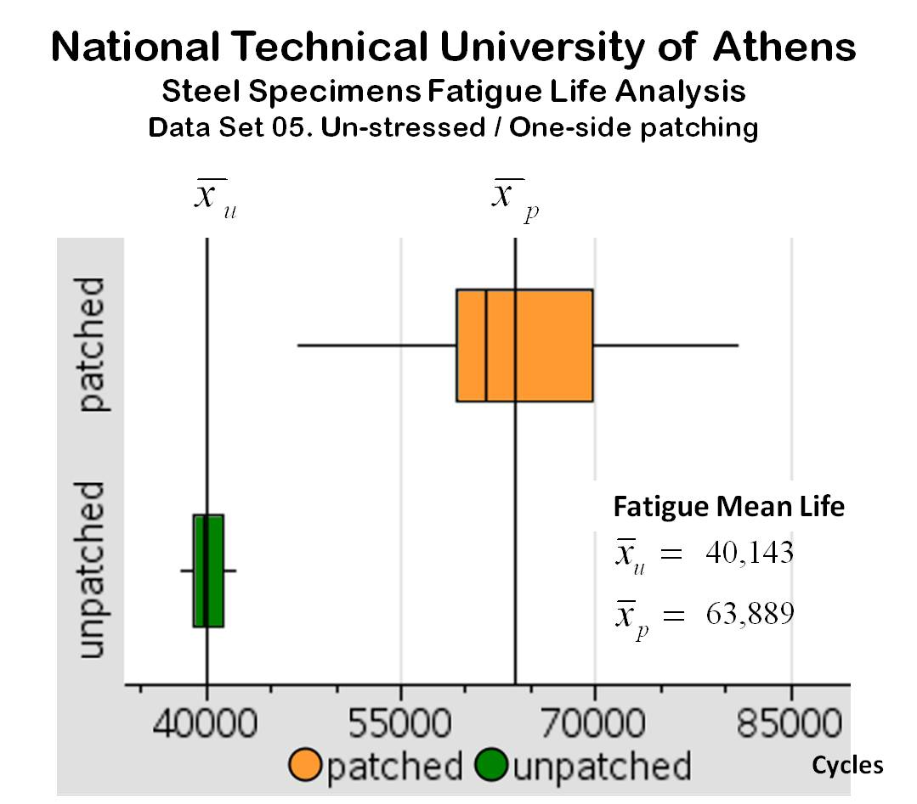

Mean Fatigue Life

**Figure E.** The repair method proposed by the National Technical University of Athens is expected to increase the mean fatigue life of cracked steel specimens about 1.6 times and be effective 100% of the time.

The box-and-whisker plot compares the fatigue life data of patched and unpatched specimens tested at the National Technical University of Athens.

The analysis of Data Set 5 shows that the CFRP patching arrangement used increased the mean fatigue life (MFL) of cracked steel specimens on average by 1.6 times, but the variability of this extended MFL is about 6.4 times the variability of the MFL of the unpatched specimens. In the graph of the five-number summary for this data set (Figure E), it can be seen that all the patched specimens (100%) performed better than the unpatched specimens. Reading the medians of the specimens tested, the *relative* *median efficiency* increased about 1.54 times, very close to the MFL ratio. In summary, this method is expected to extend the mean fatigue life of cracked steel about 1.6 times.

***Department of Civil Engineering, Technical University of Denmark, Brovej, Denmark***

|  |  |  |  |  |  |  |  |  |  |
| --- | --- | --- | --- | --- | --- | --- | --- | --- | --- |
| **Data Set 6** | | | | | | | | | |
| **Statistics** | | | | **Unpatched Specimens** | | | **Patched  Specimens** |  | **Patching Configuration** |
| Sample mean: | |  | | 470,000 | | | 1,433,789.929 |  |  |
| Sample std dev: | | Sx = | | 8,769.783 | | | 181,903.011 |  |
| C. variation (%): | | Cv = | | 1.866 | | | 12.687 |  |
| Minimum | | Min = | | 454,000 | | | 1,157,369 |  |
| First quartile: | | Q1 = | | 465,000 | | | 1,328,369 |  |
| Median: | | Q2 = | | 471,000 | | | 1,394,184.5 |  |
| Third quartile: | | Q3 = | | 477,500 | | | 1,527,369 |  |
| Maximum | | Max = | | 481,000 | | | 1,767,369 |  |
| 10% trim mean: | |  | | 470,500 | | | 1,429,026.75 |  |
| **Efficiencies:** | **ER =** | | **305.062 %** | | **EM =** | **296.005 %** | |  | unstressed/two-sides patches  97.5 MPa, 13.5 Hz |

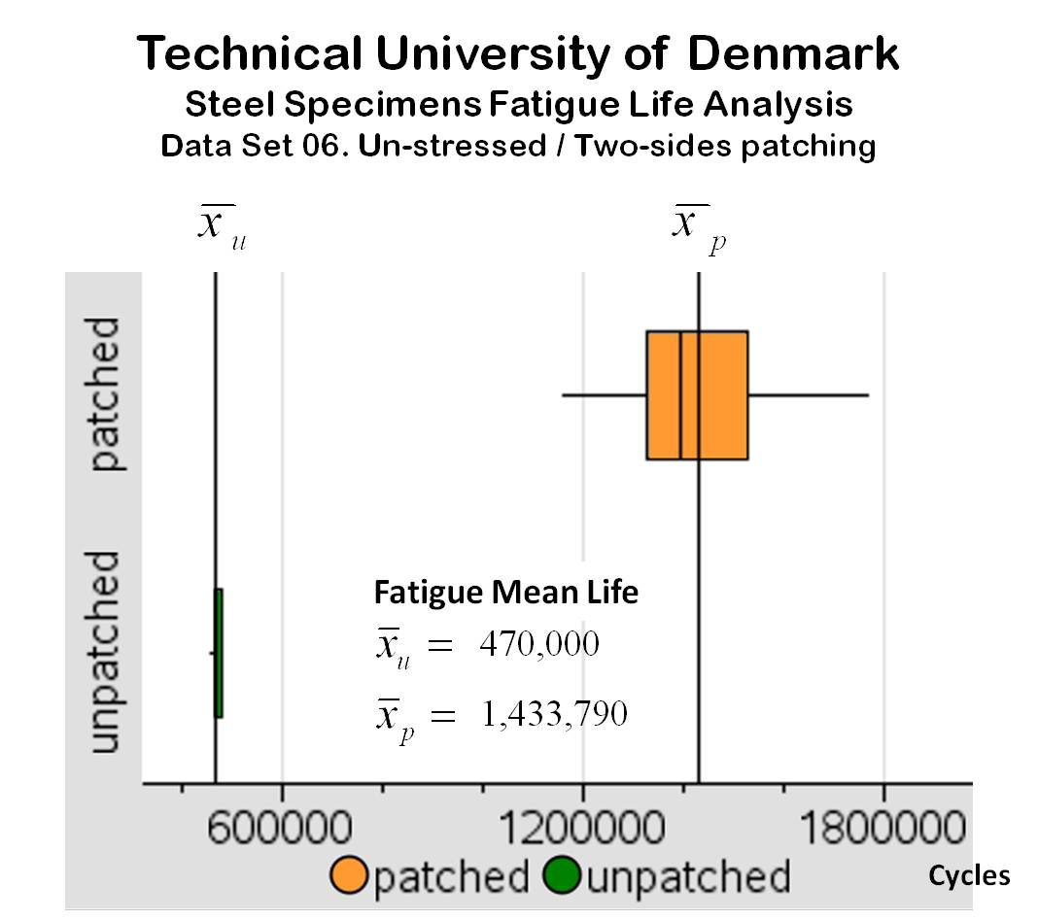

Mean Fatigue Life

**Figure F.** The first repair method proposed by the Technical University of Denmark is expected to increase the mean fatigue life of cracked steel specimens about 3 times and be effective 100% of the time.

This box-and-whisker plot compares the fatigue life data of patched and unpatched specimens tested at the Technical University of Denmark.

The analysis of Data Set 6 shows that the CFRP patching arrangement used increased the mean fatigue life (MFL) of cracked steel specimens on average by 3 times, but the variability of this extended MFL is about 21 times the variability of the MFL of the unpatched specimens. However, in the five-number summary graph for this data set (Figure F), it can be seen that all the patched specimens (100%) performed much better than the unpatched specimens; the lowest MFL of the patched set is 2.4 times the maximum MFL of the unpatched set. Reading the medians of the specimens tested, the *relative* *median efficiency* increased about 2.96 times, very close the MFL ratio. In summary, this method is expected to extend the mean fatigue life of cracked steel about 3 times.

|  |  |  |  |  |  |  |  |  |  |
| --- | --- | --- | --- | --- | --- | --- | --- | --- | --- |
| **Data Set 7** | | | | | | | | | |
| **Statistics** | | | | **Unpatched Specimens** | | | **Patched  Specimens** |  | **Patching Configuration** (Two-sides patching) |
| Sample mean: | |  | | 470,000 | | | 8,230,000 |  |  |
| Sample std dev: | | Sx = | | 8,769.783 | | | 2,866,386.092 |  |
| C. variation (%): | | Cv = | | 1.866 | | | 34.829 |  |
| Minimum | | Min = | | 454,000 | | | 3,780,000 |  |
| First quartile: | | Q1 = | | 465,000 | | | 6,730,000 |  |
| Median: | | Q2 = | | 471,000 | | | 8,275,000 |  |
| Third quartile: | | Q3 = | | 477,500 | | | 8,560,000 |  |
| Maximum | | Max = | | 481,000 | | | 15,980,000 |  |
| 10% trim mean: | |  | | 470,500 | | | 7,955,000 |  |
| **Efficiencies:** | **ER =** | | **1,751.064 %** | | **EM =** | **1,756.900 %** | |  | stressed patches @ 13.5 KN  97.5 MPa, 13.5 Hz |

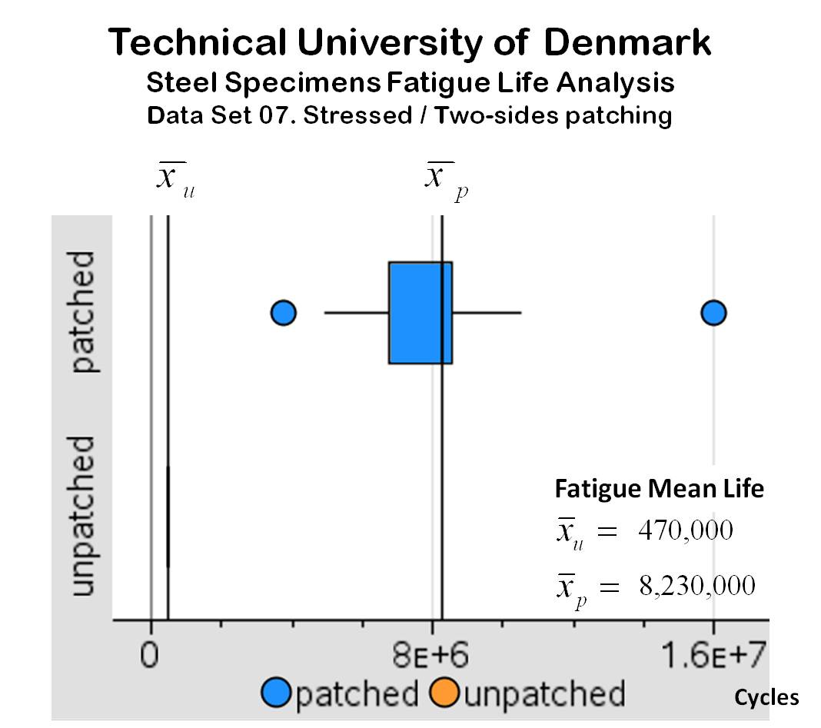

Mean Fatigue Life

**Figure G.** The second repair method proposed by the Technical University of Denmark is expected to increase the mean fatigue life of cracked steel specimens about 17.5 times and be effective 100% of the time.

This box-and-whisker plot compares the fatigue life data of patched and unpatched specimens tested at the Technical University of Denmark.

The analysis of Data Set 7 shows that the CFRP patching arrangement used increased the mean fatigue life (MFL) of cracked steel specimens on average by 17.5 times, but the variability of this extended MFL is huge compared with the variability of the MFL of the unpatched elements: 327 times! Analyzing the coefficients of variation, the CV for the patched set is about 19 times greater than the CV for the unpatched set, which indicates that even though this patching method increases the MFL considerably, the variability increases proportionally. A possible explanation of the small variability of the MFL of the unpatched elements could be the use of a very standard quality of the specimens in the experiment. The high variability of the patched elements could be the consequence of using a non-standard patching method, and some steps in this process may not be completely under control.

In the five-number summary graph for this data set (Figure G), two outliers in the patched box-and-whisker plot can be observed; the high MFL value that patched specimen achieved is notable, however the 10% trimmed mean of this data set is about the same as its MFL. Reading the medians of the specimens tested, the *relative* *median efficiency* is about 17.6 times, practically equal to the MFL ratio. In summary, this method is expected to extend the mean fatigue life of cracked steel about 17.5 times.

***Department of Civil Engineering, Monash University, Clayton, Victoria, Australia***

|  |  |  |  |  |  |  |  |  |  |
| --- | --- | --- | --- | --- | --- | --- | --- | --- | --- |
| **Data Set 8** | | | | | | | | | |
| **Statistics** | | | | **Unpatched Specimens** | | | **Patched  Specimens** |  | **Patching Configuration** |
| Sample mean: | |  | | 241,641.5 | | | 373,466.25 |  |  |
| Sample std dev: | | Sx = | | 1,891.644 | | | 55,032.453 |  |
| C. variation (%): | | Cv = | | 0.783 | | | 14.736 |  |
| Minimum | | Min = | | 238,333 | | | 298,757 |  |
| First quartile: | | Q1 = | | 240,871.5 | | | 342,753.5 |  |
| Median: | | Q2 = | | 241,614.5 | | | 350,812 |  |
| Third quartile: | | Q3 = | | 242,749 | | | 418,245 |  |
| Maximum | | Max = | | 244,950 | | | 478,351 |  |
| 10% trim mean: | |  | | 241,641.5 | | | 370,448.7 |  |
| **Efficiencies:** | **ER =** | | **154.554 %** | | **EM =** | **145.195 %** | |  | unstressed/one side patches  135 MPa, 30 Hz |

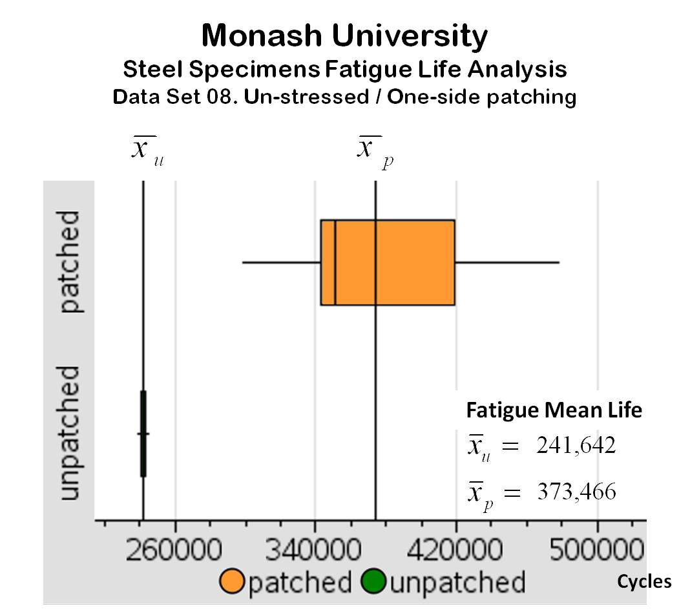

Mean Fatigue Life

**Figure H.** The first repair method proposed by Monash University is expected to increase the mean fatigue life of cracked steel specimens about 1.5 times and be effective 100% of the time.

This box-and-whisker plot compares the fatigue life data of patched and unpatched specimens tested at Monash University.

The analysis of Data Set 8 shows that the CFRP patching arrangement used increased the mean fatigue life (MFL) of cracked steel specimens on average by 1.5 times, but the variability of this extended MFL is big compared with the variability of the MFL of the unpatched elements: 29 times. Analyzing the coefficients of variation, the CV for the patched set is about 19 times greater than the CV for the unpatched set, the increase in variability is not proportional to the increase in MFL.

However, in the five-number summary graph for this data set (Figure H), it can be seen that all the patched specimens (100%) performed better than the unpatched specimens. Reading the medians of the specimens tested, the *relative* *median efficiency* is about 1.45 times, close to the MFL ratio. In summary, this method is expected to extend the mean fatigue life of cracked steel about 1.6 times.

|  |  |  |  |  |  |  |  |  |  |
| --- | --- | --- | --- | --- | --- | --- | --- | --- | --- |
| **Data Set 9** | | | | | | | | | |
| **Statistics** | | | | **Unpatched Specimens** | | | **Patched  Specimens** |  | **Patching Configuration** |
| Sample mean: | |  | | 241,641.5 | | | 1,278,717.583 |  |  |
| Sample std dev: | | Sx = | | 1,891.644 | | | 412,781.576 |  |
| C. variation (%): | | Cv = | | 0.783 | | | 32.281 |  |
| Minimum | | Min = | | 238,333 | | | 542,353 |  |
| First quartile: | | Q1 = | | 240,871.5 | | | 1,044,597.5 |  |
| Median: | | Q2 = | | 241,614.5 | | | 1,293,238 |  |
| Third quartile: | | Q3 = | | 242,749 | | | 1,561,380 |  |
| Maximum | | Max = | | 244,950 | | | 1,920,000 |  |
| 10% trim mean: | |  | | 241,641.5 | | | 1,288,225.8 |  |
| **Efficiencies:** | **ER =** | | **529.180 %** | | **EM =** | **536.249 %** | |  | unstressed/two sides patches  135 MPa, 30 Hz |

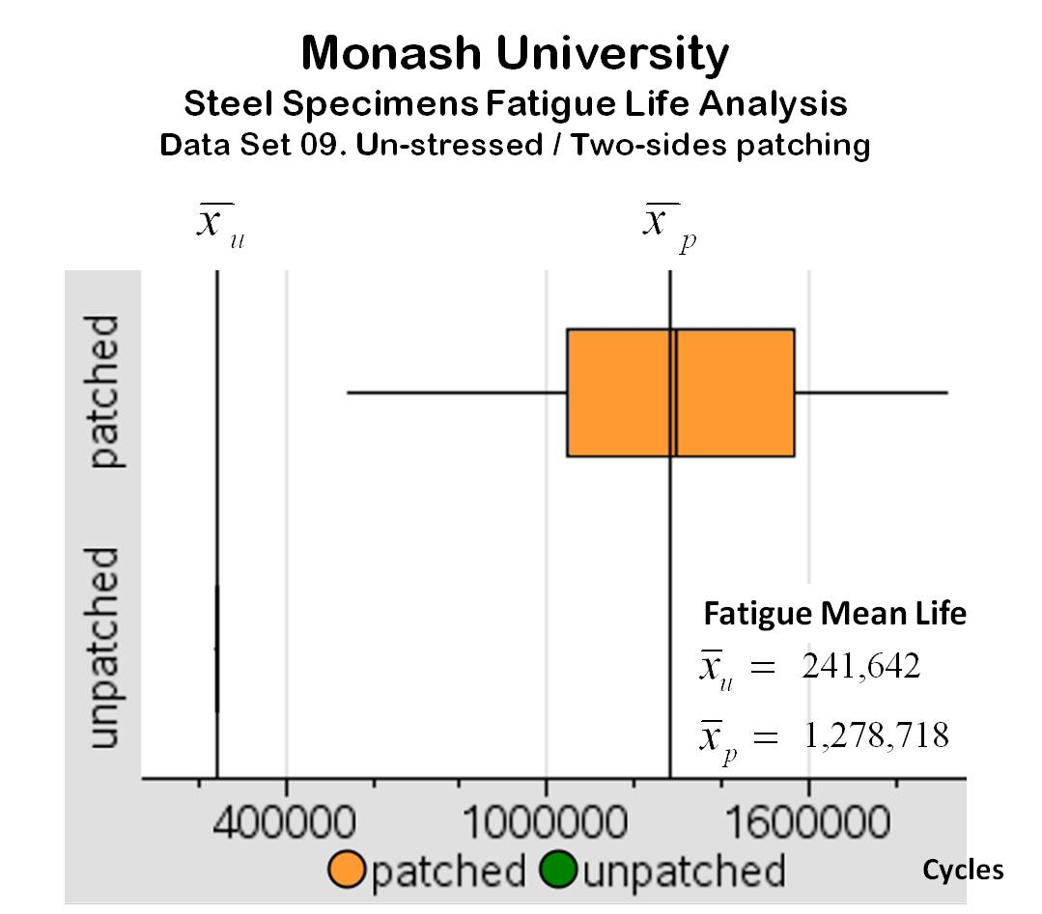

Mean Fatigue Life

**Figure I.** The second repair method proposed by Monash University is expected to increase the mean fatigue life of cracked steel specimens about 5.3 times and be effective 100% of the time.

This box-and-whisker plot compares the fatigue life data of patched and unpatched specimens tested at Monash University.

The analysis of Data Set 9 shows that the CFRP patching arrangement used increased the mean fatigue life (MFL) of cracked steel specimens on average by 5.3 times, but the variability of this extended MFL is huge compared with the variability of the MFL of the unpatched elements: 218 times! Analyzing the coefficients of variation, the CV for the patched set is about 41 times greater than the CV for the unpatched set. In this case the variability in the MFL of the patched specimens is not proportional to the increase of the MFL. Again, the differences in variability could be attributed to the steel specimens’ consistent quality and to factors that affect the patching process performance being not fully under control.

However, in the five-number summary graph for this data set (Figure I), it can be seen that all the patched specimens (100%) performed better than the unpatched specimens. Reading the medians of the specimens tested, the *relative* *median efficiency* is about 5.35, practically equal to the MFL ratio. In summary, this method is expected to extend the mean fatigue life of cracked steel about 5.3 times.

***Department of Architecture, Built Environment and Construction Engineering, ABC Politecnico di Milano, Milan, Italy***

|  |  |  |  |  |  |  |  |  |  |
| --- | --- | --- | --- | --- | --- | --- | --- | --- | --- |
| **Data Set 10** | | | | | | | | | |
| **Statistics** | | | | **Unpatched Specimens** | | | **Patched  Specimens** |  | **Patching Configuration** (6mm notch) |
| Sample mean: | |  | | 196,714 | | | 435,110 |  |  |
| Sample std dev: | | Sx = | | 9,604.418 | | | 142,035.132 |  |
| C. variation (%): | | Cv = | | 4.883 | | | 32,644 |  |
| Minimum | | Min = | | 181,171 | | | 58,400 |  |
| First quartile: | | Q1 = | | 187,415 | | | 378,037 |  |
| Median: | | Q2 = | | 196,714 | | | 444,563 |  |
| Third quartile: | | Q3 = | | 204,627 | | | 512,000 |  |
| Maximum | | Max = | | 213,690 | | | 616,695 |  |
| 10% trim mean: | |  | | 196,554.778 | | | 451,370.417 |  |
| **Efficiencies:** | **ER =** | | **221.189 %** | | **EM =** | **225.995 %** | |  | unstressed/one-side patches  90 MPa, 18 Hz |

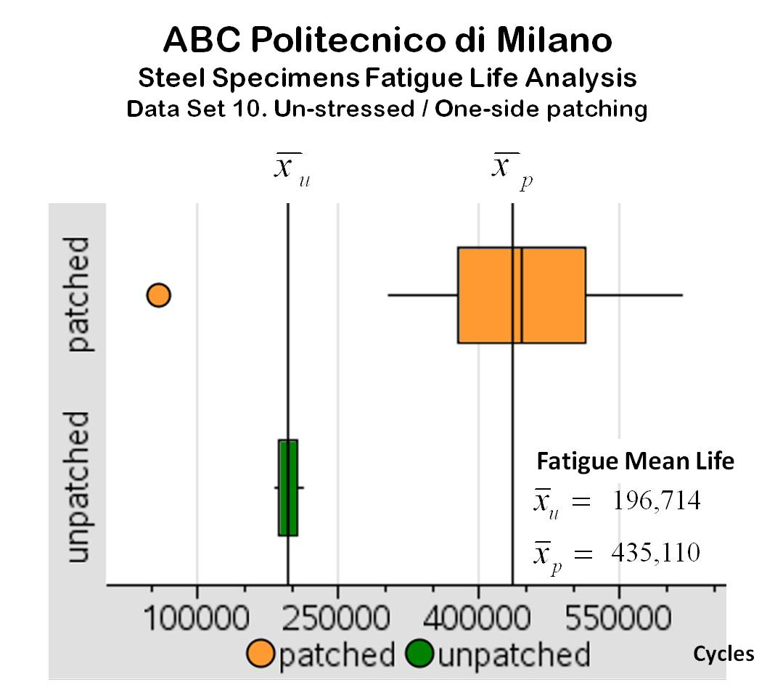

Mean Fatigue Life

**Figure J.** The first repair method proposed by the ABC Politecnico di Milano is expected to increase the mean fatigue life of cracked steel specimens about 2.2 times and be effective practically 100% of the time.

This box-and-wisker plot compares the fatigue life data of patched and unpatched specimens tested at the ABC Politecnico di Milano.

The analysis of Data Set 10 shows that the CFRP patching arrangement used increased the mean fatigue life (MFL) of cracked steel specimens on average by 2.2 times, with a variability about 15 times greater than the variability of the MFL of the unpatched specimens. Analyzing the coefficients of variation, the CV for the patched set is about 6.7 times greater than the CV for the unpatched set, an increase that could be considered proportional to the change in the MFL.

In the five-number summary graph for this data set (Figure J), it can be seen that all the patched specimens (100%) performed better than the unpatched specimens. Reading the medians of the specimens tested, the *relative* *median efficiency* is about 2.26, practically equal to the MFL ratio. In summary, this method is expected to extend the mean fatigue life of cracked steel about 2.2 times.

|  |  |  |  |  |  |  |  |  |  |
| --- | --- | --- | --- | --- | --- | --- | --- | --- | --- |
| **Data Set 11** | | | | | | | | | |
| **Statistics** | | | | **Unpatched Specimens** | | | **Patched  Specimens** |  | **Patching Configuration** (15mm notch) |
| Sample mean: | |  | | 29,264 | | | 109,760 |  |  |
| Sample std dev: | | Sx = | | 1,040.922 | | | 29,956.897 |  |
| C. variation (%): | | Cv = | | 3.557 | | | 27.293 |  |
| Minimum | | Min = | | 26,899 | | | 66,800 |  |
| First quartile: | | Q1 = | | 28,818 | | | 86,199 |  |
| Median: | | Q2 = | | 29,294 | | | 107,405.5 |  |
| Third quartile: | | Q3 = | | 29,693 | | | 129,331 |  |
| Maximum | | Max = | | 30,961 | | | 172,000 |  |
| 10% trim mean: | |  | | 29,338.222 | | | 108,153.333 |  |
| **Efficiencies:** | **ER =** | | **375.068 %** | | **EM =** | **366.647 %** | |  | unstressed/one-side patches  90 MPa, 18 Hz |

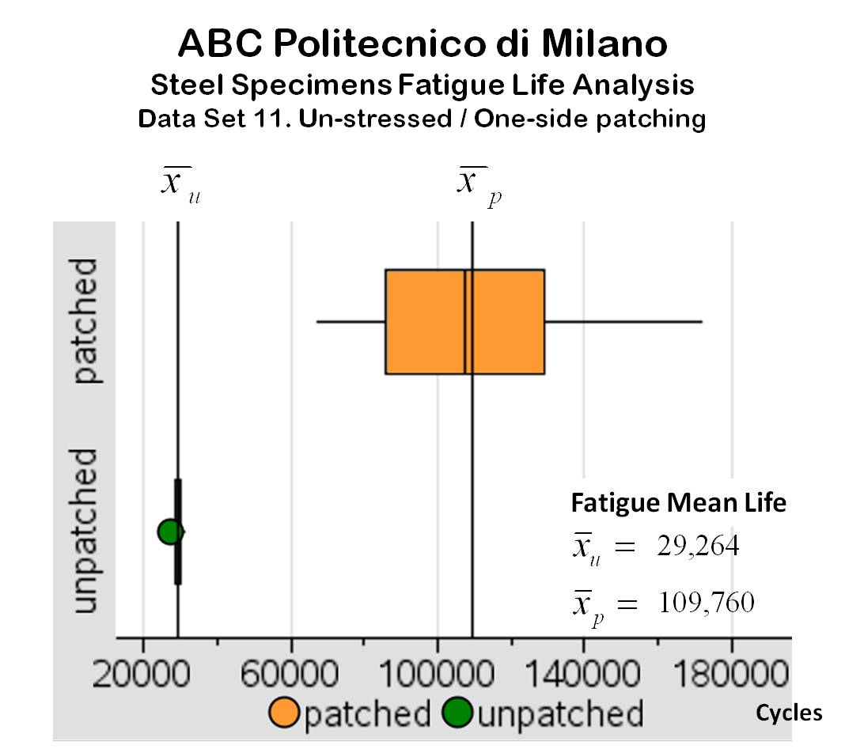

Mean Fatigue Life

**Figure K.** The second repair method proposed by the ABC Politecnico di Milano is expected to increase the mean fatigue life of cracked steel specimens about 3.75 times and be effective 100% of the time.

The box-and-whisker plot compares the fatigue life data of patched and unpatched specimens tested at the ABC Politecnico di Milano.

The analysis of Data Set 11 shows that the CFRP patching arrangement used increased the mean fatigue life (MFL) of cracked steel specimens on average by 3.75 times, with a variability about 29 times greater than the variability of the MFL of the unpatched specimens. Analyzing the coefficients of variation, the CV for the patched set is about 7.7 times greater than the CV for the unpatched set, an increase that could be considered proportional to the change in the MFL.

In the five-number summary graph for this data set (Figure K), it can be seen that all the patched specimens (100%) performed better than the unpatched specimens. Reading the medians of the specimens tested, the *relative* *median efficiency* is about 3.67, very close to the MFL ratio. In summary, this method is expected to extend the mean fatigue life of cracked steel about 3.75 times.

***Department of Civil Engineering, Cullen College of Engineering, University of Houston, TX, USA***

|  |  |  |  |  |  |  |  |  |  |
| --- | --- | --- | --- | --- | --- | --- | --- | --- | --- |
| **Data Set 12** | | | | | | | | | |
| **Statistics** | | | | **Unpatched Specimens** | | | **Patched  Specimens** |  | **Patching Configuration** |
| Sample mean: | |  | | 47,435 | | | 990,000 |  |  |
| Sample std dev: | | Sx = | | 1,844.008 | | | 86,497.6656 |  |
| C. variation (%): | | Cv = | | 3.887 | | | 8.737 |  |
| Minimum | | Min = | | 44,265 | | | 840,000 |  |
| First quartile: | | Q1 = | | 45,625 | | | 932,000 |  |
| Median: | | Q2 = | | 48,176.5 | | | 984,500 |  |
| Third quartile: | | Q3 = | | 48,622 | | | 1,045,000 |  |
| Maximum | | Max = | | 49,868 | | | 1,140,000 |  |
| 10% trim mean: | |  | | 47,496.417 | | | 990,000 |  |
| **Efficiencies:** | **ER =** | | **2,087.067 %** | | **EM =** | **2,043.527 %** | |  | stressed patches @ 30 MPa  153 MPa, 10 Hz |

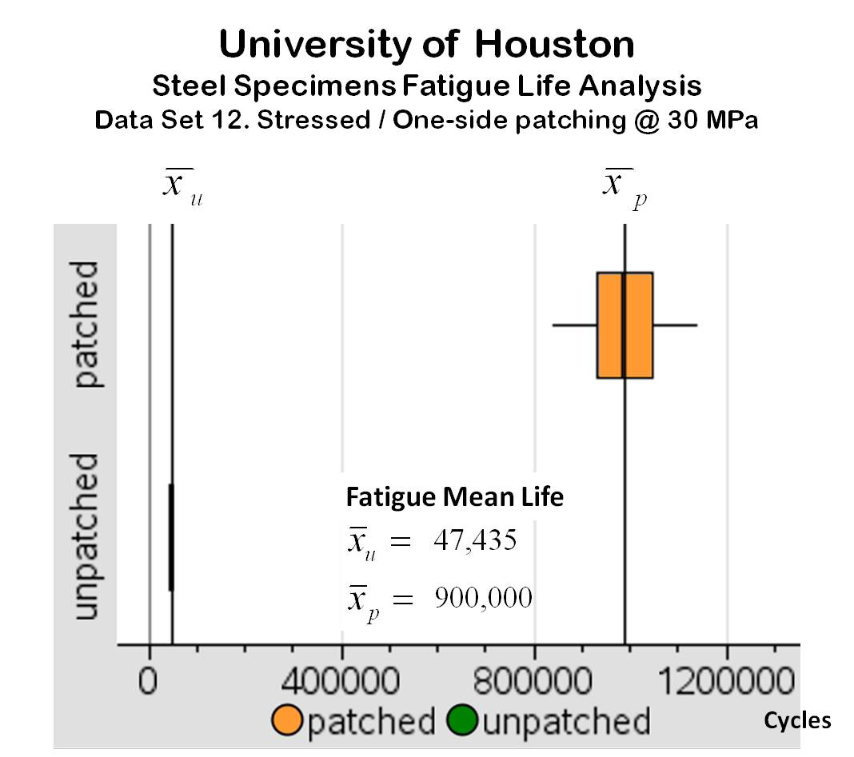

Mean Fatigue Life

**Figure L.** The repair method proposed by the University of Houston is expected to increase the mean fatigue life of cracked steel specimens about 21 times and be effective 100% of the time.

This box-and-whisker plot compares the fatigue life data of patched and unpatched specimens tested at the University of Houston.

The analysis of Data Set 12 shows that the CFRP patching arrangement used increased the mean fatigue life (MFL) of cracked steel specimens on average by 21 times, with a variability about 47 times greater than the variability of the MFL of the unpatched specimens. Analyzing the coefficients of variation, the CV for the patched set is about 2.25 times greater than the CV for the unpatched set, an increase that is very proportional to the change in the MFL, and this fact suggests that this patching process has under control most the variables that could cause performance problems.

In the five-number summary graph for this data set (Figure L), it can be seen that all the patched specimens (100%) performed a lot better than the unpatched specimens. Reading the medians of the specimens tested, the *relative* *median efficiency* is about 20.4 times, practically equal to the MFL ratio. In summary, this method is expected to extend the mean fatigue life of cracked steel about 21 times.

***Relative Efficiencies Analysis***

As can be noticed from the above data, every laboratory setup has very different experimental conditions: specimens’ cracking and patching configurations, stresses applied on specimens, frequency of the stress applied, CFRP specifications and brand, epoxy adhesive used, preparation method used, and many more.

All the above mentioned factors make impossible a direct comparison of the experimental results. But in every experimental setup it is possible to evaluate the relative efficiency of the method: the times the mean fatigue life (MFL) was extended, and this is a good point of comparison.

The following table summarizes the relative efficiencies of every repair method analyzed:

**CFRP Patching Relative Efficiencies Summary**

|  |  |  |  |
| --- | --- | --- | --- |
| **Data Set** | **Research Center** | **Relative Efficiencies % (ER, EM)** | |
| **1** | *Department of Civil and Environmental Engineering* University of Massachusetts, MA, USA | 159.576 | 143.220 |
| **2** | *Department of Civil and Environmental Engineering* University of Massachusetts, MA, USA | 125.134 | 124.984 |
| **3** | *School of Civil Engineering,*  Southwest Jiaotong University, China  *Institute for Rehabilitation of Buildings and Structures,* University of Braunschweig, Germany | 136.694 | 134.234 |
| **4** | *School of Civil Engineering*  Southwest Jiaotong University, China  *Institute for Rehabilitation of Buildings and Structures* University of Braunschweig, Germany | 336.593 | 334.835 |
| **5** | *School of Naval Architecture and Marine Engineering* National Technical University of Athens, Greece | 159.154 | 154.328 |
| **6** | *Department of Civil Engineering*  Technical University of Denmark, Brovej, Denmark | 305.062 | 296.005 |
| **7** | *Department of Civil Engineering*  Technical University of Denmark, Brovej, Denmark | 1,751.064 | 1,756.900 |
| **8** | *Department of Civil Engineering*  Monash University, Clayton, Victoria, Australia | 154.554 | 145.195 |
| **9** | *Department of Civil Engineering*  Monash University, Clayton, Victoria, Australia | 529.180 | 536.249 |
| **10** | *Department of Architecture*  *Built Environment and Construction Engineering*  ABC Politecnico di Milano, Milan, Italy | 221.189 | 225.995 |
| **11** | *Department of Architecture*  *Built Environment and Construction Engineering*  ABC Politecnico di Milano, Milan, Italy | 375.068 | 366.647 |
| **12** | *Department of Civil Engineering*  *Cullen College of Engineering*  University of Houston, TX, USA | 2,087.067 | 2,043.527 |

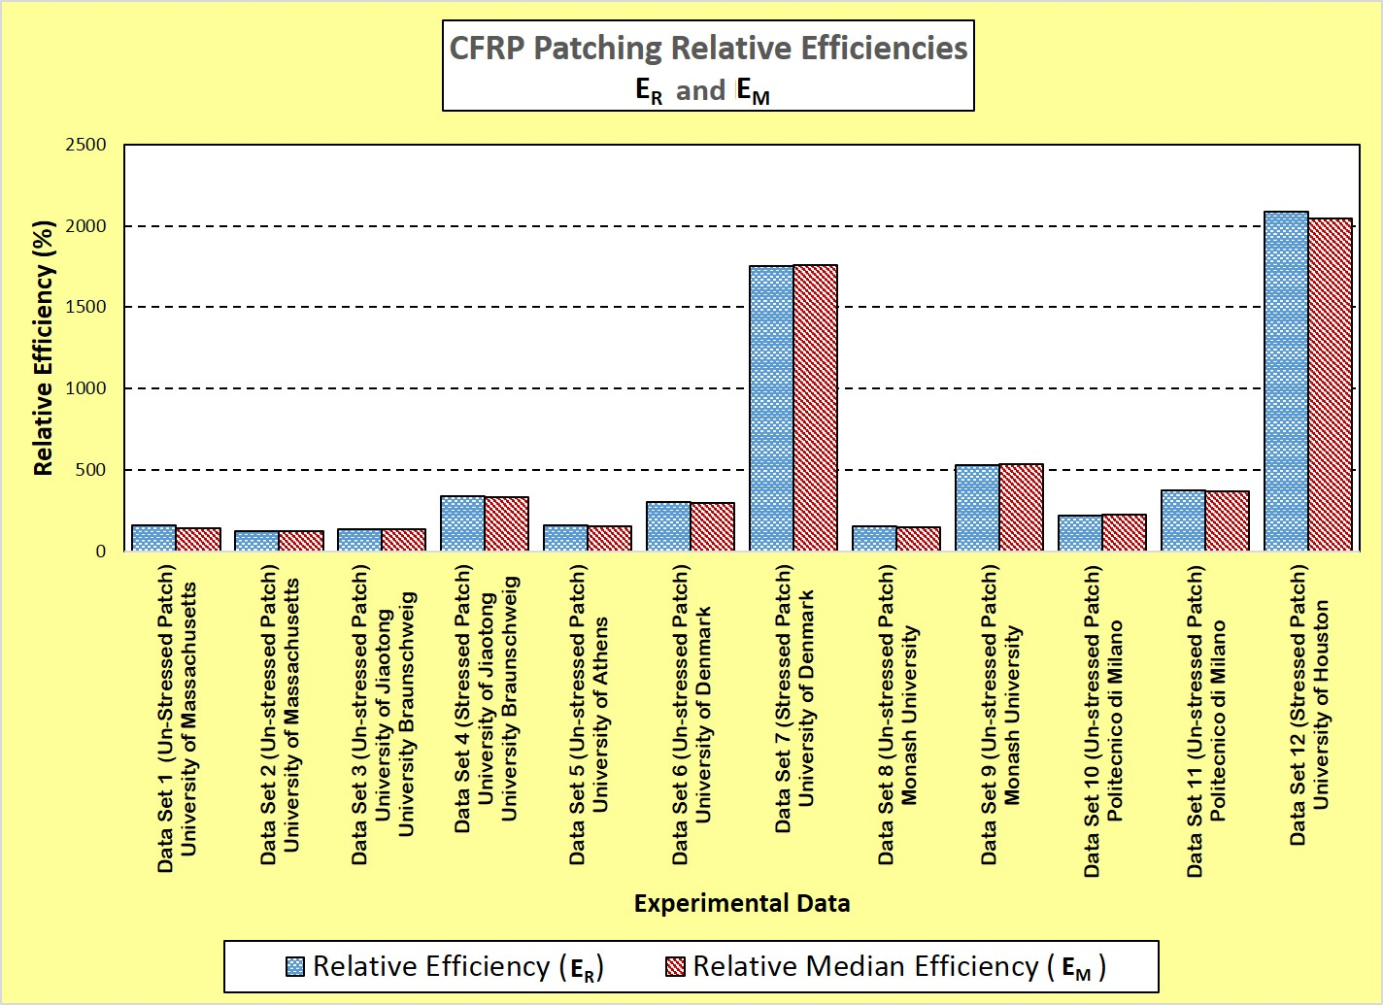A graphical display of the above data (Figure M) makes it easy to identify the most efficient repair methods. Two methods had an outstanding performance—the second method proposed by the University of Denmark and the one proposed by the University of Houston. Both performances extend the MFL about 20 times (17.5 and 21.5, respectively).

**Figure M.** *CFRP Relative Efficiencies Graphical Comparison*.   
From the direct comparison of the relative efficiencies, it can be concluded that the best repair   
methods proposed come from the University of Denmark and the University of Houston.

It is also notable that the best repair methods proposed were those using pre-stressed patches, as can be easily seen in a *Pareto Chart of the Relative Efficiencies* (Figure N).

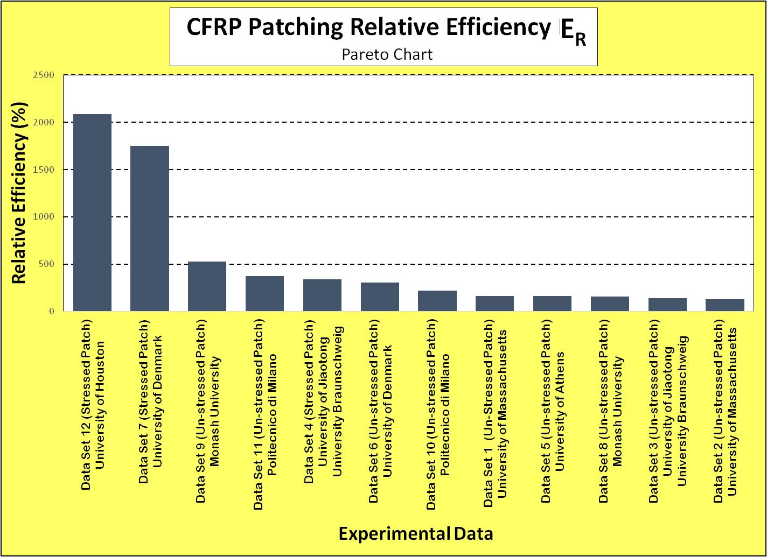

**Figure N.** *CFRP Relative Efficiencies Pareto Chart*. In this Pareto chart, it can be seen that the repair methods using pre-stressed CFRP patches are among the first five most-efficient procedures.

In conclusion, the best proposed cracked steel repair method was the CFRP-NiTiNb pre-stressed patches developed in the Cullen College of Engineering at the University of Houston.

It is important to make students aware that in real life, additional constraints must be considered in order to make a final choice and purchase: procedure cost, implementation time, implementation plan, quality control, warranties, maintenance schedule, and emergency response time are just some of the important factors to be considered. Be sure that students include mention of these constraints in their preliminary report to the mayor and city council.