Project Guidelines and Rubrics
Statistical Analysis of the Effectiveness of Composite Patches
to Rehabilitate Cracked Steel Structures
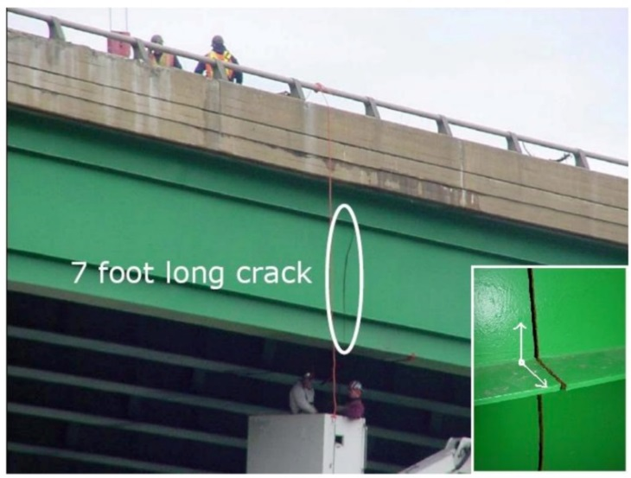
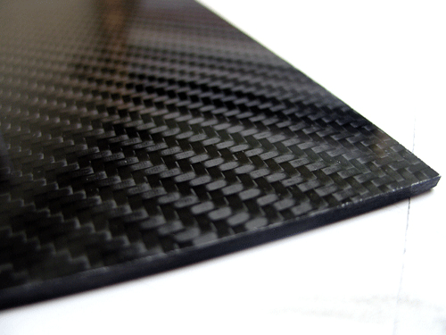

Your engineering challenge: To apply in a real-world, state-of-the-art research problem the concepts learned in an AP Statistics course, and quantify the effectiveness of the carbon-fiber-reinforced polymer-nitinol-epoxy composite patches to rehabilitate cracked steel structures. Requirements: A basic knowledge of TI-Nspire graphing calculator and Microsoft Excel, as well as how to create Microsoft PowerPoint slide presentations.
Project Guidelines
- Because of the project workload, you will work in teams of three students each.
- You are tasked with performing a statistical analysis of the sets of stress test results included in this rubric.
- To measure the effectiveness of the CFRP composite patches to stop crack propagation in steel specimens, compute for each of the unpatched and patched datasets the following statistics:
- The sample mean (in the problem context, that is the mean fatigue life [MFL] of the specimens)
- The sample standard deviation and coefficient of variation
- The five-number summary: minimum value, first quartile (Q₁), median (Q₂), third quartile (Q₃), maximum value
- The 10% trimmed mean
- The relative efficiency E_{R} (patched elements MFL / unpatched elements MFL), and the relative median efficiency E_{M} (median fatigue life of patched specimens / median fatigue life of unpatched specimens)
- Compare trimmed mean with sample mean. Conclude by stating which one gives a better description of the MFL of the steel specimens.
- Compare standard deviations and coefficients of variation. Analyze the variability of the data and determine if it is consistent with the MFL change.
- Compare median with mean and draw conclusions about which one best describes the data set.
- Compare the relative efficiency E_{R} with the median relative efficiency E_{M} and determine which one better describes the overall patching method efficiency.
- Compare the test results of the patched and unpatched specimens using modified box-and-whisker plots.
- Compare the relative efficiencies obtained for the different data sets using a clustered bar graph, and determine the two most efficient rehabilitation methods using a Pareto chart for the MFLs.
- Create a standalone PowerPoint slide show or video (mp4, wma, mpeg) to clearly present your results, conclusions and recommendation to the mayor and city council (the rest of the class).
- Present your slide presentation or video.

Project Checklist
Activities, Results and Analysis | Points |  | Evaluation
- Project Results Report | 100
- Slide with project title, student names and date | (5)
- Slides with project description, including objective, procedures, resources used | (5)
- Slides containing the 12 data sets and patching configurations used | (10)
- Slides with the computed mean (MFL), standard deviation, coefficient of variation, five-number summary, 10% trimmed mean, and relative efficiencies for each data set | (15)
- Slides with modified box-and-whisker plots comparing the five-number summaries for patched and unpatched data; include lines representing the corresponding means | (15)
- Slides with a brief interpretation of the statistics obtained for each data set | (15)
- Slide with the clustered bar graph to compare all the relative efficiencies obtained | (10)
- Slide with the Pareto chart displaying the MFLs obtained | (10)
- Project conclusions | (10)
- References | (5)
Total Points:

Results Presentation |  |  | Points |  | Evaluation
- PowerPoint slideshow containing information and results listed in points 1A-1J |  |  | (70)
- In-class presentation of results; proficient answers to questions |  |  | (20)
- Students’ professional look |  |  | (10)
 |  | Total Points:
Notes: | - No project will be accepted after the due date: [Date here: __________________________]  - Help will be provided for math, graphing, and final presentation preparation, during afterschool tutorial time.

Additional Support
The YouTube videos listed below are helpful to gain a basic understanding of the different elements and concepts used in the CFRP patching rehabilitation methods. These videos (and more) are also grouped in different tutorials under the First Semester Project playlist at https://www.sophia.org/playlists/ap-statistics-first-semester-project.
Fiber Reinforced Polymers
F1 Getting to Know Fiber Reinforced Polymers: https://www.youtube.com/watch?v=iqD9hBQXi5Y
F2 Concrete Bridge Repair w/ Fiber Reinforced Polymers - Carbon Wrap Solutions: https://www.youtube.com/watch?v=NSbpl9f0lO8
F3 Case Study - FRP Composite Bridges: https://www.youtube.com/watch?v=xS2rgXqy5GE
F4 Fiber Reinforced Polymer FRP Reinforced Concrete Solutions: https://www.youtube.com/watch?v=TbOkmzQRDcU
Carbon Fiber Composites
C1 Strong material - carbon fiber composite materials in aircraft: https://www.youtube.com/watch?v=FTUw0OWWMLU
C2 Steel Shaft vs. Carbon Fiber Shaft: https://www.youtube.com/watch?v=hjErH4_1fks
C3 Intro to Composites: https://www.youtube.com/watch?v=WYqCnEvTRUQ
C4 Composite materials intro by JEC: https://www.youtube.com/watch?v=dbywZ4PJ3QA
C5 Composite Materials 1: https://www.youtube.com/watch?v=201C6gpu8QU
C6 Composite Materials 2: https://www.youtube.com/watch?v=Cje-5EGPUY8
C7 Composites 101 (Vacuum bagging carbon fiber): https://www.youtube.com/watch?v=T4ZFj4fItWE
C8 Carbon composite product process of manufacture [2013 UCHIDA Factory]: https://www.youtube.com/watch?v=7Q5An-X-5yA
C9 Carbon Fiber for Dummies: https://www.youtube.com/watch?v=qfaW4c-Ourc
Polymers
P1 GCSE Science Chemistry Unit 1. Lesson 38: Polymers: https://www.youtube.com/watch?v=DXPmBEMsRXI
P2 GCSE Science Chemistry Unit 1. Lesson 39: Issues around using polymers: https://www.youtube.com/watch?v=wyukfA_vZhI
P3 Polymers - Crash Course Chemistry #45: https://www.youtube.com/watch?v=rHxxLYzJ8Sw
P4 Getting to Know Fiber Reinforced Polymers: https://www.youtube.com/watch?v=iqD9hBQXi5Y
P5 Fiber Reinforced Polymer FRP Reinforced Concrete Solutions: https://www.youtube.com/watch?v=TbOkmzQRDcU
P6 Case Study - FRP Composite Bridges: https://www.youtube.com/watch?v=xS2rgXqy5GE
Structure Failures
S1 Video Captured of 35W Bridge Collapse: https://www.youtube.com/watch?v=CMdv2wRaqo4
S2 35W Bridge Collapse Visualization: https://www.youtube.com/watch?v=O6ommRCUcsg
S3 Rare Interstate 35W aftermath footage shot by the Minnesota Department of Transportation: https://www.youtube.com/watch?v=LyJxDfEgEjU
S4 Alexander Kielland Rig Disaster: https://www.youtube.com/watch?v=7QVn3NUW_aQ&feature=player_embedded
S5 P36 Plataforma que afundou - Parte 1: https://www.youtube.com/watch?v=yuOoFykbZcs
S6 P36 Plataforma que afundou - Parte 2: https://www.youtube.com/watch?v=gUqXA4IMlek

References
R1 Brase, Charles H. and Brase, Corrinne P. Understandable Statistics. 8th Ed, Boston, MA: Houghton Mifflin, 2006.
R2 Carbon-fiber-reinforced polymer. Last updated February 2016. Wikipedia, The Free Encyclopedia. Accessed February 2016. https://en.wikipedia.org/wiki/Carbon-fiber-reinforced_polymer
R3 Colombi, Pierluigi, Fava, Giulia and Sonzogni, Lisa. (April 2015) “Fatigue Crack Growth in CFRP-Strengthened Steel Plates.” In Composites: Part B. https://www.researchgate.net/publication/271274747_Fatigue_crack_growth_in_CFRP-strengthened_steel_plates
R4 El-Tahan, M., Dawood, M. and Song, G. (June 2015) “Development of a Self-Stressing NiTiNb Shape Memory Alloy (SMA)/ Fiber Reinforced Polymer (FRP) Patch.” Smart Materials and Structures, Vol. 24, issue 6.
R5 Huawen, Ye, Konig, Christian, Ummenhofer, Thomas, Schizhong, Quing and Plum, Robin. “Fatigue Performance of Tension Steel Plates Strengthened with Prestressed CFRP Laminates.” ASCE Journal of Composites for Construction, Vol. 14, issue 5 (Oct. 2010), pp. 609-615.
R6 Jones, Sean, and Civjan, Scott. “Application of Fiber Reinforced Polymer Overlays to Extend Steel Fatigue Life.” ASCE Journal of Composites for Construction, Vol. 7, issue 4 (Nov. 2003), pp. 331-338.
R7 Liu, Hongbo, Al-Mahadi, Riadh and Zhao, Xiao-Ling: “Experimental Study of Fatigue Crack Growth Behavior in Adhesively Reinforced Steel Structures.” In Composite Structures, Vol. 90, no. 1, August 2009.
R8 Masuelli, Martin Alberto. “Chapter 1: Introduction of Fibre-Reinforced Polymers − Polymers and Composites: Concepts, Properties and Processes.” Fiber Reinforced Polymers – The Technology Applied for Concrete Repair, via INTECH, CC BY 3.0 license, published January 23, 2013. http://www.intechopen.com/books/fiber-reinforced-polymers-the-technology-applied-for-concrete-repair/introduction-of-fibre-reinforced-polymers-polymers-and-composites-concepts-properties-and-processes
R9 Täljsten, Björn, Hansen, Christian Skodborg and Schmidt, Jacob Wittrup. “Strengthening of Old Metallic Structures in Fatigue with Prestressed and Non-Prestressed CFRP Laminates.” Construction and Building Materials, Vol. 23, no. 4, March 2009, pp. 1665-1677.
R10 Tsouvalis, Nicholas G., Mirisiotis, Lazarus S. and Dimou, Dimitris N. “Experimental and Numerical Study of Fatigue Behavior of Composite Patch Reinforced Cracked Steel Plate.” International Journal of Fatigue, Vol. 31, no. 10, pp. 1637, September 2009.
R11 U.S. Department of Transportation. Federal Highway Administration. Manual for Repair and Retrofit of Fatigue Cracks in Steel Bridges. March 2013. FHWA Publication No. FHWA-IF-13-020. http://www.fhwa.dot.gov/bridge/steel/pubs/hif13020/hif13020.pdf
R12 What is carbon fiber? Zoltek Worldwide. http://zoltek.com/carbonfiber/

Page 1 Image Sources
- Cracked green bridge structure: Reza Haghani et al., Fatigue-Prone Details in Steel Bridges (Figure 2) MDPI. Used with permission. http://www.mdpi.com/2075-5309/2/4/456/htm
- Woven carbon fiber: 2009 Racingjeff, Wikimedia Commons
https://commons.wikimedia.org/wiki/File:Sierracomposites.com2.gif

Alexander Kielland Drilling Platform Structural Failure
Norwegian North Sea | March 27, 1980
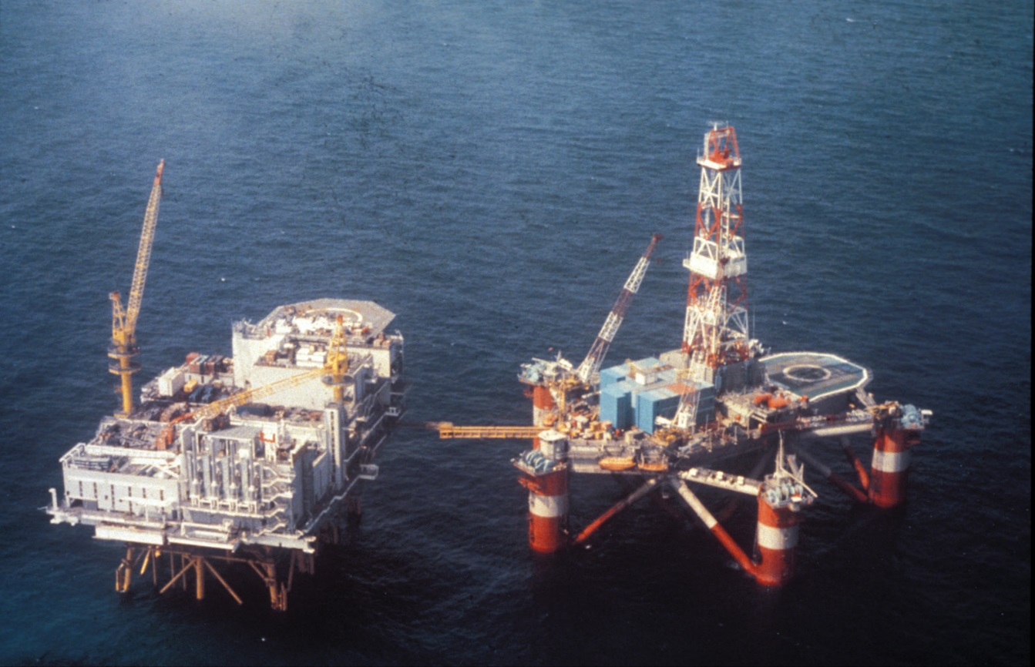

The intact Alexander Kielland drilling platform.
Source: 2009 Jan A. Tjemsland, Norwegian Petroleum Museum, Wikimedia Commons. https://commons.wikimedia.org/wiki/File:Alexander_L_Kielland_and_Edda_2-7C_NOMF-02663-1-650.jpg

To view a photograph of the collapsed structure, see:
Norwegian Oil and Gas Association. Norway’s Petroleum History at https://www.norskoljeoggass.no/no/Faktasider/Oljehistorie/

Project Results Report Rubric
 |  | Below Standard | Met Standard | Above Standard
A. | Project Title, Names  and Date | - Incomplete or missing student names, project name, and/or date | - Student names, project name, date displayed | - Student and project names, and date  - Attention-catching animation  - Background music
B. | Project  Description | - Missing or incomplete outline of project objective  - Missing or incomplete outline of procedures and resources used  - Missing or incomplete outline of results obtained | - Correct description of the project objective  - Correct outline of the procedures and resources used  - Correct summary of obtained results | - Correct description of project objective  - Correct outline of the procedures and resources used  - Correct summary of obtained results  - Eye-catching slide format & animations  - Figures/pictures to help understanding
C. | Data | - Incomplete or missing experimental data to analyze  - Data incorrectly formatted, labeled or separated  - Displayed data difficult to read (such as: font size < 24 pt, font color poor contrast with slide background color)  - Patching configuration missing  - Data source labs missing | - Complete experimental data or necessary portions to support explanations  - Data formatted, clearly labeled and separated  - Displayed data easy to read (font size > 24 pt, font color high contrast with slide background color)  - Patching configuration included  - Data source labs included | - Complete experimental data or necessary portions to support explanations  - Data formatted and clearly labeled and separated  - Displayed data easy to read (size, font)  - Patching configuration included and explained  - Data source labs included  - Eye-catching slide format & animations
D. | Statistics | - Incomplete or missing statistics  - Data incorrectly formatted, labeled or separated; calculator number format used  - Displayed data difficult to read (font size < 24 pt, font color poor contrast with slide background color) | - Complete statistics for patched and unpatched specimens  - Data correctly formatted, labeled and separated  - Displayed data easy to read (font size > 24 pt, font color high contrast with slide background color)  - Patching configuration included  - Data origins included | - Complete statistics for patched and unpatched specimens  - Data professionally formatted, labeled, and separated  - Displayed data easy to read (font size > 24 pt, font color high contrast with slide background color)  - Patching configuration included  - Data origins included  - Eye-catching slide format & animations  - Provides equations or computation methods to help understanding

 |  | Below Standard | Met Standard | Above Standard
E. | Analysis | - Omitted trimmed mean/sample mean comparison and/or interpretation  - Missing sample standard deviations and/or coefficients of variation comparisons and/or interpretations  - Missing median-mean and/or relative efficiencies comparisons and/or interpretations  - Missing or wrong box-and-whisker plots comparing patched-unpatched data; omitted graph explanation  - Box-and-whisker plots display incomplete data; sample means values not included  - Clustered bar graph comparing relative efficiencies missing or displaying incomplete data; omitted graph explanation  - Pareto chart for MFL missing or displaying incomplete data; omitted graph explanation  - Graphs incorrectly labeled, missing any of the next: title, axis labels, units, legends, appropriate scales; font size difficult to read  - Graphs formatted w colors that are difficult to read or see lines, #s or text | - Included trimmed mean/sample mean comparison and interpretation  - Included sample standard deviations and coefficients of variation comparisons and interpretations  - Included median-mean and relative efficiencies comparisons and interpretations  - Included box-and-whisker plots comparing patched–unpatched data, and explanations  - Included box-and-whisker plots displaying complete data; included sample means values  - Clustered bar graph displaying complete relative efficiencies data, and explanation included  - Pareto chart for MFL displaying complete data and explanation included  - Graphs correctly labeled: title, axis labels, units, legends, appropriate scales included; uses appropriate font sizes  - Graphs formatted with colors that make easy to read or see lines, #s or text | - Included trimmed mean/sample mean comparison and interpretation  - Included sample standard deviations and coefficients of variation comparisons and interpretations  - Included median-mean and relative efficiencies comparisons and interpretations  - Included box-and-whisker plots comparing patched-unpatched data, and explanations  - Included box-and-whisker plots displaying complete data; included sample means values  - Clustered bar graph comparing relative efficiencies displaying complete data and explanation included  - Pareto chart for MFL displaying complete data and explanation included  - Eye-catching slide format & animations  - Correct highlighting of elements as they are compared or explained  - Graphs correctly labeled and formatted in a professional way

 |  |  | Below Standard | Met Standard | Above Standard
 | F. | Project  Conclusions | - Missing or incomplete project conclusions  - Conclusions not supported with the correct statistical terms  - Conclusions missing or poorly done in problem context | - Conclusions including relevant hypothesis, procedures and results  - Conclusions using correct statistical terms  - Conclusions completely in problem context | - Conclusions including relevant hypothesis, procedures and results  - Conclusions using correct statistical terms  - Conclusions completely in problem context  - Eye-catching slide format & animations  - Provides illustrations, graphs or figures to help understanding
 | G. | Overall  Report | - Slides not formatted  - Difficult to read fonts used  - Not a standalone presentation | - Slides professionally formatted  - Most of the text in presentation in readable font (size > 24 pt, appropriate color)  - Standalone presentation | - Slides formatted using background pictures related to topic, and students’ own designs  - All text in readable font (font size > 24, pt and appropriate color)  - Eye-catching slide transitions

Project Results Report Presentation Rubric
 | Non-Professional | Quite Professional | Professional
Body Language | - Reads notes or slides  - Eyes not on audience  - Lacks confidence during the entire presentation  - Unnatural and distracting movements or gestures (fidgeting or nervous) | - Sometimes reads notes or slides  - Some eye contact with audience  - Some movement and gestures  - Some confidence and poise (but still somewhat nervous) | - Eye contact with audience  - Little or no reading of slides or notes  - Natural movements and gestures  - Appears confident during the entire presentation
Voice | - Speaks too softly to be understood  - Speaks too quickly or slowly  - Frequently uses words or sounds like: Okay, so…, you know…, uh, umm, I mean…  - Not using correct technical language or formal English | - Speaks clearly most of the time  - Sometimes speaks too quickly or slowly  - Speaks loudly enough for most of the audience  - Occasionally uses words or sounds like: Okay, so…, you know…, uh, umm, I mean…  - Uses correct technical language or formal English during most of the presentation | - Speaks clearly during the entire presentation  - Speaks at uniform volume and normal pace, not too quickly or slowly  - Speaks loudly enough for everyone to hear  - Rarely or never uses words or sounds like: Okay, so…, you know…, uh, umm, I mean…  - Uses correct technical language or formal English during the entire presentation
Overall Presentation | - No main idea presented; or wrong or incomplete  - Ideas presented in the incorrect sequence  - Missing important steps in the development  - Missing, incorrect or incomplete introduction and/or conclusion  - Poor presentation time management  - Did not correctly answer the asked question(s) | - Main idea presented, but not proficiently explained  - Ideas presented in the correct order, but lack connections or missing important points  - Introduction and conclusion present, but not effective  - Presentation done in the allotted time, but time not poorly distributed among topics or ideas  - Answers most questions correctly and in context | - Main idea presented in a clear and effective way  - Ideas presented in the correct order, emphasizing main points, and in context  - Effective introduction and conclusion  - Presentation done in the allotted time, and time proficiently distributed on topics or ideas  - Answers questions correctly and in context, enriching answers with relevant info or examples
Students’ Visual Impression (Look) | - Wearing clothes inappropriate for the occasion | - Wearing semi-formal clothes | - Wearing clothes suitable for the occasion (professional job interview)

