Graphing Data and Statistical Analysis with Excel Practice
Instructions: In this practice, you will apply your basic knowledge of Microsoft Excel to analyze data using Excel graphing tools and its built-in statistical functions. From the data tables, you will create scatter plots, calculate and graph averages and standard deviations, compute other central tendency numbers, and calculate p-values using the T-distribution.
Set up a work session:
- Open a new Excel session. Use a full screen window.
- Use the data sets provided below.
Guided Practice: Average Faculty Salaries, Males vs. Females
Instructions. For the next data set, Average Faculty Salaries, Males vs. Females, perform Exercises 1 - 6.
Correctly label all your formatted graphs and tables with results.
Save your practice in an Excel file named like this: Salaries_YourFullName_Period.xls.
College ID | Male AP | Female AP
C-1 | 34.5 | 33.9
C-2 | 30.5 | 31.2
C-3 | 35.1 | 35.0
C-4 | 35.7 | 34.2
C-5 | 31.5 | 32.4
C-6 | 34.4 | 34.1
C-7 | 32.1 | 32.7
C-8 | 30.7 | 29.9
C-9 | 33.7 | 31.2
C-10 | 35.3 | 35.5
C-11 | 30.7 | 30.2
C-12 | 34.2 | 34.8
C-13 | 39.6 | 38.7
C-14 | 30.5 | 30.0
C-15 | 33.8 | 33.8
C-16 | 31.7 | 32.4
C-17 | 32.8 | 31.7
C-18 | 38.5 | 38.9
C-19 | 40.5 | 41.2
C-20 | 25.3 | 25.5
C-21 | 28.6 | 28.0
C-22 | 35.8 | 35.1
Exercises:
- Creating a graph
For the paired data set 1, create a line graph. Place this graph as a new sheet.
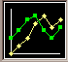
(Hint: Select data columns Males – Females ► ► ► )
To make the values in column College be the x-values in this graph:
- In the Chart Wizard – Step 2 of 4 – Chart Source Data , select tab Series.
- Click on box: click here
- Using the mouse, select only the data in column College ► press Enter.

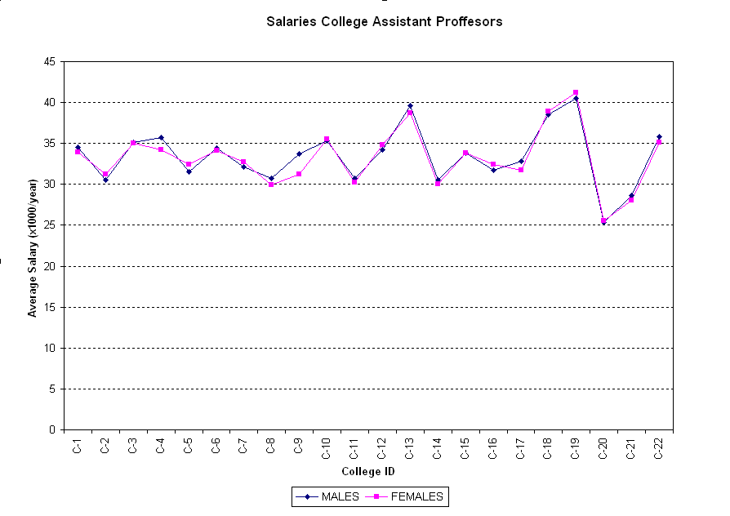
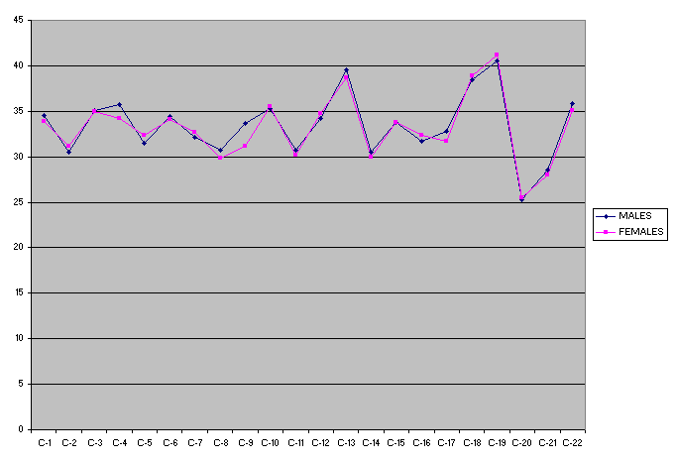
Example Exercise 1 graph
Example Exercise 2 graph

- Formatting a graph
- Place the graph legend at the bottom of the graph.
- Eliminate the plot area default gray color. (Hint: Click on Plot Area ► Format ► Select Plot Area or double click on Plot Area.)
- Change the major gridlines to a broken line. (Hint: Double click in one of the gridlines.)
- Insert the next labels. For x-axis: College ID; for y-axis: Average Salary (x1,000/year)
(Hint: Chart ► Chart Options ► Titles)
- Include in the graph title: College Assistant Professor Salaries. Males vs. Females
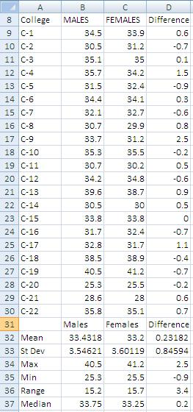
- Calculating statistics
- Compute the data differences.
- Compute samples/differences means.
[Hint: use function =average()]
- Compute sample/differences standard deviations.
[Hint: use function =stdev()]
- Find the sample/differences maximum values.
[Hint: use function =max()]
- Find the sample/differences minimum values.
[Hint: use function =min()]
- Find the sample/differences ranges.
- Find the sample/differences medians.
[Hint: use function =median()]
Example Exercise 3 results

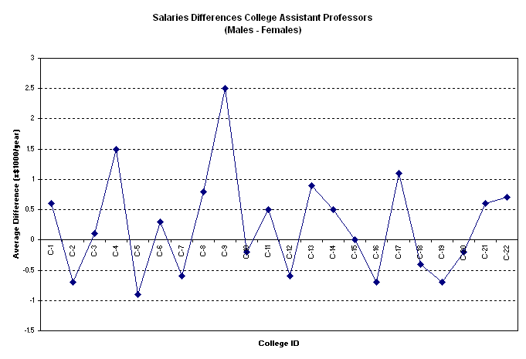
- Graphing data differences
Repeat Exercises 1 and 2 for the data differences obtained in Exercise 3, with the next changes:
  - Delete the graph legend.
  - Add a y-axis label: Average Differences (x $1,000/year)
  - Title the graph: College Assistant Professor Salary Differences: Males vs. Females
Example Exercise 4 results

- Graphing mean and standard deviation for the differences
  - Include in the graph a horizontal line representing the sample mean.
(Hint: Create a list with mean values, then Chart ► Source Data ► Add [Select created data].)
  - Include in the graph horizontal lines representing mean ± 1 standard deviation.
(Hint: Create list with ± SD, then ► Source Data ► Add [Select created data].)
  - Include in the graph a horizontal line representing mean ± 2 standard deviations.
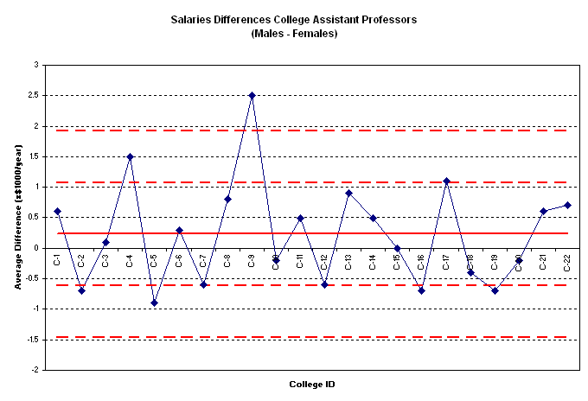
  - Format the sample mean line: Change the color to red and select the next thicker line. (Hint: Double click on line.)
  - Format the standard deviation lines: Change the color to red and select a broken thicker line (Hint: Double click on line.)

Example Exercise 5 graph

- Compute the sample differences t-value, p-value and sampling standard deviation
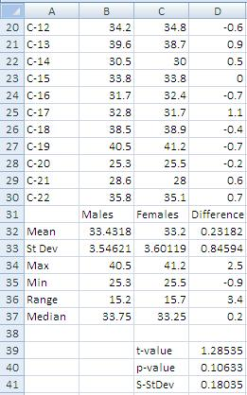
  - Compute the sample associated t-value or sample test statistic.
Use equation: , where is difference mean, n is sample size, and S_{d} is difference standard deviation. Using the values in the table:
$$t=\frac{0.23182∙\sqrt{22}}{0.84594}=1.28535$$
  - Compute p-value using T-distribution.
Use function ttest() with the values in table shown in step 2
=ttest(B8:B30,C8:C30,1,1)
where the first “1” indicates one-tail test, and the second “1” indicates a paired test.
  - Compute the sampling standard deviation for this difference.
Use equation: :
$$S_{\overline{d}}=\frac{0.84594}{\sqrt{22}}=0.18035$$
  - Do your results support the claim that no significant salary difference exists between male and female college professors…
…at the 5% level of significance?
Example Exercise 6 results
…at the 10% level of significance?
(Write your conclusions in a textbox on the results spreadsheet. Include an explanation. Example:)
Because p-value = 0.10633 is greater than 0.05 or 0.10, we have no evidence at the 5% or 10% level of significance to reject the original assumption (H₀) that female assistant professors receive, on average, the same salary as the male assistant professors.

Exercises:
- Create a graph
- Format a graph (a-e)
- Calculate statistics (a-g)
- Graph data differences (a-c)
- Graph mean and standard deviation for the differences (a-e)
- Compute the sample differences t-value, p-value and sampling standard deviation (a-d)
Independent Practice: Unemployment: College vs. High School Graduates
Instructions: For the next data set, Unemployment: College vs. High School Graduates, perform Exercises 1 - 6.
Correctly label all your formatted graphs and tables with results.
Save your practice in an Excel file named like this: Unemployment_YourFullName_Period.xls.
Year | College | High School
1999 | 2.8 | 5.9
2000 | 2.2 | 4.9
2001 | 2.2 | 4.8
2002 | 1.7 | 5.4
2003 | 2.3 | 6.3
2004 | 2.3 | 6.9
2005 | 2.4 | 6.9
2006 | 2.7 | 7.2
2007 | 3.5 | 10.0
2008 | 3 | 8.5
2009 | 1.9 | 5.1
2010 | 2.5 | 6.9
Independent Practice: Birth Rates vs. Death Rates
Instructions. For the data set, Birth Rates vs. Death Rates, perform Exercises 1 - 6.
Correctly label all your formatted graphs and tables with results.
Save your practice in an Excel file named like this: BDRates_YourFullName_Period.xls.
County ID | Birth | Death
CO-01 | 12.7 | 9.8
CO-02 | 13.4 | 14.5
CO-03 | 12.8 | 10.7
CO-04 | 12.1 | 14.2
CO-05 | 11.6 | 13.0
CO-06 | 11.1 | 12.9
CO-07 | 14.2 | 10.9
CO-08 | 12.5 | 14.1
CO-09 | 12.3 | 13.6
CO-10 | 13.1 | 9.1
CO-11 | 15.8 | 10.2
CO-12 | 10.3 | 17.9
CO-13 | 12.7 | 11.8
CO-14 | 11.1 | 7.0

