**GeoGebra Basics Practice Answer Key**

**Spheres Student Independent Practice**

*Teacher note*: Have students perform the radii measurements and the requested relative distances using Figure 1 as a referene. Require them to provide their answers to four decimals places. Expect the numbers obtained by students to be slightly different from the ones in this answer key (but at least the same integer part and first decimal) and vary from student to student.

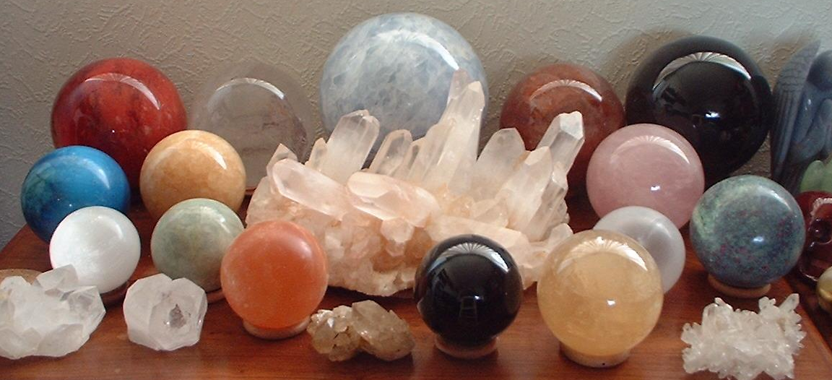

**1**

**4**

**2**

**7**

**9**

**10**

**11**

**3**

**5**

**6**

**8**

**12**

**13**

**Figure 1. Marble spheres of assorted sizes.**

**Set Up a Work Session**

1. Open a new GeoGebra session. Use the full screen window.
2. In *Graphing View*, insertthe picture file, MarbleSpheres.jpg, which is the same image as Figure 1.
3. Place the lower left image corner at the origin, and the lower right corner at (10.64, 0).
4. Set the image as the background.

**Exercises**

1. Estimate the on-screen radius for sphere 13. What is this value?

*Sphere* 13 *on screen radius* (*r*2 ≈ 0.4391)*: r* ≈ *0.6626*

1. If the real diameter of sphere 13 is 5.62 cm, estimate the real radius of sphere 1.

*Sphere* 1 *on screen radius* (*r*2 ≈ 0.6201)*: r* ≈0.7875. *Using a simple proportion:*



*Sphere* 1 *estimated real radius*: *r* ≈ 3.3397 *cm*

1. Estimate the radius of sphere 7.

*Sphere* 7 *on screen radius* (*r*2 ≈ 0.9549)*: r* ≈0.9772. *Using the scale factor a =* 4.2409

*x* = 4.2409 (0.9772)

*Sphere* 7 *estimated real radius*: *r* ≈ 4.1442 *cm*

1. Estimate the radius of sphere 10.

*Sphere* 10 *on screen radius* (*r*2 ≈ 0.7088)*: r* ≈0.8419. *Using the scale factor a =* 4.2409

*x* = 4.2409 (0.8419)

*Sphere* 10 *estimated real radius*: *r* ≈ 3.5704 *cm*

1. Estimate the radius of sphere 8.

*Sphere* 8 *on screen radius* (*r*2 ≈ 0.4032)*: r* ≈0.6350. *Using the scale factor a =* 4.2409

*x* = 4.2409 (0.6350)

*Sphere* 8 *estimated real radius*: *r* ≈ 2.6929 *cm*

1. Estimate the radius of sphere 3. Do you see any problem in this estimation?

*Sphere* 3 *on screen radius* (*r*2 ≈ 0.2725)*: r* ≈0.5220. *Using the scale factor a =* 4.2409

*x* = 4.2409 (0.5220)

*Sphere* 3 *estimated real radius*: *r* ≈ 2.2138 *cm*

*It seem that this object is not perfectly spherical*

1. What are the coordinates of the center of sphere 7? Draw a point with these coordinates.

*From corresponding circle equation in Algebra View*: (*x* – 4.9274)2 + (*y* – 4.6314)2 = 0.9549

*Center of sphere* 7: (4.9274, 4.6314)

1. What are the coordinates of the center of sphere 10? Draw a point with these coordinates.

*From the corresponding circle equation in Algebra View*: (*x* – 8.3076)2 + (*y* – 4.4974)2 = 0.7088

*Center of sphere* 10: (8.3076, 4.4974)

1. Measure the on-screen distance between centers obtained in exercises 7 and 8. What is this value? Estimate the real distance between these two spheres. What is this value?

*On-screen distance between spheres* 7 *and* 10 *centers*: ≈ 3.3829

*Using the scale factor* *a* = 4.2409:

*x* = 4.2409(3.3829) or *x* = 14.3465 *cm*

*Estimated real distance between spheres* 7 *and* 10 *centers*: ≈ 14.3465 *cm*

1. Is the distance estimated in exercise 9 reasonable? Why or why not?

*In the picture, it appears that both spheres are at the wall, so it is reasonable to expect that both centers are on a plane nearly parallel to the wall and that the segment used to measure the distance is on this same plane. Thus, it is reasonable to expect the distance estimated by this method to not be very different from the real distance.*

1. What are the coordinates of the center of sphere 1? Draw a point with these coordinates

*From corresponding circle equation in Algebra View*: (*x* – 1.6421)2 + (*y* – 4.2922)2 = 0.6201

*Center of sphere* 1: (1.6421, 4.2922)

1. What are the coordinates of the center of sphere 8? Draw a point with these coordinates

*From corresponding circle equation in Algebra view*: (*x* – 5.6674)2 + (*y* – 2.4191)2 = 0.4032

*Center of sphere* 8: (5.6674, 2.4191)

1. Measure the on-screen distance between centers obtained in exercises 11 and 12. What is this value? Estimate the real distance between these two spheres. What is this value?

*On-screen distance between spheres* 1 *and* 8 *centers*: ≈ 4.4552

*Using the scale factor* *a* = 4.2409:

*x* = 4.2409(4.4552) or *x* = 18.8941 *cm*

*Estimated real distance between spheres* 1 *and* 8 *centers*: ≈ 18.8941 *cm*

1. Is this estimated distance reasonable? Why?

*In the picture, it appears that the two spears are not in the same plane—sphere 1 is behind sphere 8. Thus, the segment used to measure the relative distance is not on a plane containing both centers. So it is expected that the distance estimated will differ considerably from the real distance.*

***References***

GeoGebra manual: <http://wiki.geogebra.org/en/Manual%3AMain_Page>

Below is the MarbleSpheres.jpg image that students must insert as the background in the GeoGebra Graphics view in order to perform the exercises.

GeoGebra channel at YouTube: <https://www.youtube.com/user/GeoGebraChannel>

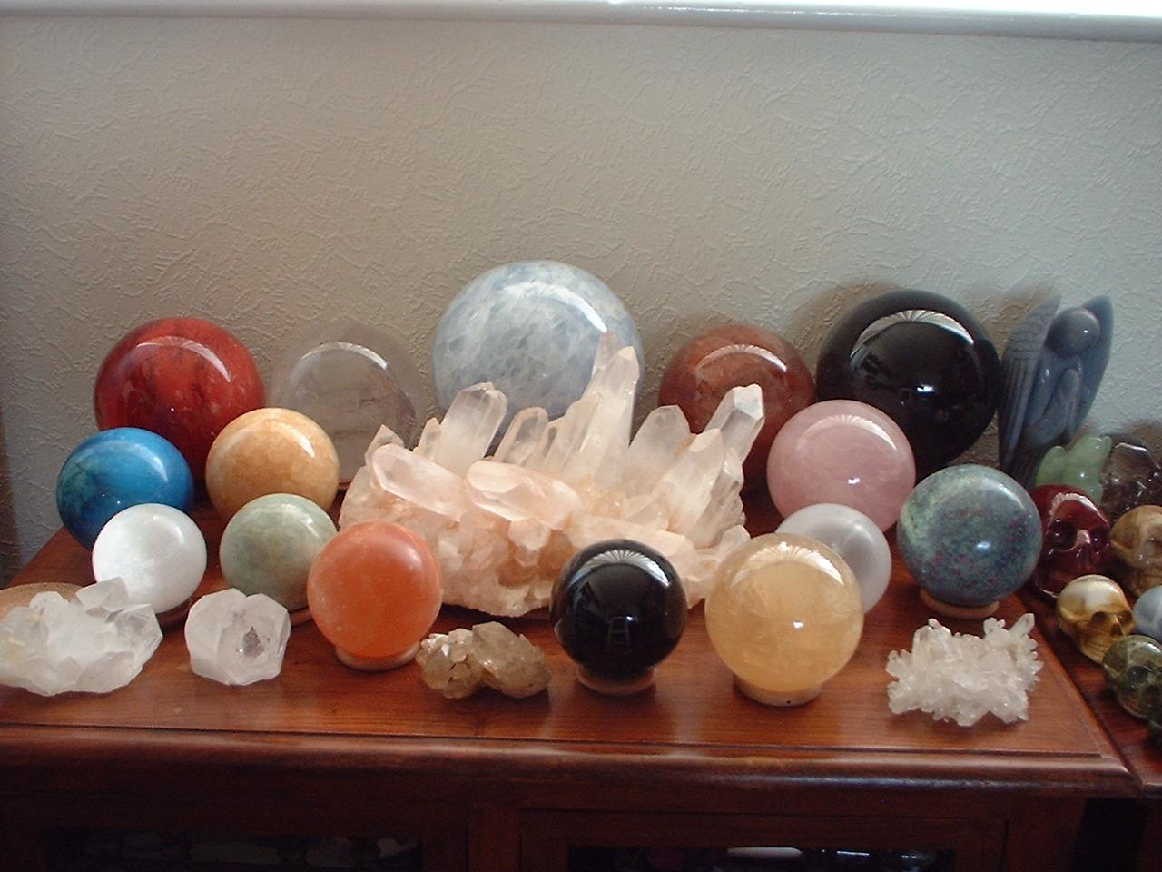

**Rapa Nui Student Independent Practice**

*Teacher note*: Have students perform the measurements of the requested relative distances. Require them to provide four decimals places in their answers and use kilometers in their estimations. Expect the numbers obtained by students to be slightly different from the ones in this answer key (but same integer part and first decimal) and vary from student to student

**Set Up a Work Session**

1. Open a new GeoGebra session. Use a full screen window.
2. In the *Graphing View*, insertthe picture file, EasterIsland.jpg (see References, below).
3. Place the lower left image corner at the origin, and the lower right corner at (11, 0).
4. Set the image as the background.

**Background Information**

Rapa Nui, also known as Easter Island (the name given by Europeans), is located in the southeast Pacific Ocean and is famous for its ~1,000 carvings of moai—massive human-faced statues. On average, the statues stand 4 meters high and weigh 12.5 metric tons; they are human heads-on-torsos carved in the male form from rough, hardened volcanic ash. The highest erected statue is 10 m long and weighs 74 tons, although one unfinished moai in the Ranu-Raraku quarry is 21 m long and weighs 180 tons.

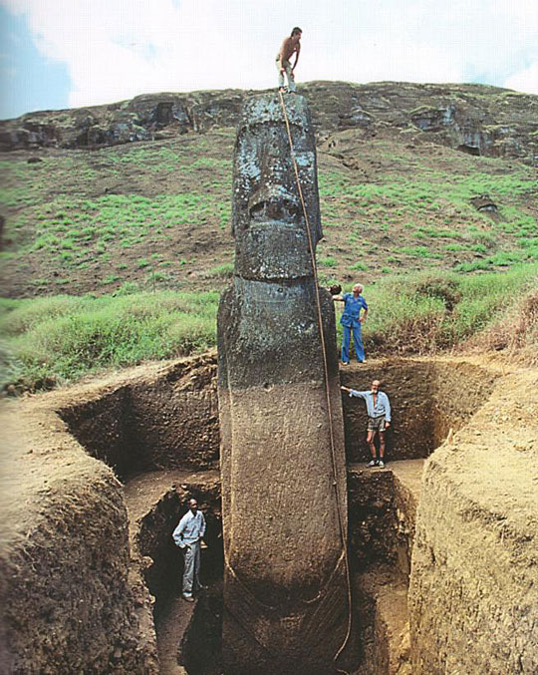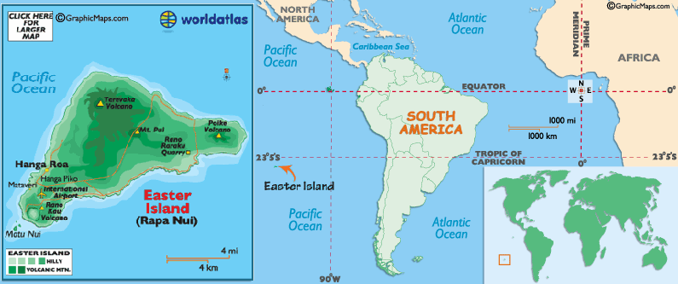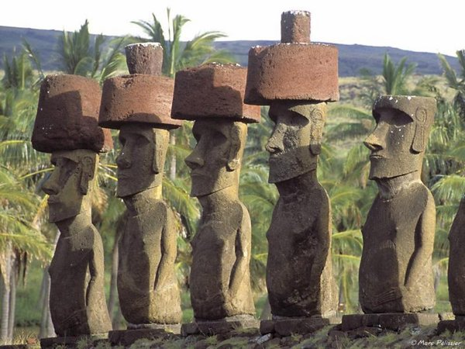

**Statistics on Easter Island's Moais**

* To date, a total of 887 monolithic statues have been located on Easter Island.
* 397 are still *in situ* in quarries at the Rano Raraku central production center.
* 288 full statues (32% of 887) were successfully transported to a variety of image ahu locations.
* 92 are *in transport;* 47 of these lie in various positions on prepared roads or tracks outside the Rano Raraku zone.

Many questions persist: For whom and for what purpose were the moais built? Why was their construction suddenly abandoned? In this short practice, you will use Geogebra to estimate some distances on Easter Island.

**Exercises**

1. Find the on-screen distance between volcano Terevaka and volcano Puakatike.

*Using the segment option in the toolbar, the length of this segment is*: 5.525

1. Using the scale in the map, estimate the real distance between volcano Terevaka and volcano Puakatike.

*The* 5 *km scale in the map corresponds to the segment with length* 2.2035; *using a simple proportion*:



*The estimated real distance between volcano Terevaka and volcano Puakatike is* ≈ 12.5369 *km*

1. Estimate the distance between Volcano Ranu Raraku and the Image ahu Vai Mata.

*Using the segment option in the toolbar, the length of this segment is*: 5.3728

*Using the scale factor a =* 2.2691: *x* = 2.2691(5.3728) *or x* = 12.1914 *km*

*The estimated real distance between Ranu Raraku and ahu Vai Mata is* ≈ 12.1914 *km*

1. Estimate the distance between the Image ahu A Tanga and Hanga Te’e.

*Using the segment option in the toolbar, the length of this segment is*: 5.2891

*Using the scale factor a =* 2.2691: *x* = 2.2691(5.2891) or *x* = 12.0015 *km*

*The estimated real distance between Ranu Raraku and ahu Vai Mata is* ≈ 12.0015 *km*

1. What is the distance between ahu *Te Hata Hero to* the Ranu Raraku Volcano?

*Using the segment option in the toolbar, the length of this segment from Ranu Raraku to Te Hata Hero is*: 6.7012

*Using the scale factor a =* 2.2691: *x* = 2.2691(6.7012) or *x* = 15.2057 *km*

*The estimated real distance between Ranu Raraku to the image ahu Te Hata Hero is* ≈ 15.2057 *km*

1. What is the distance between the most separated points of Easter Island.

*Using the segment option in the toolbar, the length of this segment from Cape Cumming and the cape below Orongo Ruins is*: 10.3

*Using the scale factor a =* 2.2691: *x* = 2.2691(10.3) or *x* = 23.3717 *km*

*The estimated real distance between Cumming and the cape below Orongo Ruins is* ≈ 23.3717 *km*

1. **Advanced Question**. It is assumed that the moais were transported to the ahu sites along the shores. Estimate the *along-shore* distance covered from Ranu Raraku Quarry to Vinapu.   
   (Hint: Explore Polyline option in Tool bar.)

*Using the Polyline tool, draw the shore shape by inserting the necessary vertices, these vertices define the polyline; to end the polyline, once the last vertex is reached, click on the first or initial point of the line. The length of the polyline appears in Algebra view. In this case the polyline length is:* 6.5276

*Using the scale factor a =* 2.2691: *x* = 2.2691(6.5276) or *x* = 14.8118 *km*

*The estimated real distance a moai was transported from Ranu Raraku Quarry to Vinapu is* ≈ 14.8118 *km*

1. **Advanced Question**. Estimate the area of the Easter Island.  
   (Hint: Explore the Line and Angle Toolbar menus.)

*Using the Polygon option in the toolbar to create a polygon like the Easter Island shape, and the area option in the toolbar;, the area of the drawn polygon is*: 31.5263 square units

*Using the scale factor a =* 2.2691, *find the corresponding real distance for a segment of length* 1: 2.2691 *km. The real area corresponding to a square unit is then*: 5.1488 *km*2

*The estimated area for Eastern Island is: A* = 5.1488(31.5263) *or A* = 162.3226 *km*2

Teacher note: *The real area of Easter Island is*: 163.6 *km*2

***References***

GeoGebra manual: <http://wiki.geogebra.org/en/Manual%3AMain_Page>

Below is the EasterIsland.jpg image that students must insert as the background in the GeoGebra Graphics view in order to perform the exercises. *Source*: 2007 Eric Gaba, Wikimedia Commons <https://commons.wikimedia.org/wiki/File:Easter_Island_map-en.svg>

Owen Jarus: *Easter Island (Rapa Nui) & Moai Statues* <http://www.livescience.com/24021-easter-island-rapa-nui.html>

PBS-Online: Secrets of Eastern Island. <http://www.pbs.org/wgbh/nova/easter/civilization/giants.html>

GeoGebra channel at Youtube: <https://www.youtube.com/user/GeoGebraChannel>

