PROJECTIONS AND COORDINATES EXPLORED THROUGH GOOGLE EARTH EXERCISE (SOLUTION SHEET)
Name:
Date:
Period:
Note: Correct answers on some problems are indicated with a yellow highlight.
PROJECTIONS
- Here are some Mercator projections of the world. A Mercator projection is like when someone puts a can around the earth and then rolls the earth onto the inside of the can and lays it out flat as a map. The projection is GOOD for keeping angles and shapes correct, but large shapes and size are distorted.
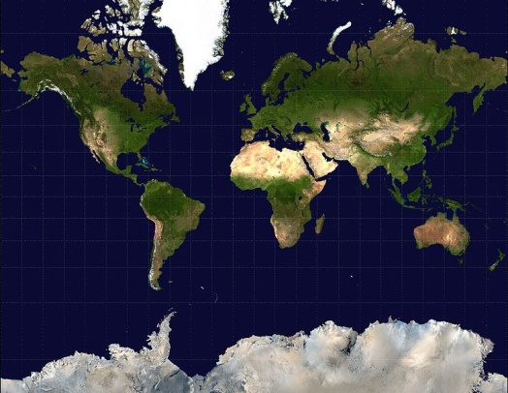
Figure 1. Mercator projection of the world. Public Domain. Both found in Wikimedia Commons as they were originally obtained from NASA’s “Blue Marble” series. http://commons.wikimedia.org/wiki/File:Mercator-projection.jpg
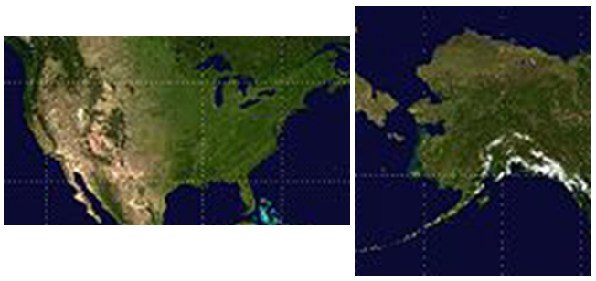
Figure 2. The continental US (left) and Alaska (right) in Mercator projection under the same scale. Details of Figure 1.
In the figures, how big is Alaska compared to the US, 10%, 20%, 50%, or 90%? (Circle One)
Is Alaska bigger, smaller, or the right size for what it should be? (Circle one)
Why is Alaska distorted in the projection and why is it OK for us to distort it?
It is distorted because a Mercator projection, in order to get a flat earth, stretches the size of objects at the poles while preserving their general overall shape. The shape is increased relative to the rest of the land masses. It’s ok for us to distort it because people know that a world map, or any map for that matter, is a projection. It is impossible to completely preserve the size, shape, and distances when turning a curved surface into a flat surface.

- What is shown below is a Robinson projection. It was created so that it doesn’t completely preserve angles, shapes, or size but it is a good approximation to a globe.
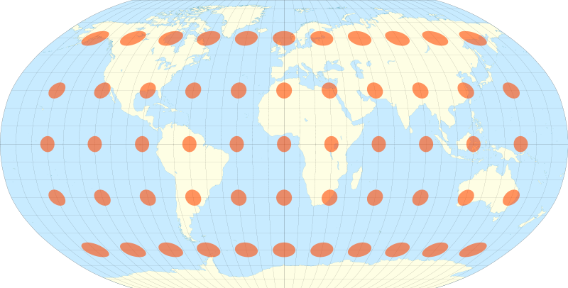
Figure 3. Robinson projection of the earth. From public domain on Wikimedia Commons at http://en.wikipedia.org/wiki/File:Tissot_indicatrix_world_map_Robinson_proj.svg. Created by Eric Gaba.
How is the Robinson projection (Figure 3) different from the Mercator projection (Figure 1)?
The Robinson projection allows the longitude lines to curve, which they actually do. So the sizes of the land masses are closer to reality. If we use the typical indicator of Greenland and Africa, we can see that they are much closer (though not exactly) at the right sizes. You can also see the curvature preserved in that the east and west ends of map still have a “globe-like” appearance.
The longitude (up and down) lines on the Robinson projection are allowed to curve while the latitude lines (right to left) remain straight. (1) Do you think this stretches the map more up and down (vertical) or left and right (horizontal)? (Hint: Consider the distance between the longitude and latitude lines. Which distances change more on different parts of the map?) (2) Which part of the map is the least distorted? (Two questions to answer)
- The greater stretching happens vertically. You can tell this because the distance between latitude lines is greater towards the poles, and the latitude lines are also not allowed to curve, which they do on the real globe. Since latitude measures vertical distance (though the lines themselves are horizontal), this mean that the vertical scale likely has more error than the horizontal scale.
- The least distorted part of the map is the center. This makes sense logically. If someone wants to make a map, generally the eye is drawn to what is at the center first. So they would normally want to make the map most accurate at this focus point. Beyond the mapmaker motivation, you can see stretching at the poles (especially on Antarctica). So this means the areas farthest from these stretched zones are the most accurate (least distorted).
COORDINATE SYSTEMS
Open Google Earth on your computer. Then look to the left side of the screen. You should see an area of the window called “Places”. Below that are some different layers. There are two that you will be using. They are called
- Earth Point Grid: UTM/UPS
- Earth Point Grid: Degrees Minutes Seconds (DMS)
Note to Teachers: Feel free to change the section on Fonville Middle School to whatever school you are at. Just know that the answers for coordinates and distance will be different.
Make sure that you can click in the check box next to each one to turn it on and off. As you turn it on, you should see some yellow gridlines appear over the earth model that is shown in the main viewing window. Once you have confirmed that you can do that, then turn on the UTM layer. Type in “725 Little York Rd, Houston, Harris, Texas 77037.” This will take you to Fonville Middle School.
Zoom in to the school until you see some pink gridlines appear. It may take a minute for them to load. These lines are UTM 100-meter grid lines. Between every two dots are 100 meters. Using these lines, please find the following. Note that if you mouse over a grid, it will light up and give you the coordinates of that one square in UTM coordinates. Note also that if you go down to the Layers window on the left side of the screen that you can turn the roads layer on and off if you need it.
- The UTM coordinates for the right (east) half of Fonville Middle School 15R 269200mE 3306800mN
- The distance from Nordling to Van Ness St along the front of the school. Guess it from the UTM pink grid 250-280 METERS. Now give convert that estimate of distance to FEET (if you don’t know the conversion, look it up on the internet) 820-920FEET.
- Click on the “Show Ruler” tool on the top of Google Earth 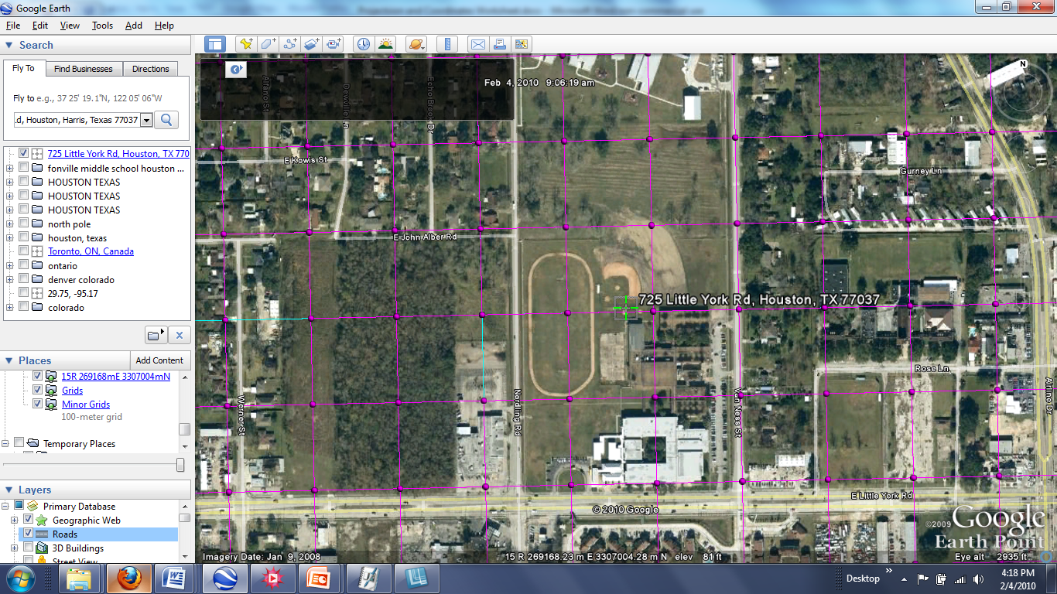. Use it to find the distance in MILES from the top to the bottom of the track. 0.1 MILES
- Now turn OFF the UTM/UPS grid and turn ON the DMS grid in the Places window on the left. Mouse over the grid that is now there and write down the coordinates of the school in DEGREES(˚), MINUTES(‘), and SECONDS(“) for Latitude and Longitude. The symbols in parentheses that you just read will tell you which numbers are degrees, minutes, and seconds 29˚ 52’13” -095˚23’23” .
- Turn the UTM/UPS grid back on. You will see two pink sets of grids appear. They do not match exactly. Is the distance between two points in each grid the same? Which one has larger grids, UTM/UPS or DMS? (Circle one) Use the “Show Ruler” tool to measure if you are having trouble.
- Why are the two coordinate systems different?
UTM/UPS is a coordinate system that tries to preserve a right angle grid structure at any particular mapping location on the earth. Sometimes it suffers from inaccuracy, but over small areas, it doesn’t make a difference. Latlong is an earth-wide system that follows the curvature of the earth, but because of that it is a little hard to use on small areas that could be approximated as 90˚ grids. The coordinate systems are different in that they have different centers of their system (lat-long centered around equator and poles while UTM is centered within each zone), and the grid spacing is different because UTM is really based on distances and simple subdivisions while lat-long is based on angles. They are basically different because they have different purposes for their use.
- Will both coordinates get you to Fonville Middle School? Why or why not?
Yes both coordinates will get you to Fonville. You can use Google Earth and type in the coordinates that were written in part (A) and (D) to prove that. They both work because they are good coordinate systems that have every point on the earth described by unique coordinates. They have different strengths and weakness, but they both have unique locations for every coordinate.

Now we will leave Fonville. Type in the following Latitude-Longitude coordinates into Google Earth.
58 35 46.77 N 49 39 47.27 E
Note to Teachers: Feel free to change the location for this second section of this activity at Kirov, Russia to something that may be more meaningful to your students. You will need to find the answers for that new place and adjust some of these questions. For example, one part of this section asks students to find the color of the Gertson Library. You can use the “Panoramio” layer under the “Primary Layer” grouping in Google Earth to find a suitable image to ask questions on. See image below to find that layer.
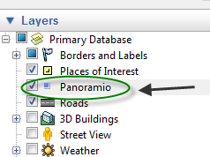
Once you get there, you may need to zoom out a little bit if it is blurry. Congratulations, you have just arrived a Kirov, Russia, the birthplace of your teacher!

Make sure that the Wikipedia layer and Geographic Web are turned on in the Layers window at that the UTM/UPS layer is turned on and DMS turned off in the Places window. Also note that in the lower part of the main viewer, you will see latitude and longitude coordinates displayed where you put the cursor. Move the cursor around to watch them change. Click on the white square W link to open a Wikipedia article about the city. Note all of the information that is there. Also remember that you can use the ruler tool at the top of the screen to measure distances easily in any unit. You can also get a picture of any blue dot on the screen if you click on it. Now find the following.

- The approximate coordinates of Kiov in UTM/UPS (use the grid) 39V 422000mE 6495000mN
- The population of Kiov in 2002 (remember all of the information is right there on the map) 457,578
- The distance that Kiov is from Moscow in KILOMETERS 900 and MILES (use a web conversion if necessary) 558
- Find the Bridge over the Viatka River on the Northeast part of the city. Find the length of the bridge in SMOOTS 165
- The color of the Gertsen Library (you’ll find it, keep looking) Light Yellow and Cream

Now we’re going somewhere different. Enter the decimal latitude-longitude coordinates and make sure that the UTM/UPS grid is turned on.

-89.944793 -16.893496

You should recognize this place with a little looking. You can move around a little bit if you aren’t sure where you are. Just enter the coordinates in again if you get too far off. This place uses a different coordinate system (Universal Polar Stereographic or UPS) than the rest of the other because it is so different. Zoom out a little bit, and you will see a big yellow circle around this area in the UTM grid. Now please give the following.

- The UTM/UPS coordinate near here (should be an orange grid) Probably four different choices for this one (B 2000000mE 1990000mN, A 1990000mE 1990000mN, A 1990000mE 2000000mN, B 2000000mE 2000000mN)
- The diameter of the yellow circle that surrounds this area (use the ruler tool) in MILES ~1400
- What is the name of this place? The South Pole or Antarctica

Lastly, go to these last lat-long coordinates. 71°40'22.60"S 2°50'20.95"W

What is this place? It is the South African National Antarctic Expedition (SANAE) IV research base. It is used to research in Antarctica. It is used to study the physical sciences, oceanography, biology, geology, and geomorphology. (Information taken from Wikipedia article).

