Plastics and The Great Pacific Garbage Patch
Eugene F. Blankenship
January 14, 2010

WHAT IS THE GREAT PACIFIC GARBAGE PATCH?
The Great Pacific Garbage Patch (GPGP) is region of the Pacific ocean stretching from the western coastline of the United States until Japan. Made actually of two separate regions, the Western and Eastern Garbage Patches, the water there swirls in wide swathes called ocean gyres [1]. When something floating moves into the gyre, it simply remains there until it either sinks, degrades, or is removed by an animal. The GPGP is an ocean gyre that contains millions of pounds of non-biodegrading plastics in higher concentrations than plankton. The GPGP is actually one of five gyres that can form garbage patches in the world, and it has been estimated to be roughly twice the size of Texas [2].
THE FAULT LIES WITH US ALL
The GPGP contains tiny bits of plastic strewn throughout the swirling waters, but there are many instances where it is quite clear what the plastic was. Dishwashing soap bottles, drinking water bottles, toys, and toothbrushes are just some of the examples of whole items that have been pulled up by, Charles Moore, the primary research and discover of the GPGP. The labels on the plastic debris are written in Chinese, English, and other languages from nations all along the Pacific Rim, and so the plastic is coming from all of those places [3], if they enter a stream and make it to the ocean will often end up here. Of the 200 billion pounds per year of plastic that is produced globally, 10% of it ends up in the oceans [4]. It’s not a high percentage, but it is enough to ensure that if the world keeps growing and using plastic, our GPGP will continue to grow.
ENVIRONMENTAL EFFECTS OF PLASTIC
Some might say, “This ‘garbage patch’ is thousands of miles away from me. Why should I care if it’s floating out there? Plastic isn’t toxic. We use it on our own food all the time.” In a sense, such an attitude is correct. Plastic generally is not toxic, and so it is not as if it’s adding more chemical pollution to the ocean. It’s not a shiny oil spill. What researchers have discovered, however, is that the plastic is very good at gathering and concentrating chemical pollutants such as PCB and DDT in the water [2]. It’s a like a magnet for toxic chemicals. When fish and birds eat the plastic, they take in these chemicals. If the animals are not killed by the toxics, then if we catch the fish or the fish that eats that fish, then we too will have these toxics passed onto us. Even if the plastics did not contain toxics, aquatic life and birds would be harmed by confusing the plastic for food. Small size fish have had as much as 84 pieces of plastic in the fish [2]! The oceans are very large, but they are connected. Can we expect to avoid the toxics from seafood that come from these plastics? Are we willing to stand by and watch marine life suffer when we are the cause of the suffering?
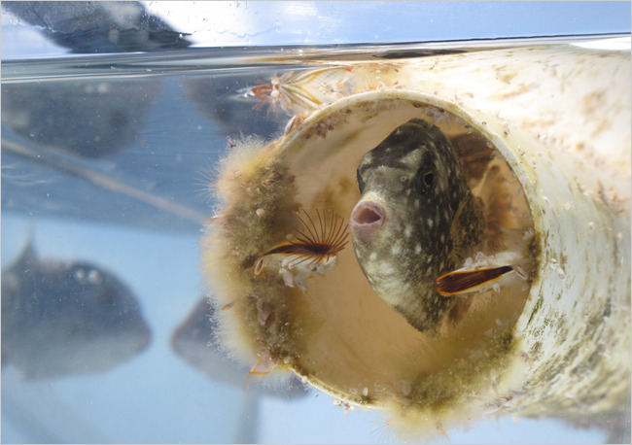
A spotted gray trigger fish inside a caulking tube found on one of Charles Moore’s expeditions. Photo: Lindsey Hoshaw for The New York Times
- Silverman, J. Why is the world’s biggest landfill in the Pacific Ocean? Howstuffworks.com, accessed 2010.
- Hoshaw, L. Afloat on the ocean, expanding islands of trash. New York Times. November 9, 2009.
- Associated Press. Growth of ocean ‘garbage patch’ alarms experts. MSNBC. August 28, 2009
- Greenpeace International. Ocean plastic pollution and how you can help. October 30, 2006.

