How Septic and Sewer Systems Work
Let’s look at the inner workings of sewer systems so that you can understand how they handle
the billions of gallons of wastewater that humans produce every day!
Why Do We Need Sewer Systems?
Each time you flush the toilet or you wash something down the sink’s drain, you create sewage (also known in polite society as wastewater). One question that many people might ask is, “Why not simply dump this wastewater onto the ground outside the house, or into a nearby stream?” Well, three main characteristics about wastewater make it something you do not want to release into the environment:
- It stinks. If you release wastewater directly into the environment, things get very smelly very fast.
- It contains harmful bacteria. Human waste naturally contains coliform bacteria (for example, E. coli) and other bacteria that can cause disease. Once water becomes infected with these bacteria, it becomes a health hazard.
- It contains suspended solids and chemicals that affect the environment. For example:
- Wastewater contains nitrogen and phosphates that, being fertilizers, encourage the growth of algae. Excessive algae growth can block sunlight and foul the water.
- Wastewater contains organic material that environmental bacteria will start to decompose. When they do, these bacteria consume oxygen in the water. The resulting lack of oxygen kills fish.
- The suspended solids in wastewater make the water look murky and can affect the ability of many fish to breathe and see.
The increased algae, reduced oxygen and murkiness destroy the ability of a stream or lake to support wildlife, and all of the fish, frogs and other life forms quickly die. In addition, no one wants to live in a place that stinks, is full of deadly bacteria and cannot support aquatic life. That's why communities build wastewater treatment plants and enforce laws against the release of raw sewage into the environment.
Private Treatment: The Septic Tank
In rural areas where houses are spaced so far apart that a sewer system would be too expensive to install (requires miles of piping), people install their own, private sewage treatment plants, called septic tanks.
A septic tank is simply a big concrete or steel tank that is buried in the yard. The tank might hold 1,000 gallons (4,000 liters) of water. Wastewater flows into the tank at one end and leaves the tank at the other. The tank looks something like this in cross-section:
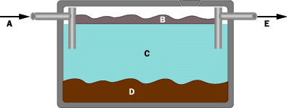

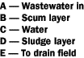

In this side-view drawing of a septic tank, you can see three layers. Anything that floats rises to the top and forms a layer known as the scum layer. Anything heavier than water sinks to form the sludge layer. In the middle is a fairly clear water layer that contains bacteria and chemicals (such as nitrogen and phosphorous that act as fertilizers), but is largely free of solids.

Wastewater comes into the septic tank from the sewer pipes in the house, as shown here:
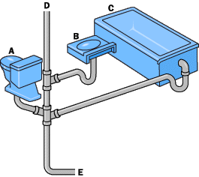
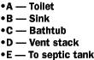
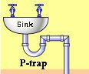

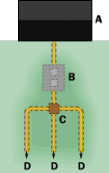
A septic tank naturally produces gases (caused by bacteria breaking down the organic material in the wastewater), and these gases do not smell good. Therefore, sinks have pipe bends called P-traps that hold water in the lower loop to block gases from flowing back into the house. The gases flow up a vent pipe instead; notice the roof of any house to see one or more vent pipes poking through.
As new water enters the tank, it displaces the water that is already there. This water flows out of the septic tank and into a drain field. A drain field is made of perforated pipes buried in trenches filled with gravel.
The diagram to the right shows an overhead view of a house, septic tank, distribution box and drain field:
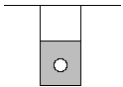
A typical drain field pipe is 4 inches (10 cm) in diameter and is buried in a trench that is 4 to 6 feet (~1.5 m) deep and 2 feet (0.6 m) wide. The gravel fills the bottom 2 to 3 feet of the trench and dirt covers the gravel, as shown by this side-view diagram:
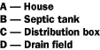
In the drain field, the water is slowly absorbed and filtered by the ground. The size of the drain field is determined by how well the soil absorbs water. In places where the ground is hard clay that absorbs water very slowly, the drain field must be much bigger that if the ground was sandier.
A septic system is usually powered by gravity alone. Water flows down from the house to the tank, and then down from the tank to the drain field. It is a completely passive system.
You may have heard the expression, “The grass is always greener over the septic tank.” Actually, it is the drain field, and the grass really IS greener—it benefits from the moisture and nutrients in the drain field.
Urban Wastewater Systems
In urban and suburban areas where people are packed closer together and much more wastewater needs is produced, the community constructs a sewer system to collect wastewater and take it to a wastewater treatment facility.
Ideally, sewer systems are completely gravity-powered, just like septic systems. Pipes from each house or building flow to a sewer main (a pipe) that runs, for example, under the asphalt down the middle of the street. The sewer main might be 3 to 5 feet (1 to 1.5 m) in diameter. Periodically, a vertical pipe runs up from the main to the surface, where it is covered by a manhole cover. Manholes allow access to the main for maintenance purposes.
Why are manhole covers round?
Answer: To avoid accidents.
Round covers cannot fall down into the hole, whereas square or rectangular covers could.
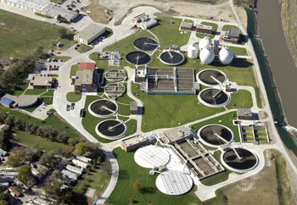
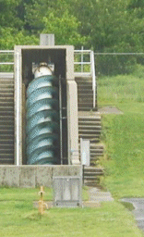

Aerial view of a water treatment plant (left), and example screw pump moving wastewater (right).

Sewer mains flow into progressively larger pipes until they reach the wastewater treatment plant. To help gravity do its job, wastewater treatment plants are usually located in low-lying areas, and sewer mains often follow creek beds and streambeds (which flow naturally downhill) to the plant. Often, the lay of the land does not completely cooperate, and gravity cannot do all the work. In these cases, a sew er system includes a grinder-pump or a lift station to move the wastewater up over a hill.
Once wastewater reaches a treatment plant, it goes through one, two or three stages of treatment (depending on the sophistication of the plant). Here’s what each stage does:
The first stage, known as primary treatment, does the same thing a septic tank does. It lets the solids settle out of the water and the scum to rise. Then, the system collects the solids to use as biosolids fertilizer or soil amendment, or for disposal (either in a landfill or an incinerator).
Primary treatment is very simple—it involves a screen followed by a set of pools or ponds that let the water sit so that the solids can settle out. Primary treatment might remove half of the solids, organic materials and bacteria from the water. If the plant does no more than primary treatment, then the water is chlorinated to destroy the remaining bacteria, and discharged.
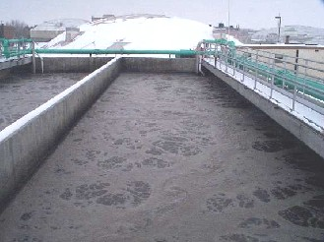
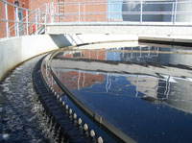

Example primary clarifier (left) and aeration basin (right).

The second stage, known as secondary treatment, removes organic materials and nutrients with the help of bacteria. The water flows to large, aerated tanks where bacteria consume everything they can. Then the wastewater flows to settling tanks where the bacteria settle out. Secondary treatment might remove 90% of all solids and organic materials from the wastewater.

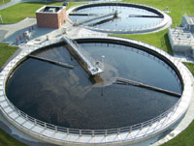
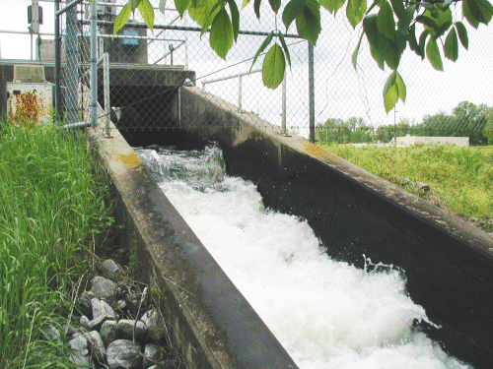

Example secondary clarifier (left), and clean effluent released from a water treatment plan (right).

The third stage, known as tertiary treatment, varies, depending on the community and the wastewater composition. Typically, the third stage uses chemicals to remove phosphorous and nitrogen from the water, but may also include filter beds and other types of treatment, such as disinfection using ultraviolet light. Chlorine added to the water kills any remaining bacteria, and the water is discharged.
Measuring the Effectiveness of Treatment Plants
Wastewater treatment plant effectiveness is measured on several different scales. The most common are:
- pH: The water's acidity is measured as it leaves the plant. Ideally, the pH matches the pH of the river or lake that receives the plant's output.
- BOD (bio-chemical oxygen demand): BOD is a measure of how much oxygen in the water is required to finish digesting the organic material left in the effluent. Ideally, the BOD is zero.
- Dissolved oxygen: This is the amount of oxygen in the water as it leaves the plant. If the water contains no oxygen, it will kill any aquatic life that comes into contact with it. Dissolved oxygen should be as high as possible and needs to cover the BOD.
- Suspended solids: This is the measure of the solids remaining in the water after treatment. Ideally, suspended solids are zero.
- Total phosphorous and nitrogen: This is the measure of the nutrients remaining in the water.
- Chlorine: The chlorine used to destroy harmful bacteria must be removed so it does not kill beneficial bacteria in the environment. Ideally, chlorine should not be detectable.
- Coliform bacteria count: This is the measure of fecal bacteria remaining in the water. Ideally, this number is zero. Note that water in the environment is not totally free of fecal bacteria; birds and other wildlife introduce a small amount.
These indicators must be watched very closely because communities produce a huge quantity of wastewater. Discharge levels ranging from 10 million to 100 million gallons per day (38 million to 380 million liters) are common for wastewater treatment plants.
Article and diagrams: Brain, Marshall. "How Sewer and Septic Systems Work" Last updated April 1, 2000. HowStuffWorks.com. Accessed March 28, 2011. http://home.howstuffworks.com/home-improvement/plumbing/sewer.htm.
P-trap drawing: City of Columbus, OH http://utilities.columbus.gov/content.aspx?id=38119
Some photos (aerial plant, primary clarifier, secondary clarifier): City of Lincoln NE http://lincoln.ne.gov/city/pworks/waste/wstwater/treat/
Few photos (screw pump, clean effluent released): City of Murray, KY http://www.murrayky.gov/publicworks/sewer/beecreek.htm
Aeration basin photo: South Dakota Dept. of Environment and Natural Resources http://denr.sd.gov/des/sw/ActivatedSludge.aspx

