Wastewater Treatment Laboratory Investigation Worksheet
- How do you know that your water is clean?

- Why do you trust that the water from your faucet is safe for you to drink?

- Why is important for local ecosystems to continue to have clean water?

- Looking at the three jars, develop your hypothesis to the following question:
Which jar will have the highest bacteria concentration? The lowest? Why?

- Draw your hypothesis in the diagram below. ⬇ Record your Day 2 observations below. ⬇
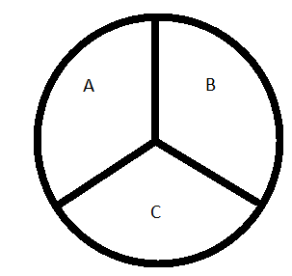

- Describe your final observations (use the back of this sheet if you need more space):

- What would happen if we let the bacteria grow for another day? For another week? For a month?

- Was your hypothesis correct? Why or why not?

