Sewer and Septic Systems Question Sheet
- How do the suspended solids and chemicals affect the surrounding wildlife? Give 3 examples.

- What is a septic tank?

- What is the purpose of a P-trap?

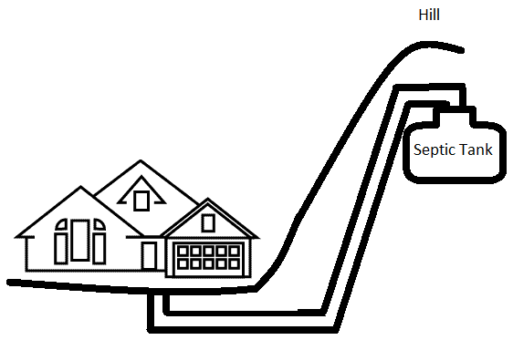
- Look at the drawing: Is this a realistic set-up for a house? Why or why not?

- Why are wastewater treatment facilities located in low-lying areas?

- What does a facility have in case gravity cannot do all of the work?

- What happens in primary treatment?

- What happens in secondary treatment?

- What happens in tertiary treatment?

- Match the vocabulary word to the correct definition:

_______ chlorine A. Fecal bacteria remaining in water.
_______ BOD B. The amount of oxygen in water.
_______ coliform bacteria count C. A chemical used to kill bacteria.
_______ dissolved oxygen D. A measure of how much oxygen in the water is required to finish digesting organic material.

