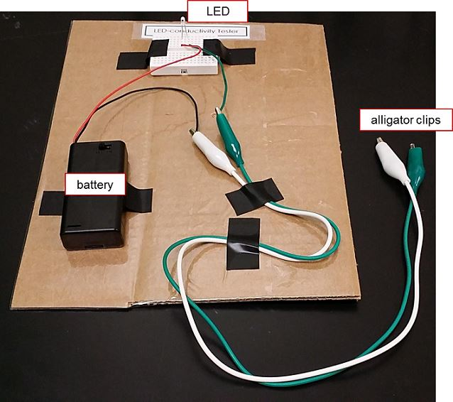
Lab Equipment Testing Instructions
Figure 1. LED-conductivity tester.
For Part 1. Measuring Electrical Conductivity of Different Liquids
Steps for Using the LED-Conductivity Tester
- At the LED-conductivity tester setup, like the one shown in Figure 1,
turn on the battery switch.
- Then submerge the two ends of alligator clips into one sample
and compare the relative brightness of the LED.
- Record your observation in worksheet Table A.
- Before testing the next sample, rinse the clip ends in the pure water
labeled “rinse here,” and use a paper towel to dry the clips.
- Repeat until all water samples are tested.
- Rinse and dry the clip ends.
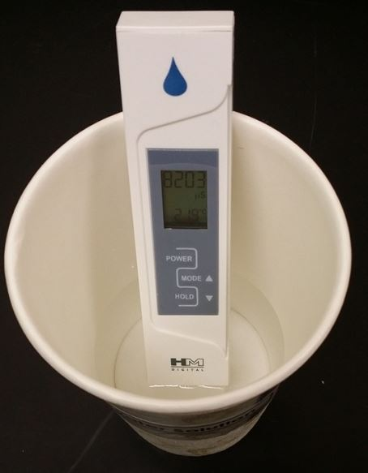
Figure 2. Electrical conductivity tester.
Steps for Using the Electrical Conductivity Tester
- To measure the electrical conductivity of the samples, submerge the electrical conductivity tester (EC tester) into one sample, as shown in Figure 2.
- Record the measurement in worksheet Table A.
- Before testing the next sample, rinse the EC tester in pure water and use a paper towel to dry it.
- Repeat until all water samples are tested.
- Rinse and dry the tester.

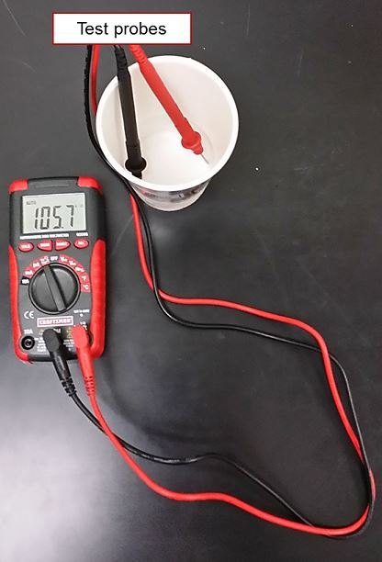
Steps for Using the Digital Multimeter
Figure 3. Setup for resistance measurement using digital multimeter.
- To measure the resistance of the samples, turn on the digital multimeter (DMM) and make sure it is in the “resistance” setting. For most DMMs, that means turning the dial to the setting that has the Ω (ohm) symbol.
- Verify that all the parts are connected correctly, as shown in Figure 3.
- Submerge the two test probes into one sample container, pressing the probes against the opposite sides of the container (as shown in Figure 3). Wait about 1 minute to achieve a stable reading on the meter.
- Record the resistance reading (in Ω) in worksheet Table A. Check the units shown in the multimeter. (MΩ=10⁶ Ω; kΩ=10³ Ω)
- Use pure water to rinse and dry the electrodes before measuring the resistance of the next sample.
- Repeat until all water samples are tested.
- Rinse and dry the probe ends.

