Modeling Bacteria Transformation Worksheet Answer Key
DATA and OBSERVATIONS

[ Staple recombinant model here. ]

OVERVIEW of BACTERIA TRANSFORMATION
Instructions: Using the word choices provided in the boxes, fill in the numbered boxes with the steps of bacteria transformation and the lettered lines with the name of the structure next to it.

plasmid
foreign DNA with desired gene
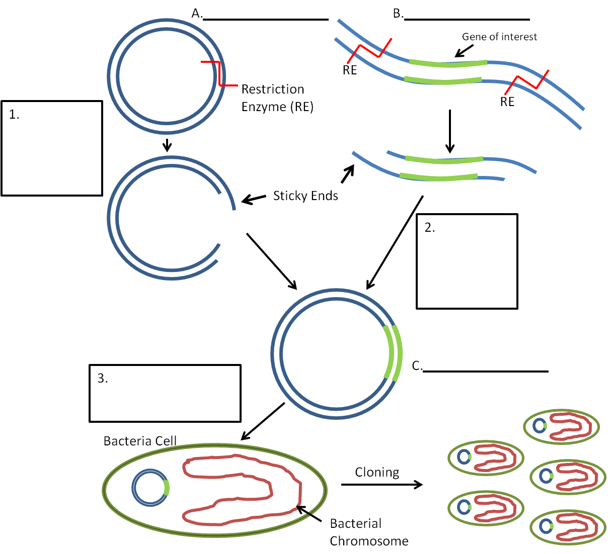

plasmid cut with restriction enzyme

Word Choices for Letters
- foreign DNA with desired gene
- plasmid
- recombinant DNA
Word Choices for Numbers
- bacteria transformed with recombinant plasmid
- plasmid cut with restriction enzyme
- DNA ligase joins sticky ends to form recombinant plasmid
bacteria transformed…
recombinant DNA
DNA ligase joins sticky ends

