Recommended Insulation Levels for Retrofitting Existing Wood-Framed Buildings
Insulation levels are specified by R-value. R-value is a measure of insulation’s ability to resist heat traveling through it. The higher the R-value the better the thermal performance of the insulation. The table below shows what levels of insulation are cost-effective for different climates and locations in the home.
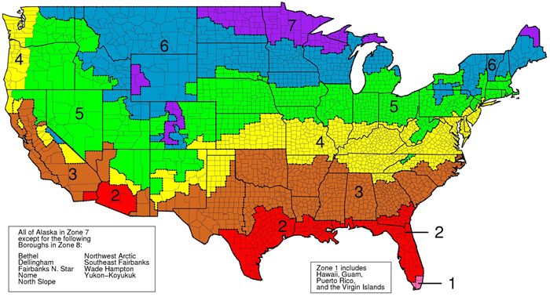

Zone | Add Insulation to Attic |  | Floor
Zone | Uninsulated Attic | Existing 3–4 Inches of Insulation | Floor
1 | R30 to R49 | R25 to R30 | R13
2 | R30 to R60 | R25 to R38 | R13 to R19
3 | R30 to R60 | R25 to R38 | R19 to R25
4 | R38 to R60 | R38 | R25 to R30
5 to 8 | R49 to R60 | R38 to R49 | R25 to R30
Wall insulation: Whenever exterior siding is removed on an uninsulated wood-frame wall:
- Drill holes in the sheathing and blow insulation into the empty wall cavity before installing the new siding, and
- Zones 3–4: Add R5 insulative wall sheathing beneath the new siding
- Zones 5–8: Add R5 to R6 insulative wall sheathing beneath the new siding.
Insulated wood-frame walls:
- For Zones 4 to 8: Add R5 insulative sheathing before installing the new siding.
Source: Energy Star, US Department of Energy http://www.energystar.gov/index.cfm?c=home_sealing.hm_improvement_insulation_table

