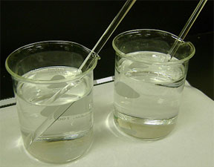
Disappearing Glass Demo Instructions
Follow the procedure below to conduct the “disappearing glass” demonstration. Several ways exist to conduct this demo; refer to book and internet resources for additional information.
Materials List
- 2 clear glass beakers (500 ml)
- glycerin (or Wesson veg. oil)
- water
- Pyrex stirring rods (important to use Pyrex brand)
Procedure
- Pour water into one beaker so it is at least half full. Do the same with the liquid glycerin in the other beaker.
- Place one Pyrex stirring rod in the beaker with water. Ask for student observations. Expect students to clearly see the stirring rod all the way to the bottom of the beaker. It is transparent.
- Slowly put the other Pyrex stirring rod into the beaker with the glycerin. Ask for student observations. Expect students to marvel that it appears as if the lower half of the stirring rod has disappeared so that it looks invisible!
It’s not magic… it’s simply SCIENCE!

