We Have Liftoff Worksheet
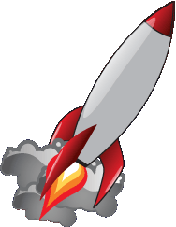
Rocket science is an interdisciplinary field that requires the expertise of engineers and scientists who specialize in different topics. Rockets are an engineering marvel! The ability to move a huge piece of machinery more than 10,000 km past the Earth’s atmosphere and against gravity is quite an accomplishment. Many things must be considered when building rockets, and because they are so costly, efficiency and accuracy are of the utmost importance.
For the miniature rockets you will be building, we won’t be too concerned about the depth of engineering for the miniature rockets we will build in this class. The purpose of this activity is to give you a basic understanding of rocket design.
You will build small rocket prototypes using crafting supplies and other household items. The fuel for your rockets will be a mixture of potassium nitrate, found in stump remover and gun powder, and household sugar. The unbalanced combustion reaction equation for the fuel is:

$$C_{12}H_{22}O_{11}+KNO_{3}+O_{2}→CO_{2}+H_{2}O+K_{2}CO_{3}+N_{2}+KOH$$
$$sugar+potassium nitrate+oxygen →carbon dioxide+water+potassium carbonate+nitrogen gas+potassium hydroxide$$
Materials
Each group needs:
- cat litter
- granulated sugar
- potassium nitrate (found in stump remover)
- wooden dowel, 3/8 in x 9 in (0.95 cm x 22.86 cm)
- strip of Kraft project paper, 2.5 in x 10 in (6.4 cm x 25.4 cm)
- fuse, ~12 cm long
- two 1-cm pieces of a plastic straw
- mortar and pestle
- closed 80- to 100-ml container
- safety glasses
To share with the entire class:
- balance
- white glue
- scissors
- ruler
- drill bit (1/8-in or 0.3175-cm diameter) or nail
- ring stand
- skewer or ¼-in (0.635-cm) dowel with a spike at one end

Procedure
- Spread white glue evenly on one side of the Kraft paper. Wrap it tightly around the 3/8-inch wooden dowel, such the dowel is not glued to the paper, to form the shape of a cylindrical rocket motor casing that is 6.4-cm long. Remove the dowel and let the glue dry.
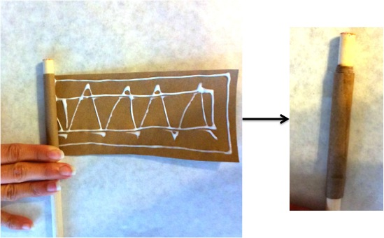

- Using a mortar and pestle, finely ground some cat litter. When the rocket body (paper cylinder) has dried, hold it vertically with one open end on a flat surface and pour the litter into the cylinder. Use the dowel to pack it down. Make the packed litter layer about 0.85-cm thick. The layer serves as a plug at the base of the rocket body. If the litter powder is fine enough, packing it down will, in a sense, make it into a solid. If you are having trouble packing the litter, mix it with some water so that it begins to clump, and then retry packing.
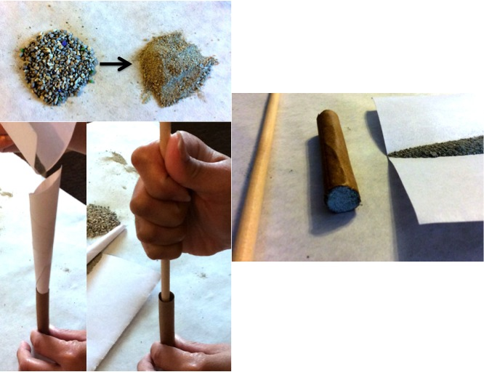
- Weigh out 6 grams of sugar and pour it into the mixing container.
- Given the known amount of 6 grams of sugar, balance the combustion equation below and determine the appropriate amount of KNO₃ needed for the fuel. Complete the table below.
DO NOT CONTINUE ONTO THE NEXT STEP
UNTIL YOU HAVE CONFIRMED YOUR ANSWERS WITH THE TEACHER.
$$_____C_{12}H_{22}O_{11}+_____KNO_{3}+_____O_{2}→_____CO_{2}+{_____H}_{2}O+{_____K}_{2}CO_{3}+__{____N}_{2}+_____KOH$$

Substance | Weight (g) | Molecular Weight (g/mol) | Moles
C12H₂₂O₁₁ | 6 | 342.3
KNO₃ |  | 101.103
O₂ |  | 32
CO₂ |  | 44.01
H₂O |  | 18
K₂CO₃ |  | 138.205
N₂ |  | 28
KOH |  | 56.106

- Weigh out the amount of KNO₃ determined from your calculations. Using a CLEAN mortar and pestle, grind the crystals into a fine powder.
Question: Is it better to have fine powder or course powder for combustion? ___________________
Question: Why? ____________________________________________________________________
__________________________________________________________________________________
__________________________________________________________________________________
- Add the KNO₃ powder to the mixing container. Shake to create an evenly mixed powder.
- Pour the fuel powder into the open end of the rocket body (paper cylinder) and compress it with the dowel until about 1 cm of unfilled space remains at the top of the cylinder.
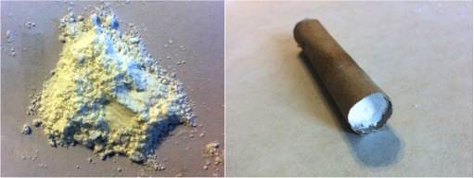
- Pour more cat litter into the top of the rocket body, packing it down, until the litter layer is flush with the end of the rocket body.
- Using the drill bit or nail, slowly and carefully bore a hole down the middle of the rocket body into its packed fuel contents. Be sure that the borehole does not puncture the cat litter-plug at the other end of the rocket.
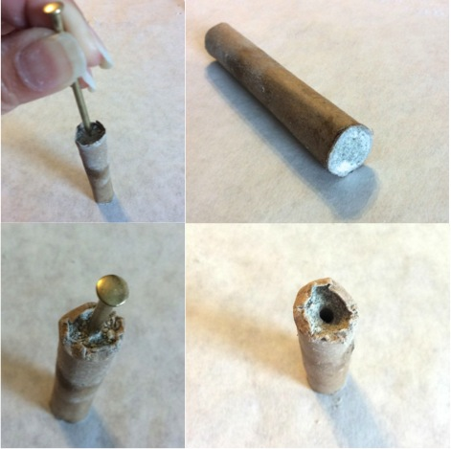
- Glue the two 1-cm straw pieces to the side of the rocket body in a vertical direction. During the launch, these loops will be placed over the skewer (or thin dowel) to serve as a guide. So, when gluing, make sure that the straws are aligned along the cylinder and in a straight line to each other.
- Insert the igniter fuse into the borehole. Bend the top of the fuse, if necessary, to make sure that it fits snuggly.
- Launch the rockets in an open and safe area. Using the ring stand and skewer (or thin dowel), set up a launch pad in such a way that the bottom of the rocket body rests on the stand and the straw loops along the rocket body slide over the skewer. Wearing safety glasses, light the fuse and back away immediately.
Results Analysis Questions
- What factors contributed to the success or failure of your prototype rocket launch?

- If you could redesign your rocket, using the same procedure, what would you do differently to improve your rocket’s flight?

- How would changing the compactness of the powders affect how the fuel burns?

- What is the significance of the borehole through the rocket fuel? What does the hole do?

- What could be done/added to make your rocket fly straight?

