**Magic Magnetic Fluid Activity –   
Liquid Magnets Worksheet**

**C:\Users\yowell\AppData\Local\Microsoft\Windows\Temporary Internet Files\Content.IE5\2ZBOBS2T\MC900340404[1].wmf**

**Background**

Most materials fall into three categories of magnetic materials: paramagnetic, diamagnetic and ferromagnetic. Amongst these categories, ferromagnetic materials exhibit the largest magnetic permeability. As the name suggests ferrofluids are composed of ferromagnetic particles, surfactant, and carrier fluid. Ferromagnetic particles are used because of its large magnetic permeability as compared to other classifications of magnets. Essentially, the resultant magnetic field is orders of magnitude larger than the induced magnetic field. This becomes important when manipulating ferrofluids under moderate and controlled magnetic fields.

As engineers, you are the material scientist manipulating your own ferrofluid. Your challenge is to become exceptional observers and document everything you see. Use your observation skills and newly found knowledge of ferrofluids to complete the handout.

**Part 1: Concepts**

1. How can a Liquid be magnetic?

1. What type of magnetic material (paramagnetic, diamagnetic, or ferromagnetic) would be best for making a liquid magnet? Explain the fundamental differences between the three classifications of magnets and why you would use one over the other.

1. The picture below depicts what is going on in your test tube. Although you cannot see the particles, they are there. Fill in the three spaces in the magnified picture. Below the picture write the purpose of each labeled component.

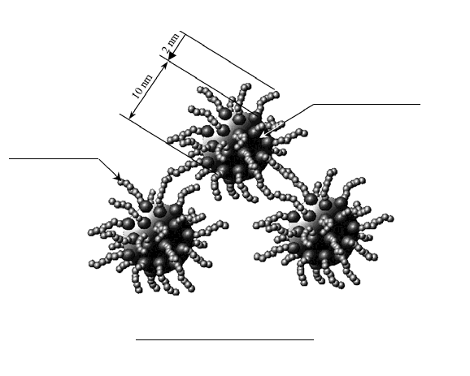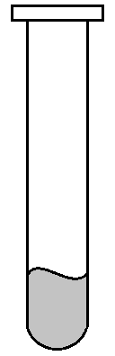

Component 1:

______________________________________________________________________________

Component 2:

______________________________________________________________________________

Component 3:

______________________________________________________________________________

**Part 2**

**Procedure**

*Fun with ferrofluids*

1. Place permanent magnet under clear plastic dish and pour a small amount of fluid over the plastic area that the magnet occupies beneath and outside the dish.
2. Add two drops of red food coloring and mix using the magnet, located outside the dish.
3. Using your hands, manipulate the magnet, outside the dish, and fluid (blood) making squares, triangles and circles. Remove the magnet from under the plastic dish, and observe how the fluid behaves. Fairly quickly, place the magnet back under the dish, and observe how the fluid behaves
4. Place the magnet outside the dish and under the fluid, as above, and begin touching fluid with a latex glove. Can you spin your fluid?
5. Complete worksheet.
6. Cleanup plastic dish by wiping magnetic fluid up with paper towels. Make sure no fluid residue is present on dish.
7. Cleanup laboratory area.

**Questions**

1. In the boxes below, draw your observations of the ferrofluid when exposed to the external magnet and when not exposed.

**With Magnetic Field**

**Without Magnetic Field**

1. How would you describe the ferrofluid when it is NOT exposed to an external magnet?

1. How would you describe the ferrofluid when it is exposed to an external magnet? Explain how the physical properties of the fluid changed.

1. In the space provided below draw the magnetic domains associated with nanoparticles. Compare this behavior to traditional magnetic materials.

1. Why do ferrofluid materials behave differently than bulk magnetic materials?

1. Where might you use this type of technology or property manipulation? Name 3 applications with a 1-2 sentence explanation.