Mold Construction Instructions
Materials List
- 9-in x 12-in sheet of aluminum foil
- masking tape
- scissors
- ruler

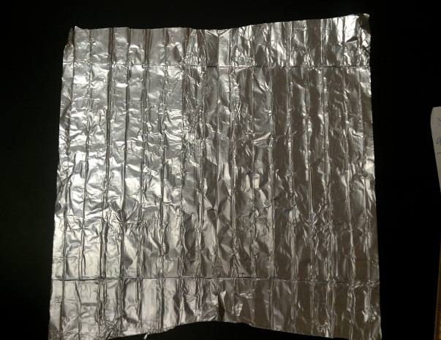  12-in  9-in  Start with a 9 x 12-in foil sheet ➔ | 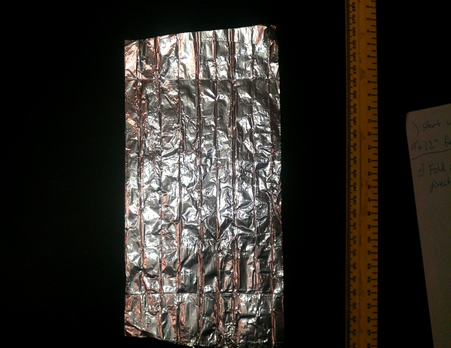  seam  Fold in half with seam along 12-in direction
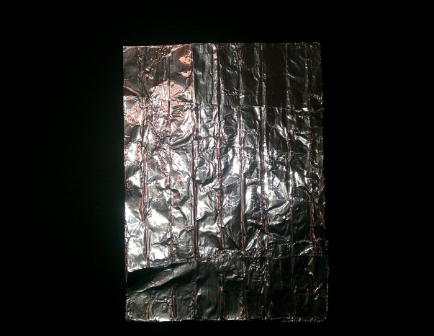  seam  2”  Fold top and bottom edges 2 inches towards center with both fold seams along 9-in direction | 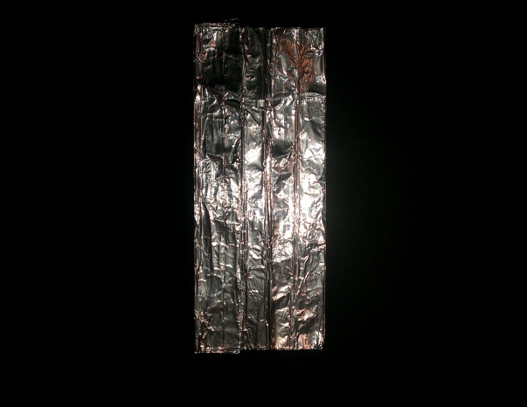  1.5”  Fold left and right sides 1.5-in in towards center
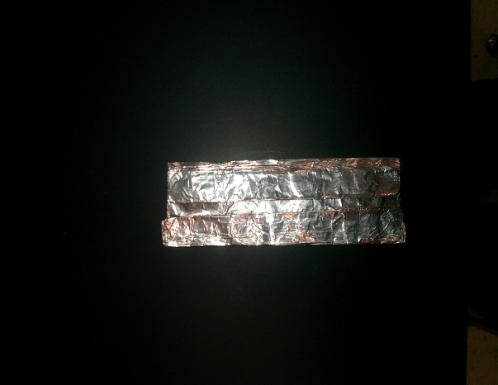  0.5 in  Rotate foil 90 degrees and fold top and bottom edges 0.5-in towards center ➔ | 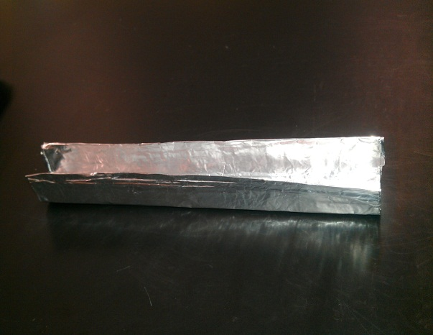  Flip foil over and fold top and bottom sides up forming a U shape with 0.5-in wide base
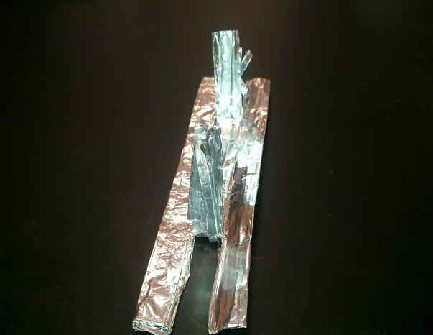  1.5 in  Cut base on both sides of left and right  sides 1.5 in in towards center | 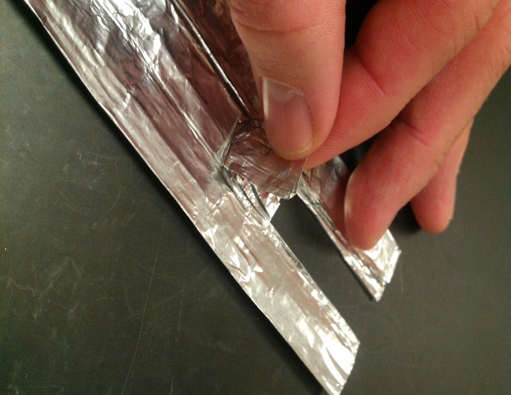  fold 1 in  Fold both middle tabs way from  mold center 1.0 in
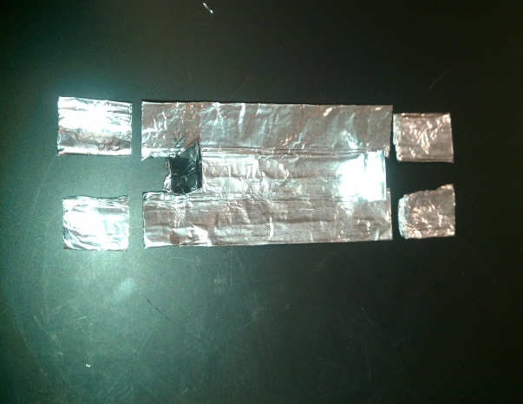  0.5 in  Cut outer tabs down to 0.5-in on both sides | 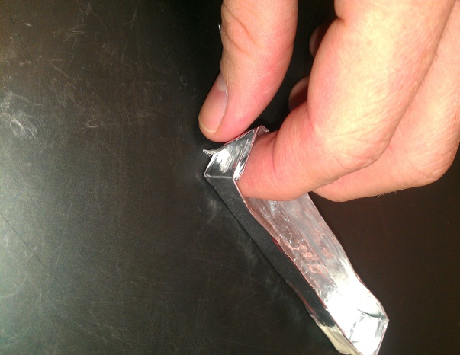  Fold outer tabs behind middle tab forming end mold wall; repeat on other end
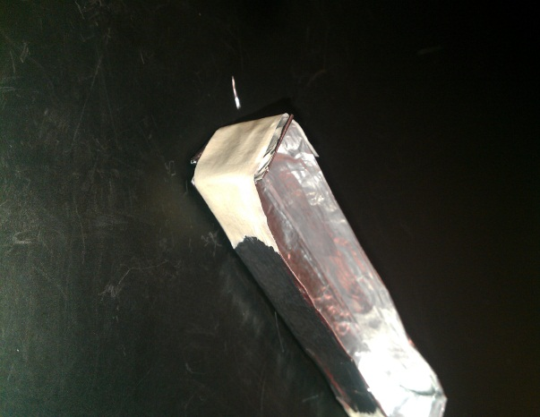  Take 1.5-in strip of masking tape and tape wrapped mold side walls to mold wall end ➔ | 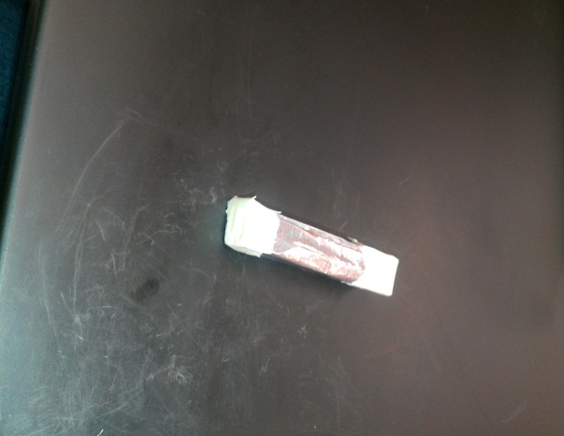  Place 1-in strip of masking tape so half is on mold bottom and the other half is on the end mold wall
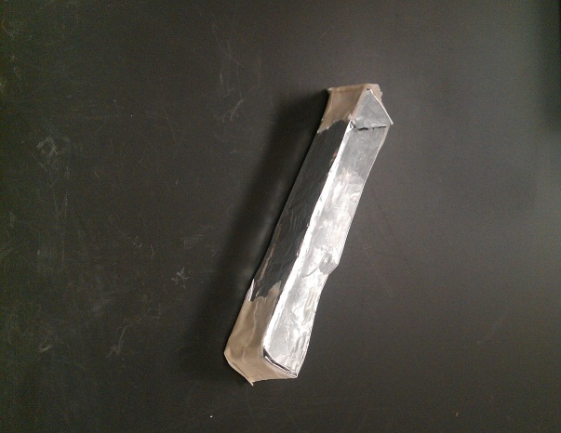
Final beam mold!
Final mold dimension = 0.5 x 0.5 x 5 inches (1.27 x 1.27 x 12.7 cm)
(NOTE: Adjust slightly, as needed, to make dimensions as close to final beam dimensions as possible)

