Marauders Map Intro to GIS

Quiz Description: Based on GIS introductory presentation given to 8th graders, this quiz tests their knowledge on what they observed during one day's lesson in class. Some of the quiz requires the use of 1916 map of Lower Manhattan.

Note that this quiz was actually given as an online quiz using the website www.proprofs.com/quiz-school
Question 1: Please explain in your own words what it was about the Marauders Map in Harry Potter that makes it so different from paper maps that we use today. What is magical about this map?

Question 2: Why can't a paper map do what the Marauder's Map does?

- Paper maps CAN do what the Marauder's Map does. They show locations that can be found in space just like the Marauder's Map did.
- The Marauder's Map was magical, and no one we know in our class has magic like they do at Hogwartz.
- It would be illegal for us to do what the Marauder's Map does using a paper map.
- Paper maps give you a snapshot of one moment in time. If you put an object on the map that might move, then you're map is inaccurate

Question 3: How can you do using technology what a Marauder's Map does with magic?

- Use a cell phone signal to track locations of people and objects on a digital map.
- Use satellites to constantly watch particular individuals so that you can put it on a digital map.
- With a large map spread out on a table, hire someone to follow a person you are interested in tracking and call in their position. Then move a game piece on the map that represents the person's position.
- We cannot currently track multiple individuals' position. It is simply too hard for current technology.

Question 4: In your own words, please give at least two reasons why maps are valuable.

Question 5: Why can't a photograph by itself be a map?

- A photograph contains too much information.
- A photograph used as a map is simply too realistic. Maps should not be too realistic.
- It's too hard to take a photograph correctly that would be a map.
- Photographs are not always facing north, and they would have to be in order to be a map.
- Maps require additional information beyond just the way that space looks that you are mapping.

Question 6: There are four things that a map MUST have with it in order to be a good map. What are three?

- Scale, direction, information source
- Scale, title, information source
- Legend, title, information source
- Information source, direction, locational grid
- Legend, scale, locational grid

Question 7: Using the Lower Manhattan map, about how far is it from Trinity Church to St. Paul's Church in a straight line?

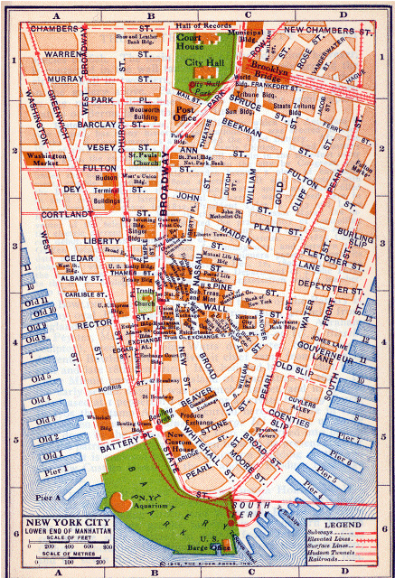

- 800 Feet
- 1500 Feet
- 400 Feet
- 2500 Feet
- 6200 Feet

Question 8: There are some transportation structures that make a loop on Cortlandt and Fulton through the Hudson Terminal Buildings. What are these structures?

- Trolley Lines
- Surface Lines
- Subways
- Tunnels
- Railroad Lines

Question 9: Which one of the following would likely not be a LAYER in a Geographic Information System (GIS)?

- Roads
- How much money you have in the bank
- Schools
- Kinds of soil
- Your friend’s house

Question 10: We talked today about African elephants in GIS. What were the GIS maps being used for with the elephants?

- Trying to find out where people might want to hunt elephants illegally.
- Trying to understand why elephants like to give birth always at the same place.
- Trying to understand the spread of an elephant disease that was originally caused by people.
- Trying to find areas that might be hard on elephants because of a combination of many people and low water supply.

Question 11: What was your favorite thing that we did today and why?

