Images taken from ESRI’s GIS Best Practices handout called “GIS in Afric” published in March of 2009. ESRI ArcGIS software was used to produce the maps.
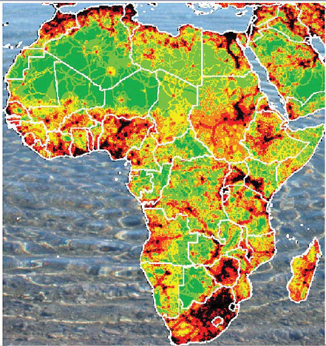
Figure 1. Geospatial analysis of human impacts on elephant populations. Red and black indicate great level of human impact and green and yellow indicate less potential for human negative impact. The coloring uses an index of human impact which takes into account population density, land mine risk, the location of national parks, major roads, and various industrial activities.
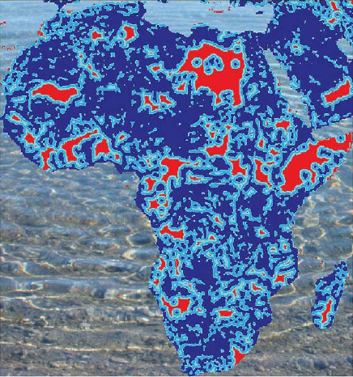
Figure 2. Distance to permanent water. Red indicates greater distance and dark blue indicates closer distance.
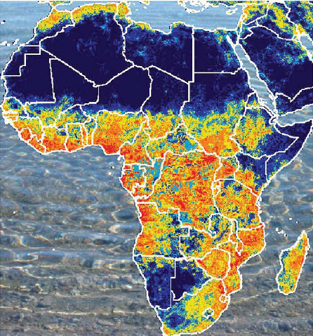
Figure 3. Model prediction of elephant-human conflict. Areas of suitable habitat are combined with spatial information on human activities to match where the greatest threat to elephants from man may lie.

