Material Science Quiz
Answer the following questions without the assistance of a neighbor, friend or teacher.
- For each material, indicate its material class.
quartz |  | Material Classes:
steel |  | 1. polymer
Teflon® |  | 2. metal
aluminum |  | 3. ceramic
plywood |  | 4. composite
fiber glass
diamond
Zip Lock® bag material
paper clip
polyvinyl chloride (PVC)
concrete
paper
- Connect each material to the corresponding material class.
ductility |  | 1. Hard, covalently bonded material
brittle |  | 2, Describes displacement of particles in a deforming body
lattice |  | 3. Measured stress at onset of plastic deformation
ceramic |  | 4. The brand of science that deals with metal properties
stress |  | 5. Irreversible alteration of a solid body under stress
plastic deformation |  | 6. Reversible alteration of a solid body under stress I
yield strength |  | 7. 3D geometric arrangement of atoms composing a crystal
elastic deformation |  | 8. Ability of material to undergo permanent deformation without fracture
strain |  | 9. Ability of material to break, or crack easily when subjected to a force
metallurgy |  | 10. Force exerted on an object over a defined cross-sectional area
- What type of bonding makes up ceramic materials?
  - covalent bonds
  - London dispersion forces
  - metallic bonds
  - ionic bonds
- How many lattice structures exist?
  - 2
  - 14
  - 7
  - 5

- How many Bravais lattice structures exist?
  - 2
  - 14
  - 7
  - 5
- The maximum attainable stress for a metal is called:
  - yield stress
  - fracture stress
  - maximum stress
  - ultimate tensile stress
- All are attributes of ceramics, except:
  - covalent bonded
  - low melting point
  - high stiffness
  - High hardness
- All are not attributes of metals, except:
  - electrical insulators
  - thermal insulators
  - high melting points
  - ductile
- Below are examples of plastic deformation, except:
  - a wire coiled 10 times around a magnetic core
  - broken glass
  - bent nail in wood
  - molded clay
- What class of material might be useful at temperatures 1100°C (2150°F)?
  - pure metals
  - polymer-polymer composites
  - ceramics-ceramic composites
  - lead-tin metal alloy
- Label the stress strain plot below:
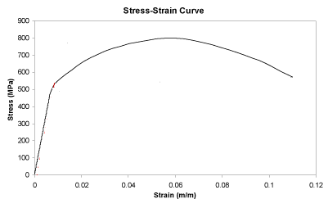
  - yield stress
  - ultimate tensile stress
  - fracture stress
  - elastic deformation region
  - plastic deformation region

- Label the lattice and packing below.

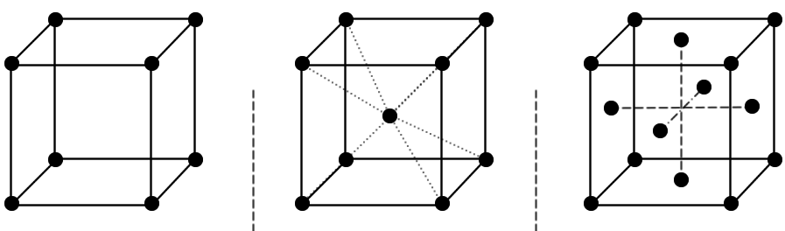

- True or False? Aluminum alloy has an FCC structure.
- True or False? Brittle materials typically fail fast and with excessive plastic deformation.
- True or False? Strain is the measure of force per unit cross-sectional area.
- True or False? Type of bonding dictates whether a material is electrically conductive or not.
- True or False? Metallurgy is the study of metals and their behavior.
- True or False? I like materials science and engineering.

