Chemical Label Sheet

Chemical # | Chemical Identity
1 | Sugar
2 | Sodium lauryl sulfoacetate
3 | Borax
4 | Salt

Chemical ID | 1
Chemical Formula | C₁₂H₂₂O₁₁
Structure | 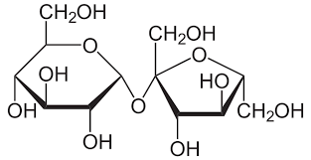

Chemical ID | 2
Chemical Formula | C₁₄H₂₇NaO₅S
Structure | 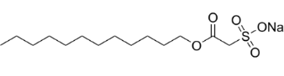

Chemical ID | 3
Chemical Formula | Na₂[B₄O₅(OH)₄]●8H₂O
Structure | 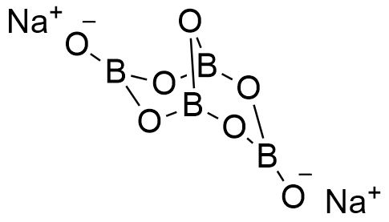

Chemical ID | 4
Chemical Formula | NaCl
Structure | 