Neuron Diagram Answer Key
Instructions: Label the neuron using these words: axon, axon terminals, cell body, dendrites, myelin

NEURON – Nerve Cell - (special cells in the brain and spinal cord that send messages to the body)
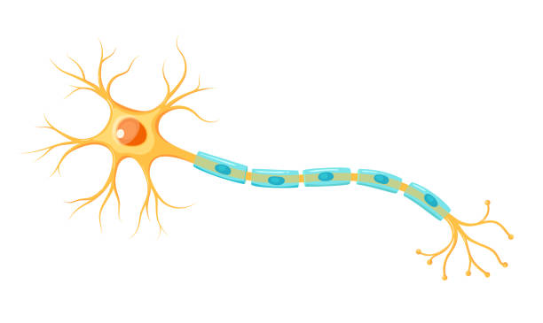
dendrites
axon terminal
_______________________
myelin sheath
_______________________
axon
cell body
_______________________
_______________________
_______________________

