Tinkercad Circuit Example – Teacher Guide

Students will need to code basic movement in Tinkercad and simulate input-output behavior. Below is an example of a Tinkercad circuit and five different options the teacher can implement. Teacher should choose the option best for their classroom depending on students’ C++ programming and Arduino background. See different options below.

Option 1: Provide Circuit Diagram
Provide students with the circuit diagram below and ask each group to build/develop the code. See the C++ Code for the Arduino Setup Sheet to view the code.
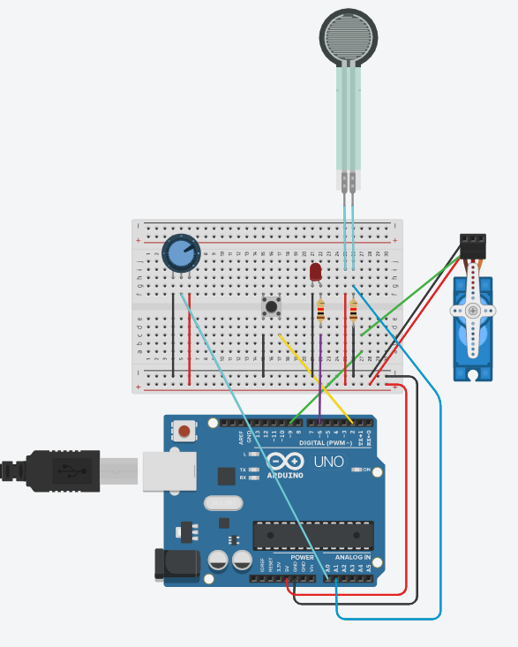
Option 2: Provide Circuit Diagram and Partial Code
Provide students with the circuit diagram below AND provide them with partial (fill in the blanks) code. Ask each group to complete the code. See C++ Code for the Arduino Setup Fill in the Blank Sheet to view the partial code and C++ Code for the Arduino Setup Fill in the Blank Answer Key Sheet to view the answers.

Option 3: Provide Code
Provide students with the code and ask groups to wire on Tinkercad. See the C++ Code for the Arduino Setup Sheet to view the code. See image below for the circuit.
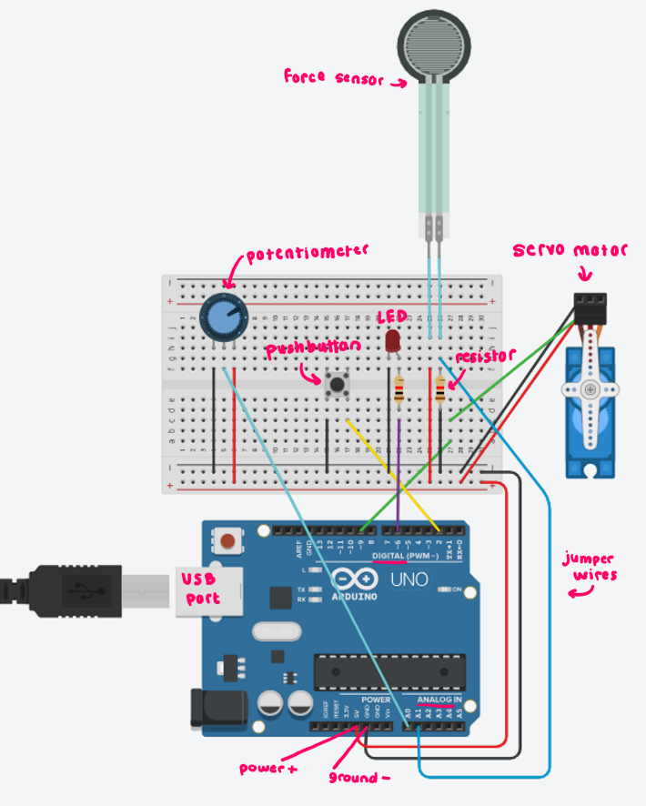
Option 4: Provide Circuit Diagram and Code
Provide students with the circuit diagram AND provide them with the code. See the C++ Code for the Arduino Setup Sheet to view the code.

Option 5: Provide Nothing!
Allow groups to wire the circuit and build the code on their own.

